SUV tyres

Nokian zLine SUV summer tyre – cool performance and extreme durability for SUVs

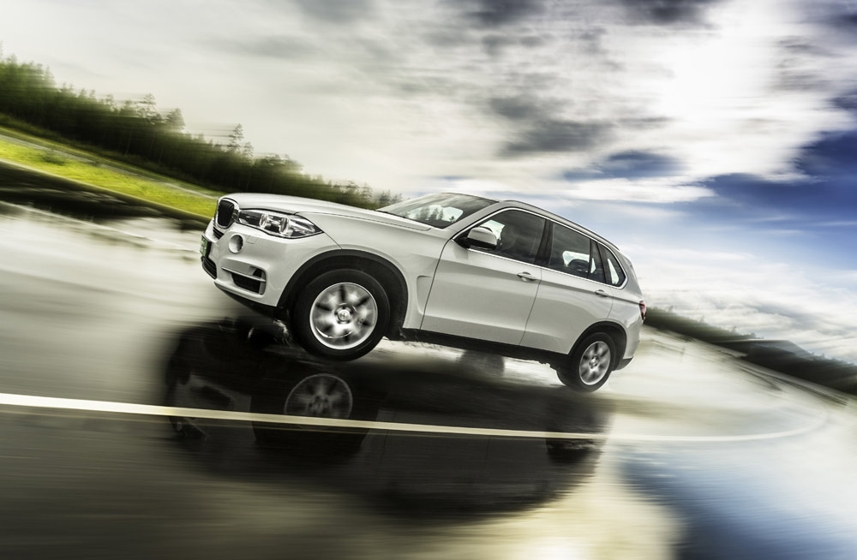
Sporty handling, control for demanding conditions and high wear resistance by Nokian Aramid Sidewall technology. Perfect driving pleasure, quick reactions and best possible wet grip for the largest SUVs.

The new sporty Nokian zLine SUV summer tyre provides precise handling, extreme durability, safety for demanding conditions and perfect driving pleasure. Its sidewalls are reinforced by the high tenacity Nokian Aramid Sidewall technology. Aramid fibres are also used in the aviation industry and provide much-needed durability to drivers wishing to unleash the full potential of their powerful SUVs. Best possible wet grip for the varying Central European asphalt roads make the largest SUVs safer. Nokian tyres from Finland are multiple test winners.

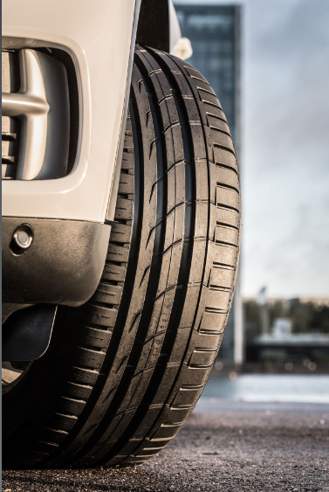
The Nokian zLine SUV steers logically, quickly, and responsively at high speeds. It is the latest display of skill from the world's northernmost tyre manufacturer from Finland that combines SUV owners' requests for safety under extreme conditions, pleasant comfort, and care-free driving.

The Nokian zLine SUV exudes power, and it is designed for the largest SUVs. The comprehensive selection of 25 sizes from 17 to 22 inches has the speed ratings V (240 km/h), W (270 km/h), and Y (300 km/h). All are now available to consumers. The main market is Europe.

Nokian Aramid Sidewall technology minimises sidewall damage

The sporty and precise Nokian zLine SUV is the result of nearly four years of careful development, and its unique durability and handling properties are the key features setting it apart from its predecessors.

“More durability, state-of-the-art handling, and the best possible safety for rain-slick roads. Drivers who want to enjoy the power of their SUVs will value durability in addition to a precise and comfortable driving feel,” says Product Development Manager Juha Pirhonen from Nokian Tyres, winter tyre inventor, innovation leader and world record holder.

SUV tyres are most often damaged by impacts to the tyre sidewall. The Nokian zLine SUV uses Nokian Aramid Sidewall technology to maximise impact and cut protection.

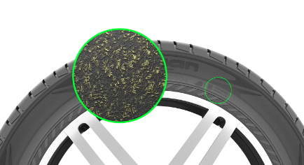
The sidewall compound includes extremely durable aramid staple fibre, and it is exceptionally resistant to wear and cuts. The same material is also utilised in the aviation and military industries. The aramid fibre stiffens and reinforces the sidewall to even better withstand external impacts and pressing against the wheel flange. Nokian Tyres is the first tyre manufacturer using Aramid in the side wall. urability for the varying Central European road conditions is also optimised by means of a strong steel belt structure and a new tread compound that is tailored for hot conditions and demanding use.

Tread pattern supports optimal handling and driving comfort

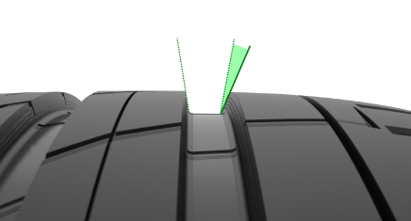
The developer of the world's first winter tyre builds its product development philosophy on tailoring products and testing them under actual conditions. The handling and grip properties of the logically behaving Nokian zLine SUV were refined on the rough Northern roads and the European high-speed circuits. The creation of the excellent wet grip and aquaplaning properties utilised high-speed camera footage, providing essential information about the interaction between the road and the tyre.

The modern, asymmetrical tread pattern of the highly durable and stylishly sporty Nokian zLine SUV perfectly supports the precise handling of this high-performance tyre. The rigid inside and outside shoulder area connects with large block patterns that are bound together by longitudinal ribs. The wide, massive ribs stiffen the tyre and reduce the movement of the pattern blocks during road contact. The tread pattern is very stiff, which translates into excellent handling in the corners. The steering feel is precise and quick even under a heavy load and at high speeds.

The Cornering Precision Shoulder provides logical handling for lane changes and cornering, along with the asymmetrical, chamfered groove corners that also improve stability.

The hemispherical indentations, reminiscent of a golf ball pattern, on the walls of the longitudinal ribs provide additional driving comfort. This Silent Groove Design innovation reduces the interior noise and external rolling noise of the vehicle. The design also reduces air resistance and cools the surface of the tyre, in turn improving wear resistance.

Blade and trumpet grooves prevent aquaplaning

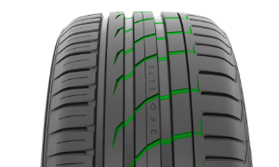
Several innovations are used to fight the ever-present danger of aquaplaning. Aggressive Blade Grooves cut through the ribs in the centre area, effectively storing water and guiding it towards the longitudinal grooves. Trumpet Grooves were also shaped in the shoulder areas in order to improve safety. The bullet-shaped indentations, which have been optimised for flow, store water from between the tyre and the road, accelerating its flow from the main grooves towards the transverse grooves and maximising grip even on rain-soaked roads.

The flow of the water displaced by the surface tread is also accelerated by the four wide and polished main grooves. Polishing the grooves gives the Nokian zLine SUV an even more appealing look and also improves its aquaplaning properties even further.

New tread compound: better steering feel and wet grip

The zLine Coral Silica tread compound uses the latest compound technology, and it was especially tailored for the higher speeds of the Central European asphalt roads. The micro-porous silica and the molecular chains in the functional rubber compound form a coral-like structure that has a wide contact surface but remains extremely rigid. This innovative compound allows the Nokian zLine SUV to remain rigid and to maintain reliable road contact even during fast driving and in tight corners.

The rubber compound works ideally along a wide temperature range, improving wet grip from spring to autumn. The feel of the road remains stable and provides no surprises under any conditions. The cut-resistant new compound also enhances driving comfort by damping the noise generated by uneven asphalt.

Added safety and comfort: Driving Safety Indicator (DSI) and information area

The tread surface is equipped with the Driving Safety Indicator (DSI), patented by Nokian Tyres and favoured by drivers who value safety and carefree operation. The numbers indicating the groove depth and the water drop symbol indicating the risk of aquaplaning are immediately visible to a driver inspecting the tyres installed on a vehicle. The water drop symbol disappears at the point that less than four millimetres of tread are remaining, indicating thereby an increased risk for aquaplaning.

The location and pressure indicators on the sidewall information area of the Nokian zLine SUV improve safety. The information area allows for recording the correct inflation pressure and installation location during tyre change. Comfort and safety are improved further by a new section that can be used to record the tightening torque of bolts for alloy rims.

Nokian zLine SUV – Tough cool performer

Precise and stable handling at high speeds
Sporty, balanced, and powerful
Aramid reinforced structure for unique durability
Effective aquaplaning prevention

Main innovations:

Nokian Aramid Sidewall technology Unique durability. The sidewall compound includes extremely durable aramid staple fibre, and it is exceptionally resistant to wear and cuts. The same material is also utilised in the aviation and military industries. The aramid fibre stiffens and reinforces the sidewall to even better withstand external impacts and pressing against the wheel flange.

Blade Grooves. Safety on wet roads. Aggressive blade grooves cut through the ribs in the centre area, effectively storing water and guiding it towards the longitudinal grooves.

Trumpet grooves. Effective aquaplaning prevention. The shoulder areas have trumpet grooves, bullet-type indentations that have been optimised for flow; they store water from between the tyre and the road, accelerating its flow from the main grooves towards the transverse grooves and maximising grip.

zLine Coral Silica tread compound. More precise handling, better wet grip. The molecular chains between the micro-porous silica and the functional rubber compound form a coral-like structure that has a wide contact surface but remains extremely rigid. Reliable and balanced road contact even at high speeds and in sharp corners. Also improves wet grip and wear resistance.

Silent Groove Design. More driving comfort. The hemispherical indentations, reminiscent of a golf ball pattern, on the walls of the longitudinal ribs provide additional driving comfort. The innovation reduces the interior noise and external rolling noise of the vehicle. The design also reduces air resistance and cools the surface of the tyre, in turn improving wear resistance.

www.nokiantyres.com

Vianor tyre and car-service of Nokian Tyres:
http://vianor.com

Edited by: Dr Falk Köhler

Photos downloads Nokian zLine SUV:

www.nokiantyres.com/zlinesuv

Videos Nokian zLine SUV:

Video: Nokian zLine SUV – Tough cool performer
http://youtu.be/sYHyUmczeS4

Video: Unique durability – Nokian Aramid sidewall concept
http://youtu.be/N5LvBke-UqY

Video: Nokian summer tyres – Testing at the extremes
http://youtu.be/6kT0wLEOxY4

Read more:

Nokian Tyres – the world's northernmost tyre manufacturer and the inventor of the winter tyre
www.nokiantyres.com/company/about-us/history/
Nokian WR is test winner 2014 in the Auto Bild winter tyre test
http://www.nokiantyres.com/company/news-article/nokian-wr-is-test-winner-2014-in-the-auto-bild-winter-tyre-test/

Nokian Tyres test success
www.nokiantyres.com/innovation/test-success/

Nokian Tyres is the world's leading winter tyre specialist, a multiple test winner, the inventor of the winter tyre and a premium brand

As the world's leading winter tyre specialist, a multiple test winner, and a premium brand, Nokian Tyres offers the safest tyres for Northern conditions. Innovative Nokian tyres from Finland for cars, trucks, and heavy machinery demonstrate their high quality particularly well in snow, ice, tough climates, and demanding driving situations. Nokian is the inventor of the winter tyre and has been designing, testing, and patenting innovative tyres for 80 years. Furthermore, Nokian produces tyres especially developed for European weather and the higher speeds on European motorways. Nokian tyres deliver excellent safety, save fuel, and are the forerunner of environmental friendliness. The company is number 1 in terms of brand recognition and appreciation in Scandinavia and Russia and has a positive, exceptional image.

Nokian WR winter tyres are test winners and have achieved numerous further test successes

Nokian WR winter tyres, optimised for European demands, are test winners and have achieved numerous further test successes. The Nokian WR D3 winter tyre scores the top rating “good”, and is thus “especially recommended” in the 2013 winter tyre test of the German automobile club ADAC and the consumer protection organisation Stiftung Warentest and is amongst the best. The Nokian WR D3 is rated “Especially recommended” by the German car magazine auto motor sport. The new Nokian WR SUV 3 high performance winter tyre comes out on top in the big SUV winter tyre test 2013 by OFF ROAD, with the top rating “highly recommended”.

Nokian winter tyres are the test winners in the 2012 winter tyre tests conducted by the German car magazines Auto Bild, auto motor sport, and AUTOStraßenverkehr earning top ratings of “exemplary”, “highly recommended”, and “very good”. In more than 20 winter tyre tests carried out by car magazines in Germany and other European countries last winter, Nokian tyres came out on top and thus confirmed the positive image of the Nordic premium brand. The Finnish tyres are given the top rating of “good” by the German automobile club ADAC and consumer protection organisation Stiftung Warentest.

Standard Nokian winter tyres set a new Guinness world record Fastest on Ice by reaching a top speed of 335.713 km/h.

Nokian tyres rated “good” in the ADAC summer tyre test 2014 and by the consumer organisation Stiftung Warentest and test winner in the German SUV magazine OFF ROAD

Nokian summer tyres are multiple test winners, offering high levels of safety and saving fuel. The Nokian Line summer tyre scores the top rating “good” in the summer tyre test 2014 of the German automobile club ADAC and with the German consumer organisation Stiftung Warentest Being rated “especially recommended”, Nokian Line is among the test winner group. As such, the Nokian tyre achieved a double success in the two best-selling tyre sizes tested for the compact and middle-sized category and for small cars. The Nokian strengths in the ADAC test: Very balanced tyre, good on wet and dry roads.

The test winner is the Nokian Z SUV in the big SUV summer tyre test 2014 by the German SUV magazine OFF ROAD, with the top rating “HIGHLY RECOMMENDED” and also in SUV MAGAZIN.

Nokian tyres were test winners 70 times or were among test winner group, scoring “good” or “recommended” 51 times in 121 test reports from autumn 2011 to spring 2014 – in Central Europe alone.

Increased safety through innovations: Winter Safety Indicator with snowflake and Driving Safety Indicator (DSI) with aquaplaning warning

The Nokian Driving Safety Indicator (DSI) with the unique snowflake symbol, the Winter Safety Indicator (WSI), on the Nokian WR winter tyre clearly shows the driver the groove depth as a number from 8 to 4 millimetres. The snowflake remains visible down to 4 millimetres. When it disappears, the risk increases and the winter tyres should be replaced. The grooves must be a minimum of 4 millimetres deep in order to provide enough grip on snow and to prevent slush planing and aquaplaning on winter and summer tyres.

The Driving Safety Indicator on the Nokian summer tyres shows the driver the groove depth as a simple figure from 8 to 3. An aquaplaning alert within this warns of the danger of aquaplaning with a drop symbol. It disappears when there are only four millimetres of remaining tread, alerting the driver of the increased risk. No other tyre manufacturer has these innovations.

Nokian Tyres achieved a 1.521 billion euro turnover in 2013

Nokian Tyres achieved a turnover of 1.521 billion euro in 2013 and had over 4,000 employees. In Central Europe, Nokian Tyres operates with own sales companies in ten countries. The company also owns the Vianor tyre and car-service chain that comprises over 1,300 outlets in 27 countries.

www.nokiantyres.com

Vianor tyre and car-service of Nokian Tyres:
http://vianor.com

Press contact:
Dr Falk Köhler PR
Dr Falk Köhler
Tel. +49 40 54 73 12 12
Fax +49 40 54 73 12 22
E-mail Dr.Falk.Koehler@Dr-Falk-Koehler.de
www.Dr-Falk-Koehler.de
Ödenweg 59
22397 Hamburg
Germany

Further information:

www.twitter.com/NokianTyresCom
www.youtube.com/NokianTyresCom
www.facebook.com/nokiantyres
www.linkedin.com/company/nokian-tyres-plc
Motorist blog:
http://hakkapedia.us/blog/en
Expert blog:
http://nordictyreblog.com/

Nokian Tyres Europe
Nokian Tyres s.r.o

V Parku 2336/22

148 00 Praha 4
Czech Republic
Business Director Central Europe Dieter Köppner, Tel. +420 222 507 761,
E-mail: dieter.koppner@nokiantyres.com
Technical Customer Service Manager CE Sven Dittmann, Dipl.-Ing., Tel. +49 8143 444 850

E-Mail sven.dittmann@nokiantyres.com

Marketing Manager Lukáš Líbal, Tel. +420 222 507 759

E-Mail lukas.libal@nokiantyres.com
www.nokiantyres.com

Nokian Tyres Finland Headquarters
Nokian Tyres plc
Pirkkalaistie 7
P.O.Box 20
37101 Nokia
Finland
Development Manager Juha Pirhonen, Tel. +358 10 401 7708

E-Mail juha.pirhonen@nokiantyres.com
Technical Customer Service Manager Matti Morri, Tel. +358 10 401 7621

E-Mail matti.morri@nokiantyres.com
Product Manager Central Europe Stéphane Clepkens, Tel. +358 50 462 7536
E-Mail stephane.clepkens@nokiantyres.com
www.nokiantyres.com

