**Proper winter grip, reliable performance**

**Nokian Weatherproof All-Weather tyres – safe year-round driving comfort**

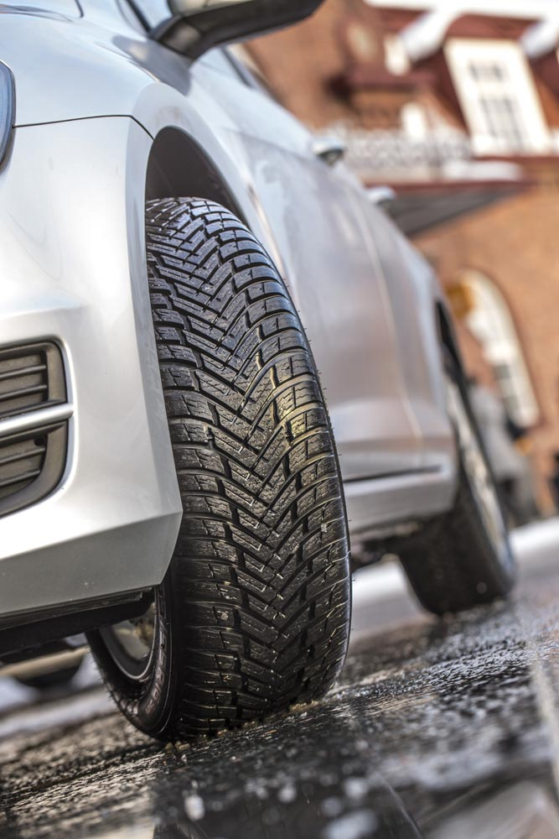The new high-performance Nokian Weatherproof family of winter tyres will put an end to the tyre change roulette that bothers drivers each spring and autumn. These top examples of Nokian Tyres' revolutionary All-Weather concept combine reliable winter safety with the precise driving stability and firm handling of the Nokian summer tyres. Top-notch innovations from the world's northernmost tyre manufacturer ensure that the Nokian Weatherproof tyre range offers comfortable driving during all seasons.

The multi-talented Nokian Weatherproof product family is designed for drivers who require a safe option for the snow and slush but who also want to drive efficiently and effortlessly in the summer.The Nokian Weatherproof product family offers durable performance for Central European roads and streets, and it offers sizes for modern passenger cars, SUVs and vans alike. All of the sizes have the Snowflake symbol (3PMSF), which indicates that the tyres have been officially approved for winter use.

The comprehensive size selection for passenger cars ranges all the way from 13 inches up to 18 inches. The range that is tailored for heavier SUV use covers sizes from 16 to 18 inches. The speed ratings for this modern product family designed for year-round use are T, H and V. A significant portion of the sizes is marked XL for the highest possible load capacity. The range for delivery vehicles and vans covers sizes from 14 to 16 inches (speed index N, R and T). The size selection of this new Nokian Weatherproof C has different tread models for larger vehicles and lighter loads.

The new Nokian Weatherproof family offers one of the most extensive product range on the market for All-Weather segment. The Nokian Weatherproof will be available at tyre retailers in the autumn of 2015. The most important market area for the new products will be Central Europe.

**Safe in the winter, precise in the summer**

The successful Nokian All-Weather concept from the world's northernmost tyre manufacturer is now being extended into the European market. The core of the concept is to offer a functional solution for drivers who want to say goodbye to the seasonal tyre changes but still want the best possible protection for snowy, slushy and rainy roads on every day of the year.

Nokian Tyres' expertise in tyre structure and rubber compounds can be seen and felt in the new product family. The innovative product development also required thousands of hours of testing at the test track of the world's northernmost tyre manufacturer in Ivalo, north of the Arctic Circle. The excellent summer characteristics received their final form after the Nokian Weatherproof underwent a strict testing programme on the high-speed tracks in Germany and Spain.

- The versatile Nokian Weatherproof is a winter tyre with excellent grip characteristics. At the same time, it is also a summer tyre that rolls precisely during hot summer conditions. According to our tests, the Nokian Weatherproof product family is much safer and more versatile than the typical all-season tyres. The snowflake symbol also indicates that the tyre is suitable and officially approved for winter use, says Product Development Manager Olli Seppälä from Nokian Tyres.

**Centre Block Channeling - Excellent grip on snow, effective slushplaning prevention**

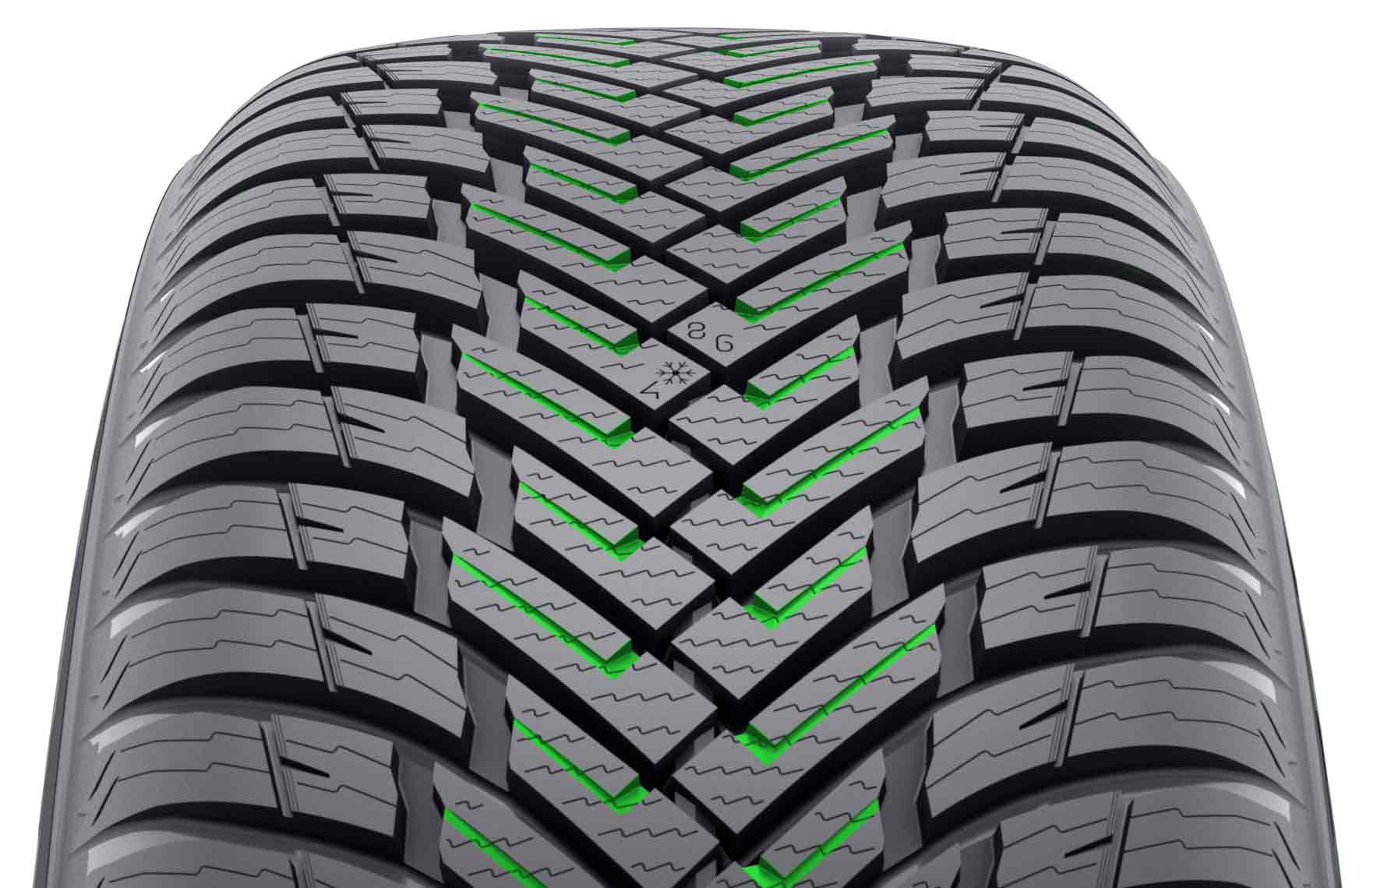Every millimetre on the aggressive tread pattern of the durable and high-performance Nokian Weatherproof has a specific role. The steep surface geometry of the centre area, with its large tread blocks, has been carefully optimised to ensure excellent grip on snowy and wet roads. The axe-like V-shaped tread blocks firmly grip the snowy road. The heavy siping and the grading of the tread blocks add more gripping edges and further improve grip. The wedge-like rises between the centre and shoulder blocks strengthen the precise steering feel and the thoroughly tested, excellent grip on snow.

The deep and open channels on the centre blocks (**Centre Block Channeling**) increase grip under extreme winter conditions. The channels also operate at full power under wet conditions. They effectively push slush and water away from between the tyre and the road, which effectively prevents slushplaning and aquaplaning. The excellent aquaplaning properties are rounded off by the stylish polished grooves that accelerate the removal of water and slush.

**Driving stability, grip and durability regardless of the temperature**

Tests show that the Nokian Weatherproof rolls lightly and precisely even on sun-scorched dry asphalt. The stiff shoulder blocks offer driving stability even at high speeds and ensure, for their part, that the new product will stop easily and quickly even on rain-soaked roads.

The greatest challenge in terms of material development was the extreme temperature variations, from dozens of degrees below zero to scorching heat waves. The tread compound of the Nokian Weatherproof is tailored for varying conditions. It works wonderfully along a wide range of temperatures and can withstand harsh wear even in hot summer weather. Winter grip is excellent at temperatures near zero and slightly below it. The next-generation silica compound also allows for good wet grip and low rolling resistance, which reduces fuel consumption.

**New Nokian Weatherproof SUV - tailored stability for SUV use**

Several effective innovations support the thread of the sturdy SUV model. A special **Stiffness Zone** was designed in the shoulder area between the tread blocks in order to stiffen the tyre shoulder. The Stiffness Zone improves precision and calmness especially on dry roads. The new Nokian Weatherproof SUV can carry and manage its high wheel loads surely and firmly on ice, snow, bare roads or even the ever treacherous slush. The tread compound is even stiffer than in the passenger car model, which allows for an especially accurate steering feel.

The carefully selected and tested structural solutions make the Nokian Weatherproof a balanced mover. The tighter wrapping of the nylon belts on the shoulder areas stiffens the steel belt structure and reduces the movement of the tread blocks. This can be felt in the precise steering feel during high-speed cornering or lane changes.

**Driving Safety Indicator - Exact information on tyre condition**

The location and pressure indicators on the Nokian Weatherproof's sidewall info area improve winter safety and user comfort. The information area allows for recording the correct inflation pressure and installation location during tyre change. Safety is improved further by a new section that can be used to record the tightening torque of the wheel nuts for alloy wheels.

As before, the tread surface has the Driving Safety Indicator (DSI), patented by Nokian Tyres. The numbers on the centre surface of the tyre indicate how much of the main groove depth remains on the tread. The snowflake symbol of the Winter Safety Indicator (WSI) remains visible to a groove depth of four millimetres. Once the snowflake has worn out, the driver should purchase new winter tyres to ensure sufficient safety.

**Nokian Weatherproof – Beyond four seasons**

* Superior on snow, excellent grip even on wet roads
* Durable high performance throughout the year
* Extremely stable and comfortable driving behaviour

**Main innovations:**

**Tailored centre area.** Excellent winter grip.The steep surface geometry of the centre area has been carefully optimised to ensure excellent grip on snowy and wet roads. The axe-like V-shaped tread blocks firmly grip the snowy road. The heavy siping and the grading of the tread blocks add more gripping edges and further improve grip. The wedge-like rises between the centre and shoulder blocks strengthen the precise steering feel and excellent grip on snow.

**Centre Block Channeling.** Extreme grip, effective slushplaning prevention**.** The deep and open channels on the centre blocks increase grip under extreme winter conditions. The channels effectively push slush and water away from between the tyre and the road, which effectively prevents slushplaning and aquaplaning.

**Nokian Weatherproof rubber compound.** Tailored safety and durability.The tread compound is tailored for varying conditions; it works wonderfully along a wide range of temperatures and can withstand harsh wear even in hot summer weather. Winter grip is excellent at temperatures near zero and slightly below it. The next-generation silica compound also allows for good wet grip and low rolling resistance, which reduces fuel consumption.

**Stiffness Zone.** Balanced and stable driving.A specialStiffness Zone was designed in the shoulder area of the Nokian Weatherproof SUV in order to stiffen the tyre shoulder. The Stiffness Zone improves precision and calmness especially on dry roads.

**Polished Grooves.** Safety on slushy and wet roads. Polished grooves facilitatethe removal of snow and slush.

[**www.nokiantyres.com**](http://www.nokiantyres.com)

Vianor tyre and car-service of Nokian Tyres:

[**http://vianor.com**](http://vianor.com/)

**Nokian All-Weather – winter tyres you can use all year long**

Nokian All-Weather tyres like the Nokian Weatherproof deliver the safety of a designated winter tyre with the stability and handling of a summer tyre. They are long-lasting and developed for year-round use.

**Snowy, wet and slushy roads**

Unlike all-season tyres, the Nokian Weatherproof bears the Snowflake symbol (3PMSF) and so you know it has passed all the requirements for a winter tyre. In fact, the Nokian Weatherproof is designed as a high performance winter tyre for year-round use. It stays flexible at low temperatures to give you strong grip on snow and precise braking on ice because of its naturally derived rubber compound made with silica and canola oil. Nokian Weatherproof also effectively prevents aquaplaning and stops instantly on wet roads.

**Dry roads**

Nokian Weatherproof delivers excellent handling on bare asphalt as well as during spring showers or winter blizzards. It offers extreme stability and grip, even at high speeds on dry roads.

**All year long**

Regardless of the temperature or even your driving style, you will appreciate the Nokian Weatherproof’s sensitive driving response. The all-weather tyre offers first-class safety as well as economy.

You will also enjoy a long tread life due in part to the tear-resistant natural oils in the compound. With such a durable tread, you will get good mileage throughout the seasons. Since the Nokian Weatherproof rolls easily, you will consume less fuel and emit less CO2.

**Product photos:**

[**www.nokiantyres.com/NokianWeatherproof**](http://www.nokiantyres.com/NokianWeatherproof)

**Read more:**

**Nokian Tyres - The world's first winter tyre with an A energy rating**

[**http://youtu.be/Wo4omb0Eil4**](http://youtu.be/Wo4omb0Eil4)

**World's first winter tyre with pop-out studs**

**www.nokiantyres.com/company/news-article/nokian-tyres-the-world-s-first-nonstudded-winter-tyre-with-studs/**

**Winter season 2014: Over 40 test wins for Nokian winter tyres**

[**www.nokiantyres.com/innovation/test-success/**](http://www.nokiantyres.com/innovation/test-success/)

**At the top of winter tyre testing: Ivalo Testing Center – White Hell**

[**http://youtu.be/UEGUTw7KHxE**](http://youtu.be/UEGUTw7KHxE)

**Nokian Hakkapeliitta 8: World record for the fastest car on ice, 335.713 km/h:**

[**www.nokiantyres.com/innovation/testing/fastest-on-ice/fastest-on-ice-2013/**](http://www.nokiantyres.com/innovation/testing/fastest-on-ice/fastest-on-ice-2013/)

**How was the world's first winter tyre invented?**

[**http://www.nokiantyres.com/first-winter-tyres**](http://www.nokiantyres.com/first-winter-tyres)

**Comparing the world's first winter tyre to the state-of-the-art non-studded winter tyre**

[**www.nokiantyres.com/company/about-us/history/this-is-how-the-winter-tyre-has-changed/**](http://www.nokiantyres.com/company/about-us/history/this-is-how-the-winter-tyre-has-changed/)

**Nokian Tyres is the world's leading winter tyre specialist, a multiple test winner, the inventor of the winter tyre and a premium brand**

As the world's leading winter tyre specialist, a multiple test winner, and a premium brand, Nokian Tyres offers the safest tyres for Northern conditions. Innovative Nokian tyres from Finland for cars, trucks, and heavy machinery demonstrate their high quality particularly well in snow, ice, tough climates, and demanding driving situations. Nokian is the inventor of the winter tyre and has been designing, testing, and patenting innovative tyres for 80 years. Furthermore, Nokian produces tyres especially developed for European weather and the higher speeds on European motorways. Nokian tyres deliver excellent safety, save fuel, and are the forerunner of environmental friendliness. The company is number 1 in terms of brand recognition and appreciation in Scandinavia and Russia and has a positive, exceptional image.

**Nokian WR winter tyres are test winners and have achieved numerous further test successes**

Nokian WR winter tyres, optimised for European demands, are test winners and have achieved numerous further test successes. The Nokian WR D3 winter tyre scores the top rating “good”, and is thus “especially recommended” in the 2013 winter tyre test of the German automobile club ADAC and the consumer protection organisation Stiftung Warentest and is amongst the best. The Nokian WR D3 is rated “Especially recommended” by the German car magazine auto motor sport. The new Nokian WR SUV 3 high performance winter tyre comes out on top in the big SUV winter tyre test 2013 by OFF ROAD, with the top rating “highly recommended”.

Nokian winter tyres are the test winners in the 2012 winter tyre tests conducted by the German car magazines Auto Bild, auto motor sport, and AUTOStraßenverkehr earning top ratings of “exemplary”, “highly recommended”, and “very good”. In more than 20 winter tyre tests carried out by car magazines in Germany and other European countries last winter, Nokian tyres came out on top and thus confirmed the positive image of the Nordic premium brand. The Finnish tyres are given the top rating of “good” by the German automobile club ADAC and consumer protection organisation Stiftung Warentest.

Standard Nokian winter tyres set a new Guinness world record Fastest on Ice by reaching a top speed of 335.713 km/h.

**Nokian tyres rated “good” in the ADAC summer tyre test 2014 and by the consumer organisation Stiftung Warentest and test winner in the German SUV magazine OFF ROAD**

Nokian summer tyres are multiple test winners, offering high levels of safety and saving fuel. The Nokian Line summer tyre scores the top rating “good” in the summer tyre test 2014 of the German automobile club ADAC and with the German consumer organisation Stiftung Warentest Being rated “especially recommended”, Nokian Line is among the test winner group. As such, the Nokian tyre achieved a double success in the two best-selling tyre sizes tested for the compact and middle-sized category and for small cars. The Nokian strengths in the ADAC test: Very balanced tyre, good on wet and dry roads.

The test winner is the Nokian Z SUV in the big SUV summer tyre test 2014 by the German SUV magazine OFF ROAD, with the top rating “HIGHLY RECOMMENDED” and also in SUV MAGAZIN.

Nokian tyres were test winners 70 times or were among test winner group, scoring “good” or “recommended” 51 times in 121 test reports from autumn 2011 to spring 2014 – in Central Europe alone.

**Increased safety through innovations: Winter Safety Indicator with snowflake and Driving Safety Indicator (DSI) with aquaplaning warning**

The Nokian Driving Safety Indicator (DSI) with the unique snowflake symbol, the Winter Safety Indicator (WSI), on the Nokian WR winter tyre clearly shows the driver the groove depth as a number from 8 to 4 millimetres. The snowflake remains visible down to 4 millimetres. When it disappears, the risk increases and the winter tyres should be replaced. The grooves must be a minimum of 4 millimetres deep in order to provide enough grip on snow and to prevent slush planing and aquaplaning on winter and summer tyres.

The Driving Safety Indicator on the Nokian summer tyres shows the driver the groove depth as a simple figure from 8 to 3. An aquaplaning alert within this warns of the danger of aquaplaning with a drop symbol. It disappears when there are only four millimetres of remaining tread, alerting the driver of the increased risk. No other tyre manufacturer has these innovations.

**Nokian Tyres achieved a 1.389 billion euro turnover in 2014**

Nokian Tyres achieved a turnover of 1.389billion euro in 2014 and had over 4,000 employees. In Central Europe, Nokian Tyres operates with own sales companies in ten countries. The company also owns the Vianor tyre and car-service chain that comprises over 1,300 outlets in 27 countries.

[**www.nokiantyres.com**](http://www.nokiantyres.com)

Vianor tyre and car-service of Nokian Tyres:

[**http://vianor.com**](http://vianor.com/)

**Press contact:**

**Dr Falk Köhler PR**

**Dr Falk Köhler**

Tel. +49 40 54 73 12 12

Fax +49 40 54 73 12 22

E-mail [Dr.Falk.Koehler@Dr-Falk-Koehler.de](mailto:Dr.Falk.Koehler@Dr-Falk-Koehler.de)

[**www.Dr-Falk-Koehler.de**](http://www.Dr-Falk-Koehler.de)

Ödenweg 59

22397 **Hamburg**

Germany

**Further information:**

[**www.twitter.com/NokianTyresCom**](http://www.twitter.com/NokianTyresCom)

[**www.youtube.com/NokianTyresCom**](http://www.youtube.com/NokianTyresCom)

**[www.facebook.com/nokiantyres](https://www.facebook.com/nokiantyres)**

[**www.linkedin.com/company/nokian-tyres-plc**](http://www.linkedin.com/company/nokian-tyres-plc)

**Motorist blog:**

[**http://hakkapedia.us/blog/en**](http://hakkapedia.us/blog/en)

**Expert blog:**

[**http://nordictyreblog.com/**](http://nordictyreblog.com/)

**Nokian Tyres Europe**

**Nokian Tyres s.r.o**

V Parku 2336/22

148 00 Praha 4

Czech Republic

Business Director Central Europe Dieter Köppner, Tel. +420 222 507 761,

E-mail: [dieter.koppner@nokiantyres.com](mailto:dieter.koppner@nokiantyres.com)

Technical Customer Service Manager CE Sven Dittmann, Dipl.-Ing., Tel. +49 8143 444 850

E-Mail [sven.dittmann@nokiantyres.com](mailto:sven.dittmann@nokiantyres.com)

Marketing Manager Lukáš Líbal, Tel. +420 222 507 759

E-Mail [lukas.libal@nokiantyres.com](mailto:lukas.libal@nokiantyres.com)

**www.nokiantyres.com**

**Nokian Tyres Finland Headquarters**

**Nokian Tyres plc**

Pirkkalaistie 7

P.O.Box 20

37101 Nokia

Finland

Product Development Manager Olli Seppälä, Tel. +358 10 401 7549

E-Mail [olli.seppala@nokiantyres.com](mailto:olli.seppala@nokiantyres.com)

Development Manager Juha Pirhonen, Tel. +358 10 401 7708

E-Mail [juha.pirhonen@nokiantyres.com](mailto:juha.pirhonen@nokiantyres.com)

Technical Customer Service Manager Matti Morri, Tel. +358 10 401 7621

E-Mail [matti.morri@nokiantyres.com](mailto:matti.morri@nokiantyres.com)

Product Manager Central Europe Stéphane Clepkens, Tel. +358 50 462 7536

E-Mail [stephane.clepkens@nokiantyres.com](mailto:stephane.clepkens@nokiantyres.com)

**www.nokiantyres.com**