All-season tyre test

Nokian Weatherproof All-Weather tyre is test winner of the "L‘argus" tyre test

Test winner Nokian Weatherproof offers very good performance and high safety in the all-season tyre test of the French car magazine "L‘argus". Very well balanced on dry and wet roads, the new All-Weather tyre of Nokian Tyres is the winner in all snow tests.

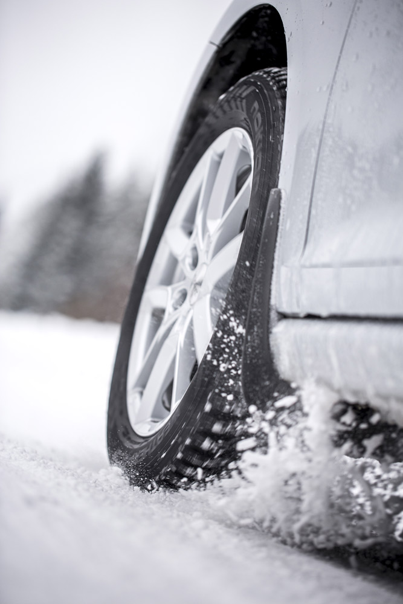
Nokian Weatherproof shows a "good performance" during braking in dry conditions and its braking distance is more than one metre shorter compared to other premium tyres. Balanced handling characteristics ensure good wet test results.

On snow, the Finn is always first. Shortest braking distance, fastest handling time, predictable, easy to control at the limits, easily recognisable grip loss, and shortest time in the acceleration test. Thus, the Nokian All-Weather tyre proves its positioning as an excellent snow specialist.

The Nokian Weatherproof, a genuine winter and summer tyre combined, performs without weaknesses in dry, wet and snowy conditions and is recommended as a good premium alternative to real winter tyres in areas with less snow. The Top 5 European 205/55 R16 sized all-season tyres were tested on a VW Golf by "L‘argus" in 2015. Multitalented Nokian Weatherproof shared the test win with another premium competitor.

Nokian Weatherproof test winner in "Auto Zeitung", VOX TV and "Auto Express"

The Nokian Weatherproof All-Weather tyre is the test winner in the 2015 all-season tyre test of the German car magazine "Auto Zeitung" with the best performance in snow and wet conditions and also the test winner of the German TV channel VOX. The multifunctional tyre is also a test winner in the all-season tyre test of the British car magazine "Auto Express", which is the partner magazine of the German "Auto Bild".

https://www.nokiantyres.com
Vianor tyre and car service from Nokian Tyres:
http://vianor.com

Editor: Dr Falk Köhler

Photo captions

Nokian_Weatherproof_015.jpg
Photo caption:

The Nokian Weatherproof All-Weather tyre is test winner of the all-season tyre test of the French car magazine "L‘argus". Photo: Nokian Tyres

Photo Downloads Nokian Weatherproof All-season tyre
www.nokiantyres.com/NokianWeatherproof

Videos

New Nokian Weatherproof All-season tyre
https://youtu.be/LonBy4JsbQI

Nokian Weatherproof All-season tyre – For all seasons
https://youtu.be/ZMXJDcykVBc

Source
L’argus online test results:
http://www.largus.fr/actualite-automobile/test-pneus-quatre-saisons-que-valent-les-pneus-toutes-saisons-6717390.html
L’argus online test results summary:
http://www.largus.fr/actualite-automobile/test-pneus-quatre-saisons-que-valent-les-pneus-toutes-saisons-6717390_p_5.html

Further information

Test winners: Nokian Weatherproof All-Weather tyre and Nokian WR SUV 3 winter tyre win the Auto Zeitung and the Off Road tyre tests
http://www.nokiantyres.com/company/news-article/test-winners-nokian-weatherproof-all-weather-tyre-and-nokian-wr-suv-3-winter-tyre-win-the-auto-zeitu/

“Remarkable ability on snow and in deep water” - New Nokian Weatherproof wins the Auto Express tyre comparison test
http://www.nokiantyres.com/company/news-article/remarkable-ability-on-snow-and-in-deep-water-new-nokian-weatherproof-wins-the-auto-express-tyre-comp/

Nokian Weatherproof All-Weather tyres – safe year-round driving comfort
http://www.nokiantyres.com/company/news-article/nokian-weatherproof-all-weather-tyres-safe-year-round-driving-comfort/

New Nokian Weatherproof

www.nokiantyres.com/all-weather-tyres/nokian-weatherproof/

Nokian Tyres is the world’s leading winter tyre specialist, a multiple test winner, winter tyre inventor, world record holder and innovation leader

As the world’s leading winter tyre specialist, a multiple test winner and inventor of the winter tyre, Nokian Tyres offers the safest tyres for the Northern conditions. Innovative Nokian tyres for passenger cars, trucks, and heavy machinery demonstrate their high quality particularly well in snow, ice, extreme climates and demanding driving conditions. Nokian Tyres is the inventor of the winter tyre and has been designing, testing and patenting innovative tyres for 80 years. Furthermore, Nokian Tyres produces tyres especially developed for European weather and the higher speeds on European motorways.

Standard Nokian winter tyres set a new Guinness World Record for “Fastest on Ice” with a car by reaching a top speed of 335.713 km/h. As a leading innovator, Nokian Tyres presented the world’s first non-studded winter tyres with studs that extend at the press of a button, allowing the tyre to grip better. The tyre manufacturer also introduced the most energy-efficient winter tyre in the world, with an “A” energy rating.

Nokian Tyres offers the world’s first AA class winter tyre in terms of wet grip and fuel efficiency as well as the first A wet grip category winter tyre in the world for cars

The world’s first winter tyre in the tyre label’s top A category in wet grip and fuel efficiency comes from Nokian Tyres, the Nokian WR SUV 3. The revolutionary Nokian WR SUV 3 winter tyre for SUVs can reduce braking distance by up to 18 metres on wet roads and save up to 0.6 litres of fuel per 100 kilometres (size 265/50 R19 V). Its Nokian Twin Trac Silica rubber compound offers extremely firm grip and low fuel consumption, and its Nokian Aramid Sidewall technology guarantees optimum durability. From 2016, the Nokian Aramid Sidewall Technology is used in the Nokian SUV premium winter tyres.

The Nokian WR D4 is the first winter tyre in the world with wet grip in the EU tyre label's best A class for cars. It is a grip champion and offers unique innovations. This versatile chameleon for winter roads provides safe driving on wet and snowy roads alike. It is a supreme ruler of every type of winter weather, providing a firm grip in rain, snow and slush and it has the shortest braking distance in the varying European winter weather.

Large winter tyre range available from the premium brand Nokian Tyres

Nokian Tyres’ exceptionally wide range of premium winter tyres includes the new Nokian WR D4, Nokian WR SUV 3, Nokian WR C3 van tyres and Nokian Weatherproof All-Weather tyres, as well as the Nokian WR A3 for high-performance cars and the multiple test winner Nokian WR D3.

Nokian tyres deliver excellent safety, save fuel and are the forerunner of environmental friendliness. The company is number 1 in terms of brand recognition and appreciation in Scandinavia and Russia and has a positive, exceptional image.

Nokian WR winter tyres are multiple test winners and have achieved numerous further test successes

Nokian WR winter tyres, optimised for European conditions are multiple test winners and have achieved numerous other test successes. Achieving the top rating “exemplary”, the Nokian WR D3 winter tyre is test winner in the 2014 winter tyre test conducted by the German car magazine Auto Bild. Safe handling and short braking distances earned it the top rating on snow. As test winners, Nokian winter tyres also won the 2014 tests by Auto Club Europa ACE, GTÜ (Germany’s largest inspection organisation of freelance certified inspectors), and the German car magazines Auto Bild allrad, OFF ROAD and SUV MAGAZIN, as well as Autoclub ARBÖ Austria. Nokian premium tyres were also awarded the top ratings “exemplary” and “highly recommended” in these tests. The Nokian Weatherproof All-Weather tyre is the test winner in the 2015 all-season tyre test of the German car magazine "Auto Zeitung", the British car magazine "Auto Express" (partner magazine of "Auto Bild"), VOX TV and the French car magazine "L‘argus". Nokian WR SUV 3 is the test winner in the Off Road winter tyre test and with SUV Magazin. New Nokian WR D4 is “very recommendable“ in the winter tyre test 2015 of German car magazine Auto Zeitung.

Nokian Tyres has achieved altogether over 25 test wins so far in winter tyre comparison tests in Central Europe, Nordic countries and in Russia. Nokian tyres came out on top in more than 40 winter tyre tests that were carried out by car magazines last winter, thus confirming the good image of the Nordic premium brand.

Nokian summer tyres are multiple test winners: in the 2015 ADAC summer tyre test, by the consumer organisation Stiftung Warentest, in the German SUV magazines Auto Bild allrad and OFF ROAD, and in other tests

Nokian summer tyres are multiple test winners, offering high levels of safety and fuel savings. The Nokian Line is test winner in the 2015 summer tyre tests of the German automobile club ADAC and of the German consumer organisation Stiftung Warentest. Being rated at a top score of “good”, it is highly recommended. The Nokian Line SUV is test winner in the Auto Bild allrad SUV summer tyre test 2015 achieving the best rating “exemplary”, as well as with auto TEST. The Nokian zLine SUV is test winner in OFF ROAD being awarded the top rating “highly recommended”.

The Nokian Line already scored the top rating “good” in the 2014 ADAC summer tyre test and with Stiftung Warentest. Being rated highly recommended, it was among the test winning group. The Nokian Z SUV was also the test winner in the German SUV magazine OFF ROAD, with the top rating “VERY RECOMMENDED”, and also in SUV MAGAZIN.

The new AA Class Nokian eLine 2 premium summer tyre provides the best of the tyre label class A in wet grip, fuel consumption, advanced security and greener mobility. The new Nokian iLine summer tyre brings better driving comfort and economy for small and medium cars.

Increased safety through innovations: Winter Safety Indicator with snowflake and Driving Safety Indicator (DSI) with aquaplaning warning

The Nokian Driving Safety Indicator (DSI) along with the unique snowflake symbol, the Winter Safety Indicator (WSI), on the Nokian WR winter tyre clearly show the driver the groove depth as a number from 8 to 4 millimetres. The numbers disappear gradually as the tyre wears and its tread depth decreases. The snowflake remains visible down to 4 millimetres. When it disappears, the risk increases and the winter tyres should be replaced. There must be a minimum of 4 millimetres of tread in order to provide enough grip on snow as well as to prevent slush planing and aquaplaning on winter and summer tyres.

The Driving Safety Indicator on the Nokian summer tyres informs drivers of the groove depth as a simple figure from 8 to 3. An aquaplaning alert within this warns of the danger of aquaplaning with a water drop symbol. It disappears when there are only four millimetres of remaining tread, alerting the driver of the increased risk. No other tyre manufacturer has these innovations.

Nokian Tyres achieved a 1.389 billion euro turnover in 2014

Nokian Tyres achieved a turnover of 1.389 billion euros in 2014 and had over 4,000 employees. In Europe, Nokian Tyres operates with own sales companies in ten countries. The company also owns the Vianor tyre and car-service chain that comprises more than 1,300 outlets in 27 countries.

www.nokiantyres.com

Vianor tyre and car-service of Nokian Tyres:
http://vianor.com

Press contact:
Dr Falk Köhler PR
Dr Falk Köhler
Tel. +49 40 54 73 12 12
Fax +49 40 54 73 12 22
E-mail Dr.Falk.Koehler@Dr-Falk-Koehler.de
www.Dr-Falk-Koehler.de
Ödenweg 59
22397 Hamburg
Germany

More information:

www.twitter.com/NokianTyresCom
www.youtube.com/NokianTyresCom
www.facebook.com/nokiantyres
www.linkedin.com/company/nokian-tyres-plc
Motorist blog:
http://community.nokiantires.com/
Expert blog:
http://nordictyreblog.com/

Nokian Tyres Europe
Nokian Tyres s.r.o

V Parku 2336/22

148 00 Praha 4
Czech Republic
Managing Director Central Europe Hannu Liitsola, Tel. +420 605 236 440
E-mail hannu.liitsola@nokiantyres.com
Technical Customer Service Manager CE Sven Dittmann, Dipl.-Ing., Tel. +49 8143 444 850

E-mail sven.dittmann@nokiantyres.com

Marketing Manager Lukáš Líbal, Tel. +420 222 507 759

E-mail lukas.libal@nokiantyres.com
www.nokiantyres.com

Nokian Tyres Finland Headquarters
Nokian Tyres plc
Pirkkalaistie 7
P.O.Box 20
37101 Nokia
Finland
Product Development Manager Jarno Ahvenlammi, Tel. +358 10 401 7741
E-Mail jarno.ahvenlammi@nokiantyres.com
Development Manager Juha Pirhonen, Tel. +358 10 401 7708

E-mail juha.pirhonen@nokiantyres.com
Product Manager Central Europe Stéphane Clepkens, Tel. +358 50 462 7536
E-mail stephane.clepkens@nokiantyres.com
www.nokiantyres.com

