**The EU tyre label’s top AA category is now a reality in winter tyres:**

**Nokian Tyres offers the world’s first AA class winter tyre in wet grip and fuel efficiency as well as the first winter tyre with class A wet grip for passenger cars**

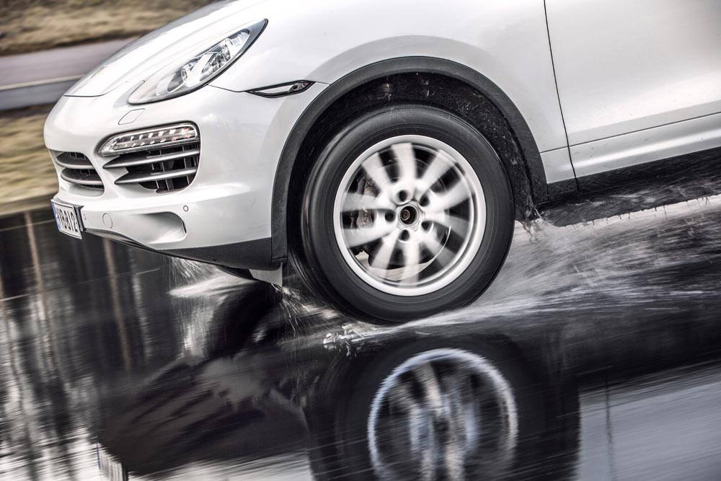

[**Nokian Tyres**](http://www.nokiantyres.com/) **introduces the world’s first winter tyre in the EU tyre label’s top A category for wet grip and fuel efficiency, the** [**Nokian WR SUV 3**](http://www.nokiantyres.com/winter-tyres/nokian-wr-suv-3/)**. Nokian Tyres also presents the world’s first winter tyre with A category wet grip for passenger cars, the** [**Nokian WR D4**](http://www.nokiantyres.com/winter-tyres/nokian-wr-d4/)**. The exceptionally wide range of premium winter tyres available includes the new Nokian WR D4, Nokian WR SUV 3,** [**Nokian WR C3**](http://www.nokiantyres.com/winter-tyres/nokian-wr-c3/) **van tyre and** [**Nokian Weatherproof**](http://www.nokiantyres.com/all-weather-tyres/nokian-weatherproof/) **All-Weather tyre as well as the** [**Nokian WR A3**](http://www.nokiantyres.com/winter-tyres/nokian-wr-a3/) **for high-performance cars and the multiple test winner** [**Nokian WR D3**](http://www.nokiantyres.com/winter-tyres/nokian-wr-d3/)**.**

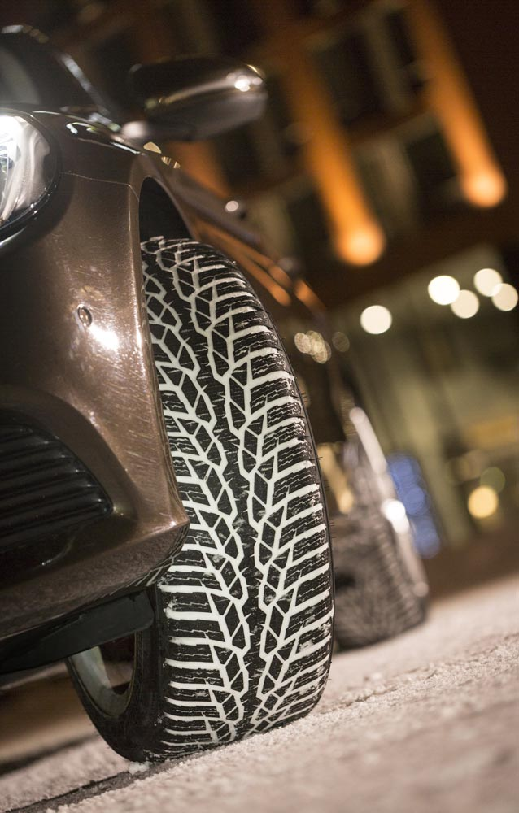

The revolutionary Nokian WR SUV 3 winter tyre for SUVs, which has the best wet grip and lowest fuel consumption in class A, can reduce braking distances by up to 18 metres on wet roads and save fuel by up to 0.6 l/100 km (size 265/50 R19 V). The Nokian Twin Trac SUV Silica rubber compound ensures the strongest grip as well as low fuel consumption, and the Nokian Aramid Sidewall technology provides excellent durability. The modern AA category Nokian WR SUV 3 is a genuine SUV winter tyre from the pioneer in winter safety and eco-friendly driving. It was developed specifically for European SUV drivers.

The new Nokian WR D4 winter tyre for passenger cars offers wet grip in the EU tyre label's best A class and is a grip champion with unique innovations. This versatile chameleon for winter roads provides safe driving on wet and snowy roads alike. The Nokian WR D4, as a supreme ruler of every type of winter weather from the pioneer in winter tyre technology, provides a firm grip in the rain, snow and slush and achieves the shortest braking distance in the varying European winter weather. The Nokian Block Optimized Siping and Nokian Twin Trac Silica rubber compound offer controlled handling and a firm grip in extreme driving situations.

**Nokian WR SUV 3 with Nokian Twin Trac SUV Silica rubber compound and Nokian Aramid Sidewall technology**

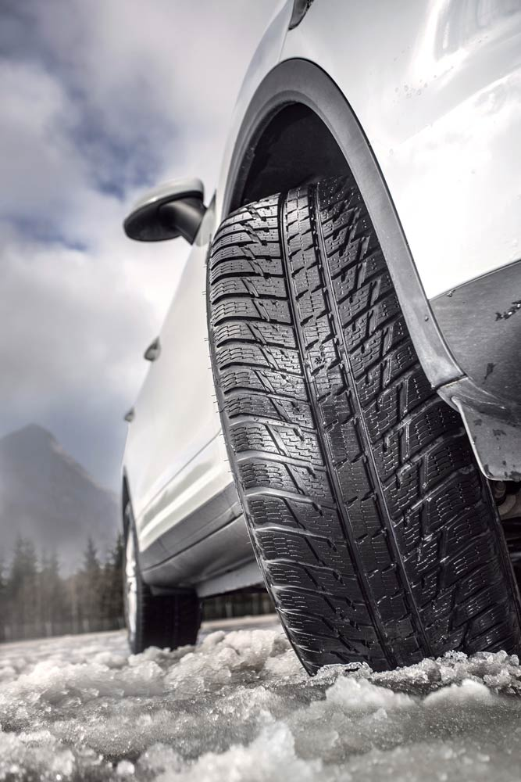The new, green Nokian WR SUV 3 (size 265/50 R19 V) from the inventor of the winter tyre is ideally suited to versatile use on a variety of SUVs, such as the Porsche Cayenne, Audi Q7, BMW X5, Volkswagen Amarok, Volkswagen Touareg, Mercedes Benz ML, Jeep Grand Cherokee or Volvo XC 60.

The Finnish Nokian WR SUV 3 utilises Nokian’s unique know-how in extreme conditions and the masterful supremacy of all winter conditions as the leading winter tyre specialist in the world.

The Nokian Twin Trac SUV Silica rubber compound and Nokian Aramid Sidewall technology prove that the Nokian WR SUV 3 is well equipped for hard SUV use with its optimum durability in the new size 265/50 R19 V. These innovations guarantee that the driver has the firmest wet and snow grip the industry offers, coupled with high fuel efficiency, precise handling and excellent durability. These same technologies will also be used for the other Nokian Tyres winter tyres in the future.

The Nokian WR SUV 3 size 265/50 R19 V with AA category performance according to the [EU tyre label](http://www.nokiantyres.com/innovation/facts-about-tyres/eu-tyre-label/) is the most impressive innovation of this winter and the top model for SUV tyres. The Nokian WR SUV 3 has already won tests conducted by the German car magazines Auto Bild allrad, OFF ROAD and SUV MAGAZIN in other sizes in 2014. The tyre is available from tyre dealers in numerous sizes from 14 to 21 inches and speed categories T (190 km/h) to V (240 km/h).

**The all-rounder Nokian WR D4: 18 metre shorter braking distance as the world’s first premium winter tyre with A category wet grip**

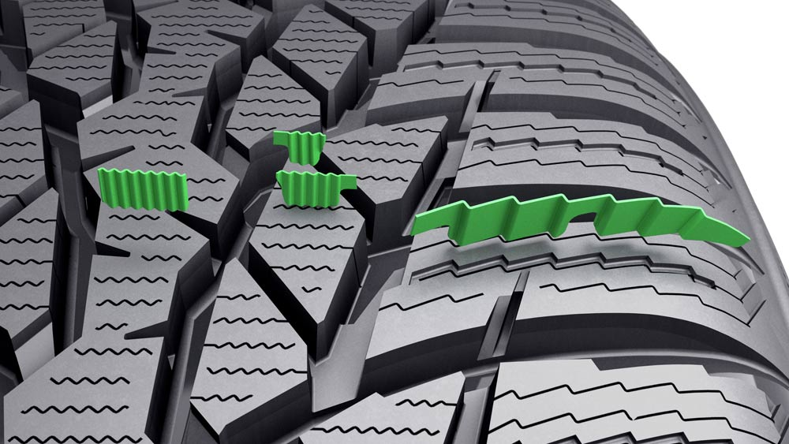

As the world’s first premium winter tyre with the EU tyre label’s A category wet grip, the all-rounder Nokian WR D4 has an 18-metre shorter braking distance than category F tyres. Its Slush Blower combats aquaplaning in rain and slush. Nokian Block Optimized Siping provides firmer winter grip and enhanced handling. Each tread block and sipe in the stylish profile has a precise form and task.

The Nokian Twin Trac Silica rubber compound offers outstanding grip, excellent durability and low fuel consumption thanks to its extremely low rolling resistance. The green, winter king Nokian WR D4 from the world record holder from Finland represents the new generation, following from the Nokian WR D3 which was a multiple test winner in the comparison tests conducted by car magazines such as in the German “Auto Bild” winter tyre test in 2014.

The comprehensive range of sizes for the Nokian WR D4 runs from 14 to 20 inches in the speed categories Q (160 km/h) to W (270 km/h). This versatile, multi-talented range offers sizes specifically for sporty driving but it has also been optimized for modern electric cars. Special models offer Flat Run technology, and many tyres are categorised as XL, the top load index for a car tyre. The many size options the winter champion offers have been developed specifically for use in Central Europe and are currently available from tyre dealers.

**Nokian WR C3 van winter tyre offers flawless performance for the European winter**

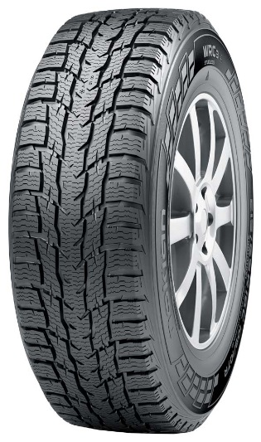

The new Nokian WR C3 winter tyre combats the extreme conditions of winter with its precise winter grip. Pump sipes guide water away on wet and icy roads thereby guaranteeing a safe grip. This tyre is designed for versatile use on transporters, delivery vehicles and vans in order to maximize safety and economy.

The Finnish Nokian WR C3 winter tyre runs safely, durably and lightly on the city and countryside roads of Europe. In addition to its car-like ride comfort and extremely low rolling resistance, the new winter tyre optimizes the safety-enhancing features on icy, snow-covered and wet roads. These winter drive qualities are essential for professional drivers.

The wide range of Nokian WR C3 tyres offers versatility and high performance tailor-made for modern transporters, delivery vehicles and vans in 22 sizes from 14 to 17 inches. The new winter tyre family of the premium brand uses a tread profile for both lighter and heavier vehicles.

**Nokian Weatherproof** [**All-Weather tyre**](http://www.nokiantyres.com/tyres/passenger-car/all-weather/) **– safe year-round driving comfort – 2-in-1**

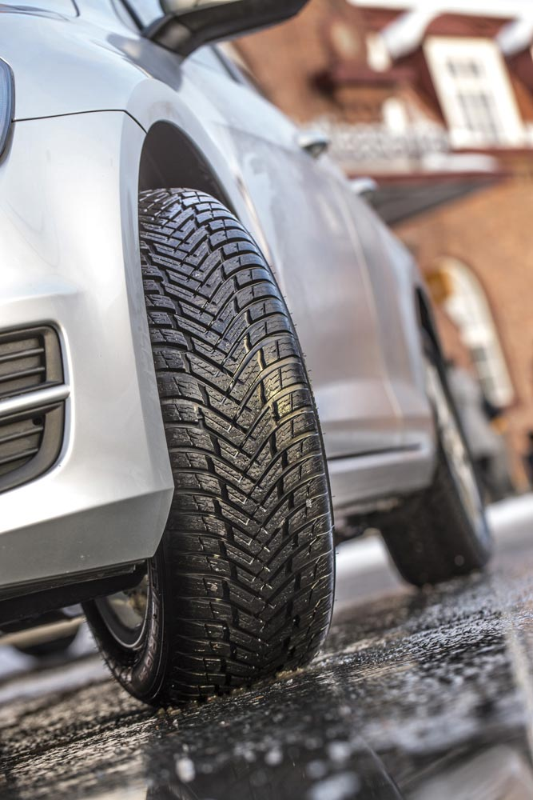The new high-performance Nokian Weatherproof All-Weather tyre family puts an end to the tyre-changing duty that gets on car drivers’ nerves each summer and winter. The Nokian Weatherproof All-Weather tyres are genuine winter and summer tyres combined – 2-in-1. These highlights of the revolutionary Nokian All-Weather tyre concept combine the reliable winter safety of Nokian winter tyres with the precise riding stability and exact handling of Nokian summer tyres. These top innovations guarantee comfortable and safe driving on European roads year-round.

The multi-talented Nokian Weatherproof winter tyre+summer tyre is designed for drivers who want to drive safely in snow and slush in the winter, but also efficiently and effortlessly in the summer. Whereas conventional All-Season tyres are actually summer tyres with some winter driving features, the Nokian Weatherproof is both a genuine winter tyre for Central Europe and a top summer tyre in one.

The Finnish All-Weather tyres offer durable performance for modern cars, SUVs, vans and transporters. All the sizes in which these All-Weather tyres are available are officially licensed as winter tyres and have the snowflake symbol (3PMSF). The Nokian All-Weather tyres stand out from the usual All-Season tyres thanks to their enhanced winter performance.

The comfortable and durable Nokian Weatherproof SUV offers excellent handling on snow, dry and wet roads and even dangerous slush. The rubber used for its tread is specifically for powerful SUVs. It runs smoothly and economically all year.

**Some All-Season tyres merely offer a mediocre performance in snow, ice and rain**

Some drivers are clearly disappointed by their All-Season tyres. They won’t be disappointed with the new All-Weather tyres from Nokian Tyres. Some All-Season tyres are dangerous when the cold weather turns the roads into snowy, slushy and icy surfaces. These All-Season tyres may only perform mediocrely on wet and dry roads. With the unique combination of safety and carefree driving comfort in all weather, drivers no longer need to worry about the weather forecast with the new Nokian Weatherproof All-Weather tyre.

The new Nokian Weatherproof All-Weather tyre family 2-i-n1 offers one of the largest product ranges on the market for the All-Season tyre segment and includes sizes from 13 to 18 inches in the speed categories T (190 km/h), H (210 km/h) to V (240 km/h). The Nokian Weatherproof SUV is available from 16 to 19 inches in the speed categories H (210 km/h) and V (240 km/h). The new Nokian Weatherproof C with size options ranging from 14 to 16 inches in the speed categories R (170 km/h) to T (190 km/h) has been developed specifically for transporters, delivery vehicles and vans.

**Nokian WR winter tyres are multiple test winners and have achieved numerous other test successes**

Nokian WR winter tyres, which have been optimized to meet the Central European requirements, are multiple test winners and have achieved numerous other test successes. With the top rating “exemplary”, the Nokian WR D3 winter tyre was the test winner in the 2014 winter tyre test conducted by Auto Bild. Safe handling and short braking distances earned it the top mark ‘grade 2+ on snow’. As test winners, Nokian winter tyres also won the 2014 tests conducted by Auto Club Europa ACE, GTÜ (Germany’s largest inspection organisation of freelance certified inspectors), and Auto Bild allrad, OFF ROAD and SUV MAGAZIN, as well as Autoclub ARBÖ Austria. Nokian premium tyres were also awarded the top ratings “exemplary” and “very recommended”.

**Large winter tyre range available from the premium brand Nokian** **Tyres**

The premium brand Nokian Tyres offers a large range of winter tyres with the new models Nokian WR D4, Nokian WR SUV 3 and Nokian WR C3 van tyres as well as the new All-Weather tyre Nokian Weatherproof, rounded off with the sporty Nokian WR A3 for high-performance cars and the predecessor model and multiple test winner Nokian WR D3. Numerous sizes from 13 to 21 inches in the speed categories Q (160 km/h) to W (270 km/h) are available with Nokian Tyres Satisfaction for almost all car models from tyre dealers either for changing onto existing wheels or on new wheels as a complete package.

[**www.nokiantyres.com**](http://www.nokiantyres.com)

**Vianor tyre and car-service of Nokian Tyres:**

[**http://vianor.com**](http://vianor.com/)

Editor: Dr Falk Köhler

**Photo captions**

New_Nokian_WR_SUV3_265_50_R19_b.jpg

Caption:

The revolutionary Nokian WR SUV 3 is the first AA category winter tyre in the world in terms of wet grip and fuel efficiency Photo: Nokian Tyres

Nokian_WR_D4_015.jpg

Caption:

The Nokian WR D4 winter tyre offers the best wet grip in the A category of the EU tyre label and runs equally safely on wet and snowy roads Photo: Nokian Tyres

New_Nokian_WR_SUV3_265_50_R19_a.jpg

Caption:

The world’s first AA category winter tyre Nokian WR SUV 3 can reduce the braking distance by up to 18 metres on wet roads and save up to 0.6 litres of fuel per 100 kilometres Photo: Nokian Tyres

Nokian_WR_D4_sipes.jpg

Caption:

Nokian Block Optimized Siping: Firmer winter grip and enhanced handling Photo: Nokian Tyres

Nokian_WR_C3.jpg

Caption:

The Nokian WR C3 winter tyre for vans runs safely, durably and lightly on city and countryside roads Photo: Nokian Tyres

Nokian_Weatherproof_009.jpg

Caption:

The Nokian Weatherproof All-Weather tyre combines the reliable winter safety of Nokian winter tyres with the precise ride stability and exact handling of Nokian summer tyres – 2-in-1 Photo: Nokian Tyres

**Photo Downloads:**

**Photo Downloads Nokian WR SUV 3:**

[**www.nokiantyres.com/AA-labelNokianWRSUV3**](http://www.nokiantyres.com/AA-labelNokianWRSUV3)

**Photo Downloads Nokian WR D4:**

[**www.nokiantyres.com/NokianWRD4**](http://www.nokiantyres.com/NokianWRD4)

**Photo Downloads Nokian WR C3:**

[**www.nokiantyres.com/NokianWRC3**](http://www.nokiantyres.com/NokianWRC3)

**Photo Downloads Nokian Weatherproof:**

[**www.nokiantyres.com/NokianWeatherproof**](http://www.nokiantyres.com/NokianWeatherproof)

**Videos:**

**New Nokian WR D4 - Forget the Forecast**

[**https://youtu.be/hVtAQcSP9m4**](https://youtu.be/hVtAQcSP9m4)

**New Nokian Weatherproof - Beyond four seasons**

[**https://youtu.be/75e5hcpLeGE**](https://youtu.be/75e5hcpLeGE)

**Nokian Tyres: The first winter tyre in the top AA category of the EU tyre label**

[**https://youtu.be/LtTGEK64nZE**](https://youtu.be/LtTGEK64nZE)

**New Nokian WR D4 for Central European winters**

[**https://youtu.be/PwIGMzpEJMM**](https://youtu.be/PwIGMzpEJMM)

**Nokian Tyres - The world's first winter tyre with an A energy rating**

[**https://youtu.be/Wo4omb0Eil4?list=PLpIeqaqxjQ7vh_PX5dGE54RDJ1jrH0oKj**](https://youtu.be/Wo4omb0Eil4?list=PLpIeqaqxjQ7vh_PX5dGE54RDJ1jrH0oKj)

**Nokian WR - Test winning winter tyres for Central Europe**

[**https://youtu.be/h5R-BFewOtg?list=PLpIeqaqxjQ7vh_PX5dGE54RDJ1jrH0oKj**](https://youtu.be/h5R-BFewOtg?list=PLpIeqaqxjQ7vh_PX5dGE54RDJ1jrH0oKj)

**Nokian Tyres' winter tyre testing**

[**https://youtu.be/UEGUTw7KHxE?list=PL25F9FACDA4308546**](https://youtu.be/UEGUTw7KHxE?list=PL25F9FACDA4308546)

**Nokian Tyres: Aramid saves tyres and lives**

[**https://youtu.be/3iyB-nn1Jfs**](https://youtu.be/3iyB-nn1Jfs)

**Read more:**

**Nokian Tyres offers the world's first AA class winter tyre in terms of wet grip and fuel efficiency**

[**http://www.nokiantyres.com/company/news-article/nokian-tyres-offers-the-world-s-first-aa-class-winter-tyre-in-terms-of-wet-grip-and-fuel-efficiency/**](http://www.nokiantyres.com/company/news-article/nokian-tyres-offers-the-world-s-first-aa-class-winter-tyre-in-terms-of-wet-grip-and-fuel-efficiency/)

**The new Nokian WR D4 winter tyre masters the varying Central European winter weather**

[**http://www.nokiantyres.com/company/news-article/the-new-nokian-wr-d4-winter-tyre-masters-the-varying-central-european-winter-weather/**](http://www.nokiantyres.com/company/news-article/the-new-nokian-wr-d4-winter-tyre-masters-the-varying-central-european-winter-weather/)

**New Nokian WR C3 van tyre delivers unfailing performance for the European winter**

[**http://www.nokiantyres.com/company/news-article/new-nokian-wr-c3-van-tyre-delivers-unfailing-performance-for-the-european-winter/**](http://www.nokiantyres.com/company/news-article/new-nokian-wr-c3-van-tyre-delivers-unfailing-performance-for-the-european-winter/)

**Nokian Weatherproof All-Weather tyres – safe year-round driving comfort**

[**http://www.nokiantyres.com/company/news-article/nokian-weatherproof-all-weather-tyres-safe-year-round-driving-comfort/**](http://www.nokiantyres.com/company/news-article/nokian-weatherproof-all-weather-tyres-safe-year-round-driving-comfort/)

**State-of-the-art green winter tyre technology for electric cars: The world's first winter tyre with an A energy rating by Nokian Tyres**

[**http://www.nokiantyres.com/company/news-article/state-of-the-art-green-winter-tyre-technology-for-electric-cars-the-world-s-first-winter-tyre-with-a/**](http://www.nokiantyres.com/company/news-article/state-of-the-art-green-winter-tyre-technology-for-electric-cars-the-world-s-first-winter-tyre-with-a/)

**Nokian Tyres Fastest on Ice: New Nokian Hakkapeliitta 8 sets New World Record of 335.713 km/h!**

[**http://www.nokiantyres.com/company/news-article/undefined-105/**](http://www.nokiantyres.com/company/news-article/undefined-105/)

**Nokian Tyres: The world's first non-studded winter tyre with studs**

[**http://www.nokiantyres.com/company/news-article/nokian-tyres-the-world-s-first-nonstudded-winter-tyre-with-studs/**](http://www.nokiantyres.com/company/news-article/nokian-tyres-the-world-s-first-nonstudded-winter-tyre-with-studs/)

**Nokian WR is test winner 2014 in the Auto Bild winter tyre test**

[**http://www.nokiantyres.com/company/news-article/nokian-wr-is-test-winner-2014-in-the-auto-bild-winter-tyre-test/**](http://www.nokiantyres.com/company/news-article/nokian-wr-is-test-winner-2014-in-the-auto-bild-winter-tyre-test/)

**Test success for Nokian tyres**

[**http://www.nokiantyres.com/innovation/test-success/**](http://www.nokiantyres.com/innovation/test-success/)

**Nokian WR SUV 3 Winter tyre**

[**http://www.nokiantyres.com/winter-tyres/nokian-wr-suv-3/**](http://www.nokiantyres.com/winter-tyres/nokian-wr-suv-3/)

**Nokian WR D4 Winter tyre**

[**http://www.nokiantyres.com/winter-tyres/nokian-wr-d4/**](http://www.nokiantyres.com/winter-tyres/nokian-wr-d4/)

**Nokian Kelirengas mastered safe turns in snowy weather**

[**http://www.nokiantyres.com/company/news-article/80-years-since-the-invention-of-the-winter-tyre-nokian-kelirengas-mastered-safe-turns-in-snowy-weath/**](http://www.nokiantyres.com/company/news-article/80-years-since-the-invention-of-the-winter-tyre-nokian-kelirengas-mastered-safe-turns-in-snowy-weath/)

**This is how the winter tyre has changed – comparing the world's first winter tyre to the state-of-the-art non-studded winter tyre**

[**http://www.nokiantyres.com/company/about-us/history/this-is-how-the-winter-tyre-has-changed/**](http://www.nokiantyres.com/company/about-us/history/this-is-how-the-winter-tyre-has-changed/)

**EU tyre label – Safety, savings and environmental efficiency**

**http://www.nokiantyres.com/innovation/facts-about-tyres/eu-tyre-label/**

**Nokian Tyres is the world’s leading winter tyre specialist, a multiple test winner, winter tyre inventor, world record holder and innovation leader**

As the world’s leading winter tyre specialist, a multiple test winner and inventor of the winter tyre, Nokian Tyres offers the safest tyres for the Northern conditions. Innovative Nokian tyres for passenger cars, trucks, and heavy machinery demonstrate their high quality particularly well in snow, ice, extreme climates and demanding driving conditions. Nokian Tyres is the inventor of the winter tyre and has been designing, testing and patenting innovative tyres for 80 years. Furthermore, Nokian Tyres produces tyres especially developed for European weather and the higher speeds on European motorways.

Standard Nokian winter tyres set a new Guinness World Record for “Fastest on Ice” with a car by reaching a top speed of 335.713 km/h. As a leading innovator, Nokian Tyres presented the world’s first non-studded winter tyres with studs that extend at the press of a button, allowing the tyre to grip better. The tyre manufacturer also introduced the most energy-efficient winter tyre in the world, with an “A” energy rating.

**Nokian Tyres offers the world’s first AA class winter tyre in terms of wet grip and fuel efficiency as well as the first A wet grip category winter tyre in the world for cars**

The world’s first winter tyre in the tyre label’s top A category in wet grip and fuel efficiency comes from [Nokian Tyres](http://www.nokiantyres.de), the [Nokian WR SUV 3](http://www.nokiantyres.de/winterreifen/nokian-wr-suv-3/). The revolutionary Nokian WR SUV 3 winter tyre for SUVs can reduce braking distance by up to 18 metres on wet roads and save up to 0.6 litres of fuel per 100 kilometres (size 265/50 R19 V). Its Nokian Twin Trac Silica rubber compound offers extremely firm grip and low fuel consumption, and its Nokian Aramid Sidewall technology guarantees optimum durability.

The Nokian WR D4 is the first winter tyre in the world with wet grip in the EU tyre label's best A class for cars. It is a grip champion and offers unique innovations. This versatile chameleon for winter roads provides safe driving on wet and snowy roads alike. It is a supreme ruler of every type of winter weather, providing a firm grip in rain, snow and slush and it has the shortest braking distance in the varying European winter weather.

**Large winter tyre range available from the premium brand Nokian Tyres**

Nokian Tyres’ exceptionally wide range of premium winter tyres includes the new Nokian WR D4, Nokian WR SUV 3, Nokian WR C3 van tyres and Nokian Weatherproof All-Weather tyres, as well as the Nokian WR A3 for high-performance cars and the multiple test winner Nokian WR D3.

Nokian tyres deliver excellent safety, save fuel and are the forerunner of environmental friendliness. The company is number 1 in terms of brand recognition and appreciation in Scandinavia and Russia and has a positive, exceptional image.

**Nokian WR winter tyres are multiple test winners and have achieved numerous further test successes**

Nokian WR winter tyres, optimized for European conditions are multiple test winners and have achieved numerous other test successes. Achieving the top rating “exemplary”, the Nokian WR D3 winter tyre is the test winner in the 2014 winter tyre test conducted by the German car magazine Auto Bild. Safe handling and short braking distances earned it the top rating on snow. As test winners, Nokian winter tyres also won the 2014 tests by Auto Club Europa ACE, GTÜ (Germany’s largest inspection organisation of freelance certified inspectors), and the German car magazines Auto Bild allrad, OFF ROAD and SUV MAGAZIN, as well as Autoclub ARBÖ Austria. Nokian premium tyres were also awarded the top ratings “exemplary” and “highly recommended” in these tests.

Nokian tyres came out on top in more than 40 winter tyre tests that were carried out by car magazines last winter, thus confirming the good image of the Nordic premium brand.

**Nokian summer tyres are multiple test winners: in the 2015 ADAC summer tyre test, by the consumer organisation Stiftung Warentest, in the German SUV magazines Auto Bild allrad and OFF ROAD, and in other tests**

Nokian summer tyres are multiple test winners, offering high levels of safety and fuel savings. The Nokian Line is test winner in the 2015 summer tyre tests of the German automobile club ADAC and of the German consumer organisation Stiftung Warentest. Being rated at a top score of “good”, it is highly recommended. The Nokian Line SUV is test winner in the Auto Bild allrad SUV summer tyre test 2015 achieving the best rating “exemplary”, as well as with auto TEST. The Nokian zLine SUV is test winner in OFF ROAD being awarded the top rating “highly recommended”.

The Nokian Line already scored the top rating “good” in the 2014 ADAC summer tyre test and with Stiftung Warentest. Being rated highly recommended, it was among the test winning group. The Nokian Z SUV was also the test winner in the German SUV magazine OFF ROAD, with the top rating “VERY RECOMMENDED”, and also in SUV MAGAZIN.

**Increased safety through innovations: Winter Safety Indicator with snowflake and Driving Safety Indicator (DSI) with aquaplaning warning**

The Nokian Driving Safety Indicator (DSI) along with the unique snowflake symbol, the Winter Safety Indicator (WSI), on the Nokian WR winter tyre clearly show the driver the groove depth as a number from 8 to 4 millimetres. The numbers disappear gradually as the tyre wears and its tread depth decreases. The snowflake remains visible down to 4 millimetres. When it disappears, the risk increases and the winter tyres should be replaced. There must be a minimum of 4 millimetres of tread in order to provide enough grip on snow as well as to prevent slush planing and aquaplaning on winter and summer tyres.

The Driving Safety Indicator on the Nokian summer tyres informs drivers of the groove depth as a simple figure from 8 to 3. An aquaplaning alert within this warns of the danger of aquaplaning with a water drop symbol. It disappears when there are only four millimetres of remaining tread, alerting the driver of the increased risk. No other tyre manufacturer has these innovations.

**Nokian Tyres achieved a 1.389 billion euro turnover in 2014**

Nokian Tyres achieved a turnover of 1.389billion euros in 2014 and had over 4,000 employees. In Europe, Nokian Tyres operates with own sales companies in ten countries. The company also owns the Vianor tyre and car-service chain that comprises more than 1,300 outlets in 27 countries.

[**www.nokiantyres.com**](http://www.nokiantyres.com)

Vianor tyre and car-service of Nokian Tyres:

[**http://vianor.com**](http://vianor.com/)

**Press contact:**

**Dr Falk Köhler PR**

**Dr Falk Köhler**

Tel. +49 40 54 73 12 12

Fax +49 40 54 73 12 22

E-mail [Dr.Falk.Koehler@Dr-Falk-Koehler.de](mailto:Dr.Falk.Koehler@Dr-Falk-Koehler.de)

[**www.Dr-Falk-Koehler.de**](http://www.Dr-Falk-Koehler.de)

Ödenweg 59

22397 **Hamburg**

Germany

[**www.twitter.com/NokianTyresCom**](http://www.twitter.com/NokianTyresCom)

[**www.youtube.com/NokianTyresCom**](http://www.youtube.com/NokianTyresCom)

**[www.facebook.com/nokiantyres](https://www.facebook.com/nokiantyres)**

[**www.linkedin.com/company/nokian-tyres-plc**](http://www.linkedin.com/company/nokian-tyres-plc)

**Motorist blog:**

[**http://community.nokiantires.com/**](http://community.nokiantires.com/)

**Expert blog:**

[**http://nordictyreblog.com/**](http://nordictyreblog.com/)

**Nokian Tyres Europe**

**Nokian Tyres s.r.o**

V Parku 2336/22

148 00 Praha 4

Czech Republic

Managing Director Central Europe Hannu Liitsola, Tel. +420 605 236 440

E-mail [hannu.liitsola@nokiantyres.com](mailto:hannu.liitsola@nokiantyres.com)

Technical Customer Service Manager CE Sven Dittmann, Dipl.-Ing., Tel. +49 8143 444 850

E-mail [sven.dittmann@nokiantyres.com](mailto:sven.dittmann@nokiantyres.com)

Marketing Manager Lukáš Líbal, Tel. +420 222 507 759

E-mail [lukas.libal@nokiantyres.com](mailto:lukas.libal@nokiantyres.com)

**www.nokiantyres.com**

**Nokian Tyres Finland Headquarters**

**Nokian Tyres plc**

Pirkkalaistie 7

PO Box 20

37101 Nokia

Finland

Product Development Manager Olli Seppälä, Tel. +358 10 401 7549

E-mail [olli.seppala@nokiantyres.com](mailto:olli.seppala@nokiantyres.com)

Development Manager Juha Pirhonen, Tel. +358 10 401 7708

E-mail [juha.pirhonen@nokiantyres.com](mailto:juha.pirhonen@nokiantyres.com)

Technical Customer Service Manager Matti Morri, Tel. +358 10 401 7621

E-mail [matti.morri@nokiantyres.com](mailto:matti.morri@nokiantyres.com)

Product Manager Central Europe Stéphane Clepkens, Tel. +358 50 462 7536

E-mail [stephane.clepkens@nokiantyres.com](mailto:stephane.clepkens@nokiantyres.com)

**www.nokiantyres.com**