**Check your tyres**

**Nokian Tyres innovations enhance traffic safety during the summer holidays**

**Driving Safety Indicator with aquaplaning alert shows the tread depth in simple figures, and the info area indicates the tyre pressure**

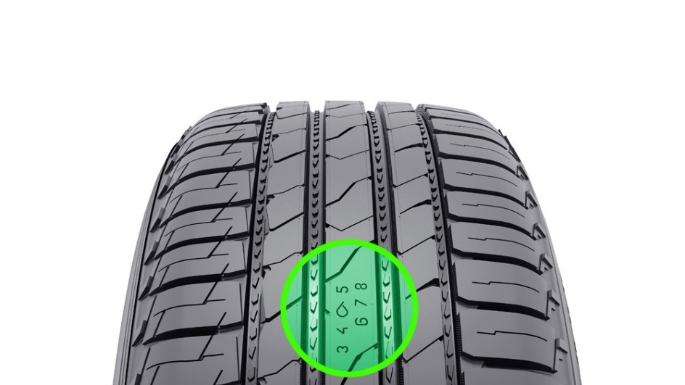Motorists should check their tyres before the holiday season in order to increase safety and comfort and maximize their peace of mind. When it rains in summer, water collects in the ruts in the road surface, creating a risk of aquaplaning. Tyres should have at least 4 mm tread depth in order to reduce the risk of aquaplaning.

According to a test by Nokian Tyres, a car driving on a straight road in the rain with new summer tyres will aquaplane at a speed of approximately 80 km/h. Old tyres with half the groove depth aquaplane already at 60 km/h.

Other tests conducted by Nokian Tyres show that the braking distances of new and worn tyres on wet surfaces differ significantly. When driving at a speed of 80 km/h, the braking distance of new tyres, with 8 mm of tread remaining, was approximately 22 metres. When using older tyres, with 4 mm of tread remaining, the braking distance increases by over four metres at the same speed.

**Figures from 8 to 3 indicate the tread depth in millimetres, the raindrop warns of aquaplaning**

To enable motorists to check the tread depth of their tyres more effectively, Nokian Tyres has invented an innovation that increases safety – namely, the Driving Safety Indicator with aquaplaning alert.

The Driving Safety Indicator on the Nokian summer tyres shows the driver the groove depth as a simple figure from 8 to 3. An aquaplaning alert within this warns of the danger of aquaplaning with a drop symbol. It disappears when there are only four millimetres of remaining tread, alerting the driver of the increased risk. No other tyre manufacturer has these innovations.

However, if your car aquaplanes, you will lose control of it. If this happens, never attempt to brake. “With manual transmission, press the clutch all the way down. With automatic transmission, lift your foot off the accelerator. Do not turn the wheel before your tyres contact the road again,” Matti Morri, Technical Customer Service Manager for Nokian Tyres, advises.

**Save money without skimping on safety – the air in your tyres costs nothing**

“Ensuring the correct tyre pressure is an important safety factor – a kind of life insurance. If a tyre is underinflated, the vehicle is slower to respond. Its braking distance is longer and its grip worse compared to a tyre with the correct inflation pressure.”

According to ADAC tests, if just one front tyre has 1 bar (100 kPa) less pressure than recommended, the car's braking distance increases by as much as 10 m on wet roads. If all four tyres are underinflated by 1 bar, the lateral grip is less than half than with the correct pressure.

“Check your tyre pressure every three weeks”, is expert Morri’s recommendation to motorists. “If the pressure is too low, the car uses more fuel. You notice this when you come to fill up. Whereas pumping air into your tyres costs nothing.” A correctly inflated tyre can save over half a litre in petrol over 100 km due to the fact that its rolling resistance is reduced by up to 10 %.

**Location and pressure indicators on the information area: correct inflation pressure and installation location during tyre change**

The location and pressure indicators on the sidewall info area improve safety. 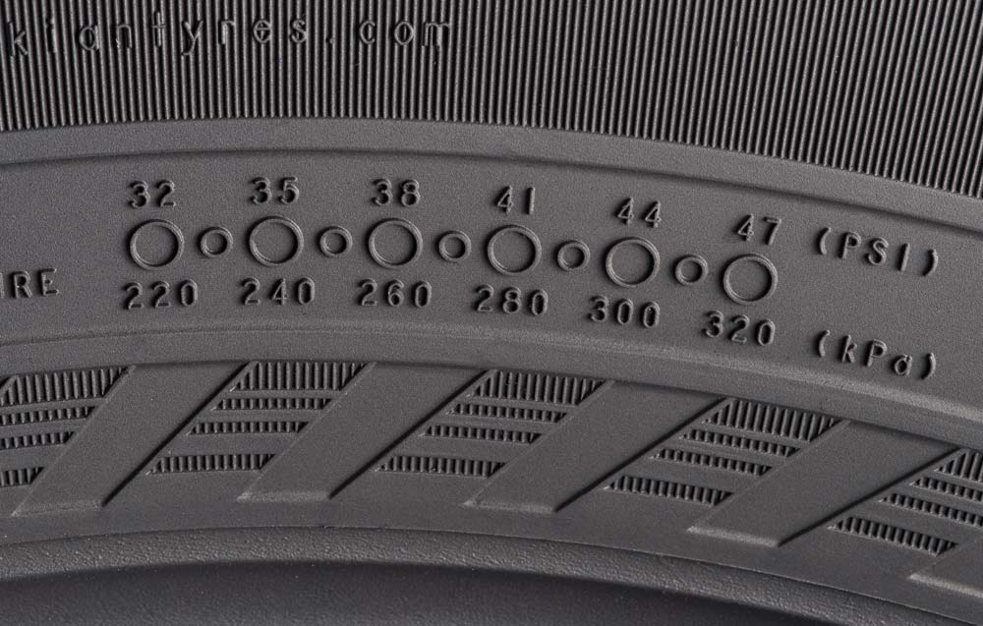The information area allows for recording the correct inflation pressure and installation location during tyre change. Safety and comfort are improved further by a new section that can be used to record the tightening torque of the wheel nuts for alloy wheels. The correct tyre pressure makes driving safer and steering more responsive, reduces tyre wear and saves fuel.

**Check the condition of your tyres before setting off on holiday!**

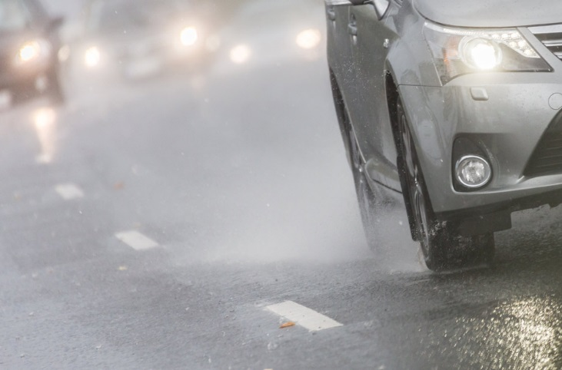Four millimetres is generally considered a safe tread depth. If the tread depth is not sufficient, the car will aquaplane more easily and its braking distance on wet asphalt will be longer. Therefore, you should pay attention to the tread depth of your tyres before the holiday season.

Tyres that are evenly worn provide better grip, especially around corners, and more control. If the tyres are evenly worn, you should rotate them from the front axle to the rear. If two tyres are better than the others, you should fit them on the rear axle.

A good way to keep your tyres in shape for longer is to rotate them regularly, either once every 8,000 kilometres during normal driving or when the tyres have a difference in wear of 2 millimetres.

You should check whether the inner and outer sidewalls of the tyres are clean and whether any abnormal bulges, cracks or punctures are visible.

Every now and then, you should remove large stones from the tyre’s main grooves. Rocks that are firmly wedged into the grooves will not fall out while driving; instead, they will penetrate deeper into the tyre and may cause tyre damage.

Inflation pressure will directly affect handling and driving safety. You can find the correct tyre pressure in the vehicle’s manual. When the car is heavily loaded, you need to increase the tyre pressure by 10 - 15 per cent.

Special attention should be paid to vans and motor homes with a tyre pressure that should be close to double compared to ordinary cars. Hard loads require more tyre pressure. Pressure levels of C-tyres targeted for heavy use are typically approx. 4-5.5 bar (400 kPa to 550 kPa).

Tips for summer tyre maintenance:

[www.nokiantyres.com/innovation/facts-about-tyres/useful-tips-for-tyre-maintenance/](http://www.nokiantyres.com/innovation/facts-about-tyres/useful-tips-for-tyre-maintenance/)

[**www.nokiantyres.com**](http://www.nokiantyres.com)

**Vianor tyre and car-service of Nokian Tyres:**

**[http://vianor.com](http://vianor.com/)**

Editor: Dr Falk Köhler

**Photos captions**

DSI_Nokian_Line_SUV.jpg

Caption:

The Driving Safety Indicator with aquaplaning alert by Nokian Tyres indicates the tread depth of the tyres Photo: Nokian Tyres

Info_area_Nokian_Line_SUV_b.jpg

Caption:

The location and pressure indicator on the sidewall info area by Nokian Tyres improve safety in the info area on the sidewall boosts safety Photo: Nokian Tyres

NT_Summer_tyres_wetroad_1.jpg

Caption:

Nokian Tyres innovations make driving safer during summer Photo: Nokian Tyres

**Photo downloads Nokian Line SUV**

[**www.nokiantyres.com/linesuv**](http://www.nokiantyres.com/linesuv)

**Photo downloads Nokian Tyres summer season**

[**www.nokiantyres.com/summerseason-nordic**](http://www.nokiantyres.com/summerseason-nordic)

**Videos:**

**Nokian Tyres: Test winning summer tyres**

[**https://www.youtube.com/watch?v=WYB_BDc7XK0**](https://www.youtube.com/watch?v=WYB_BDc7XK0)

**Video: Nokian Line SUV – Tough wet performer**

[**http://youtu.be/kOD9prmIPEQ**](http://youtu.be/kOD9prmIPEQ)

**Video: Nokian zLine SUV – Tough cool performer**

[**http://youtu.be/sYHyUmczeS4**](http://youtu.be/sYHyUmczeS4)

**Video Nokian Line - Test winning summer tyre for Central Europe:**

[**http://youtu.be/YbsERA80v18**](http://youtu.be/YbsERA80v18)

**Video: Nokian summer tyres – Testing at the extremes**

[**http://youtu.be/6kT0wLEOxY4**](http://youtu.be/6kT0wLEOxY4)

**Read more:**

**Nokian Line SUV and Nokian zLine SUV are test winners in Auto Bild allrad’s and OFF ROAD’s SUV summer tyre tests 2015**

[**http://www.nokiantyres.com/company/news-article/nokian-line-suv-and-nokian-zline-suv-are-test-winners-in-auto-bild-allrad-s-and-off-road-s-suv-summe/**](http://www.nokiantyres.com/company/news-article/nokian-line-suv-and-nokian-zline-suv-are-test-winners-in-auto-bild-allrad-s-and-off-road-s-suv-summe/)

**New Nokian SUV summer tyres – driving comfort and cool performance**

[**http://www.nokiantyres.com/company/news-article/new-nokian-suv-summer-tyres-driving-comfort-and-cool-performance/**](http://www.nokiantyres.com/company/news-article/new-nokian-suv-summer-tyres-driving-comfort-and-cool-performance/)

**Nokian Line SUV**

[**http://www.nokiantyres.com/company/news-article/nokian-line-suv-summer-tyre-driving-comfort-and-performance-for-versatile-use-on-suvs/**](http://www.nokiantyres.com/company/news-article/nokian-line-suv-summer-tyre-driving-comfort-and-performance-for-versatile-use-on-suvs/)

**Nokian zLine SUV**

**<http://www.nokiantyres.com/company/news-article/nokian-zline-suv-summer-tyre-cool-performance-and-extreme-durability-for-suvs/>**

**Nokian Line is test winner in the 2015 ADAC summer tyre test**

[**http://www.nokiantyres.com/company/news-article/nokian-line-is-test-winner-in-the-2015-adac-summer-tyre-test/**](http://www.nokiantyres.com/company/news-article/nokian-line-is-test-winner-in-the-2015-adac-summer-tyre-test/)

**Nokian Tyres test success**

[**www.nokiantyres.com/innovation/test-success/**](http://www.nokiantyres.com/innovation/test-success/)

**New Nokian Line – Top performance for wet roads**

[**http://www.nokiantyres.com/company/news-article/new-nokian-line-top-performance-for-wet-roads-2/**](http://www.nokiantyres.com/company/news-article/new-nokian-line-top-performance-for-wet-roads-2/)

**Nokian Tyres is the world’s leading winter tyre specialist, a multiple test winner, winter tyre inventor, world record holder and innovation leader**

As the world’s leading winter tyre specialist, a multiple test winner, and inventor of the winter tyre, Nokian Tyres offers the safest tyres for Northern conditions. Innovative Nokian tyres for passenger cars, trucks, and heavy machinery demonstrate their high quality particularly well in snow, ice, tough climates, and demanding driving conditions. Nokian Tyres is the inventor of the winter tyre and has been designing, testing, and patenting innovative tyres for 80 years. Furthermore, Nokian Tyres produces tyres especially developed for European weather and the higher speeds on European motorways.

Standard Nokian winter tyres set a new Guinness world record “Fastest on Ice” with a car by reaching a top speed of 335.713 km/h. As a leading innovator, Nokian Tyres presented the world’s first non-studded winter tyres with studs that extend at the press of a button, allowing the tyre to grip better. The tyre manufacturer also introduced the most energy-efficient winter tyre in the world, with an “A” energy rating. The pioneer in winter tyre technology also introduced the Nokian WR D4 winter tyre that achieves the EU tyre label’s best A class in terms of wet grip. The world’s first AA class winter tyre in terms of wet grip and fuel efficiency is the revolutionary Nokian WR SUV 3.

Nokian tyres deliver excellent safety, save fuel, and are the forerunner of environmental friendliness. The company is number 1 in terms of brand recognition and appreciation in Scandinavia and Russia and has a positive, exceptional image.

**Nokian WR winter tyres are multiple test winners and have achieved numerous further test successes**

Nokian WR winter tyres, optimised for European demands, are multiple test winners and have achieved numerous further test successes. Achieving the top rating “exemplary”, the Nokian WR D3 winter tyre is test winner in the 2014 winter tyre test conducted by the German car magazine Auto Bild. Safe handling and short braking distances earned it the top rating on snow. As test winners, Nokian winter tyres also won the 2014 tests by Auto Club Europa ACE, GTÜ (Germany’s largest inspection organisation of freelance certified inspectors), and German car magazines Auto Bild allrad, OFF ROAD and SUV MAGAZIN, as well as Autoclub ARBÖ Austria. Nokian premium tyres were also awarded the top ratings “exemplary” and “highly recommended” in these tests.

Nokian Tyres now presents the first winter tyre in the world for cars with the best grip on wet roads in the EU tyre label's best A class. The new Nokian WR D4 winter tyre is a grip champion and offers unique innovations. The versatile chameleon for winter roads provides safe driving on wet and snowy roads alike. This supreme ruler of every type of winter weather, coming from the pioneer in winter tyre technology, provides a firm grip in rain, snow and slush. According to the test results of the inventor of the winter tyre, it has the shortest braking distance in the ever-changing European winter weather.

Nokian tyres came out on top in more than 40 winter tyre tests that were carried out by car magazines in this winter, thus confirming the good image of the Scandinavian premium brand.

**Nokian summer tyres are multiple test winners: in the 2015 ADAC summer tyre test, by the consumer organisation Stiftung Warentest, in the German SUV magazines Auto Bild allrad and OFF ROAD, and in additional tests**

Nokian summer tyres are multiple test winners, offering high levels of safety and saving fuel. The Nokian Line is test winner in the 2015 summer tyre tests of the German automobile club ADAC and of the German consumer organisation Stiftung Warentest. Being rated a top score of “good”, it is highly recommended. The Nokian Line SUV is test winner in the Auto Bild allrad SUV summer tyre test 2015 achieving the best rating “exemplary”, as well as with auto TEST. The Nokian zLine SUV is test winner in OFF ROAD being awarded the top rating “highly recommended”.

The Nokian Line already scored the top rating “good” in the 2014 ADAC summer tyre test and with Stiftung Warentest. Being rated highly recommended, it was among the test winner group. The Nokian Z SUV was also the test winner in German SUV magazine OFF ROAD, with the top rating “VERY RECOMMENDED”, and also in SUV MAGAZIN.

**Increased safety through innovations: Winter Safety Indicator with snowflake and Driving Safety Indicator (DSI) with aquaplaning warning**

The Nokian Driving Safety Indicator (DSI) with the unique snowflake symbol, the Winter Safety Indicator (WSI), on the Nokian WR winter tyre clearly shows the driver the groove depth as a number from 8 to 4 millimetres. The numbers disappear gradually as the tyre wears and its tread depth decreases. The snowflake remains visible down to 4 millimetres. When it disappears, the risk increases and the winter tyres should be replaced. The grooves must be a minimum of 4 millimetres deep in order to provide enough grip on snow and to prevent slush planing and aquaplaning on winter and summer tyres.

The Driving Safety Indicator on the Nokian summer tyres shows the driver the groove depth as a simple figure from 8 to 3. An aquaplaning alert within this warns of the danger of aquaplaning with a drop symbol. It disappears when there are only four millimetres of remaining tread, alerting the driver of the increased risk. No other tyre manufacturer has these innovations.

**Nokian Tyres achieved a 1.389 billion euro turnover in 2014**

Nokian Tyres achieved a turnover of 1.389billion euro in 2014 and had over 4,000 employees. In Europe, Nokian Tyres operates with own sales companies in ten countries. The company also owns the Vianor tyre and car-service chain that comprises over 1,300 outlets in 27 countries.

[**www.nokiantyres.com**](http://www.nokiantyres.com)

Vianor tyre and car-service of Nokian Tyres:

**[http://vianor.com](http://vianor.com/)**

**Press contact:**

**Dr Falk Köhler PR**

**Dr Falk Köhler**

Tel. +49 40 54 73 12 12

Fax +49 40 54 73 12 22

E-mail [Dr.Falk.Koehler@Dr-Falk-Koehler.de](mailto:Dr.Falk.Koehler@Dr-Falk-Koehler.de)

[**www.Dr-Falk-Koehler.de**](http://www.Dr-Falk-Koehler.de)

Ödenweg 59

22397 **Hamburg**

Germany

[**www.twitter.com/NokianTyresCom**](http://www.twitter.com/NokianTyresCom)

[**www.youtube.com/NokianTyresCom**](http://www.youtube.com/NokianTyresCom)

**[www.facebook.com/nokiantyres](https://www.facebook.com/nokiantyres)**

[**www.linkedin.com/company/nokian-tyres-plc**](http://www.linkedin.com/company/nokian-tyres-plc)

**Motorist blog:**

**<http://community.nokiantires.com/>**

**Expert blog:**

**<http://nordictyreblog.com/>**

**Nokian Tyres Europe**

**Nokian Tyres s.r.o**

V Parku 2336/22

148 00 Praha 4

Czech Republic

Managing Director Central Europe Hannu Liitsola, Tel. +420 605 236 440

E-mail [hannu.liitsola@nokiantyres.com](mailto:hannu.liitsola@nokiantyres.com)

Technical Customer Service Manager CE Sven Dittmann, Dipl.-Ing., Tel. +49 8143 444 850

E-mail [sven.dittmann@nokiantyres.com](mailto:sven.dittmann@nokiantyres.com)

Marketing Manager Lukáš Líbal, Tel. +420 222 507 759

E-mail [lukas.libal@nokiantyres.com](mailto:lukas.libal@nokiantyres.com)

**www.nokiantyres.com**

**Nokian Tyres Finland Headquarters**

**Nokian Tyres plc**

Pirkkalaistie 7

P.O.Box 20

37101 Nokia

Finland

Product Development Manager Olli Seppälä, Tel. +358 10 401 7549

E-mail [olli.seppala@nokiantyres.com](mailto:olli.seppala@nokiantyres.com)

Development Manager Juha Pirhonen, Tel. +358 10 401 7708

E-mail [juha.pirhonen@nokiantyres.com](mailto:juha.pirhonen@nokiantyres.com)

Technical Customer Service Manager Matti Morri, Tel. +358 10 401 7621

E-mail [matti.morri@nokiantyres.com](mailto:matti.morri@nokiantyres.com)

Product Manager Central Europe Stéphane Clepkens, Tel. +358 50 462 7536

E-mail [stephane.clepkens@nokiantyres.com](mailto:stephane.clepkens@nokiantyres.com)

**www.nokiantyres.com**