**Summer tyres for SUVs**

**Nokian Tyres high-tech offers true benefit for drivers**

**Already test winners,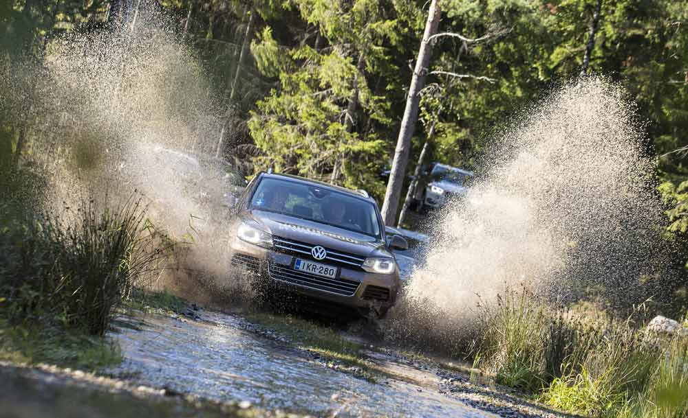 the new Nokian Tyres SUV summer tyres provide maximum durability and performance thanks to high-tech aramid sidewalls. Nokian aramid sidewall technology protects against wear, damage and cuts.**

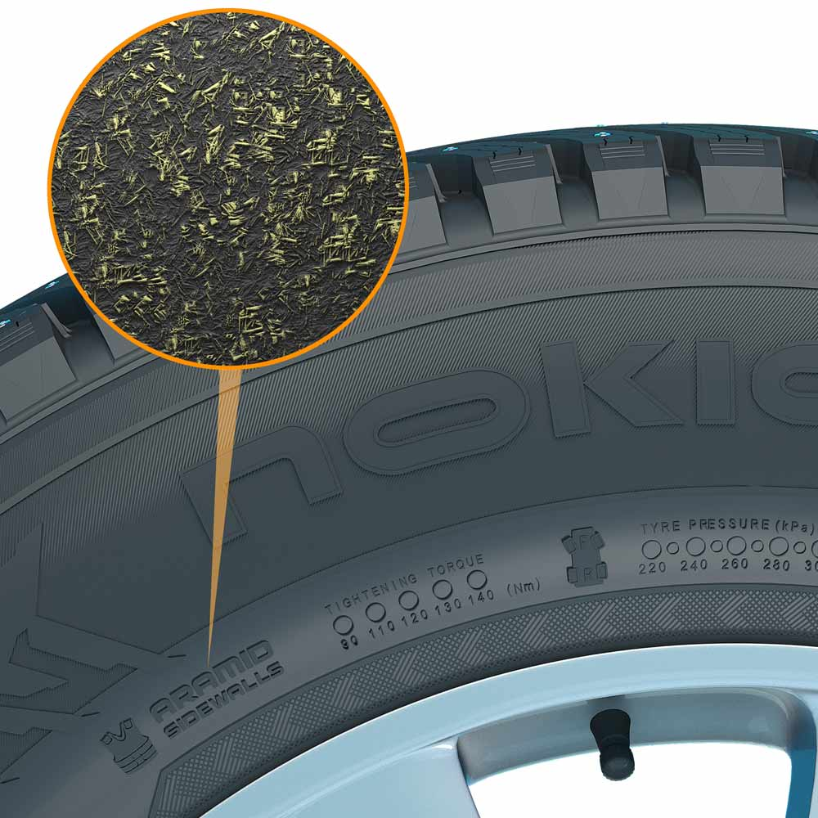

Aramid reinforces tyres and saves lives. These high-strength fibres also prove highly effective in the aviation and military industry. According to research, SUV tyres are most often damaged by impacts to the tyre sidewall. Typical scenarios include driving into potholes with low inflation pressure and parking too carelessly. Nokian Tyres is the first tyre manufacturer to use aramid in the sidewall. The new Nokian SUV summer tyres Nokian Line SUV and Nokian zLine SUV already incorporate the high-tech aramid for maximum safety.

**Nokian Line SUV is test winner in Auto Bild allrad, Nokian zLine SUV is the outright test winner in OFF ROAD**

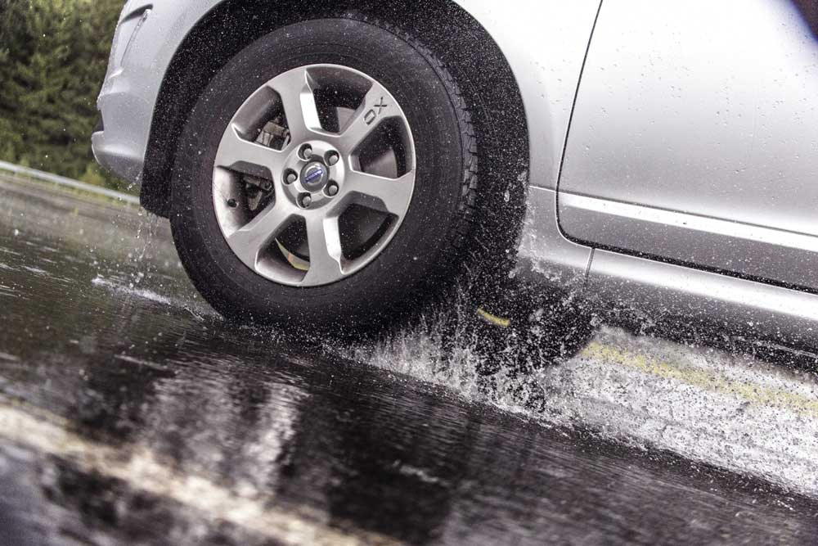The Nokian Line SUV is test winner in the SUV summer tyre test 2015 of the German car magazine Auto Bild allrad, achieving the top rating “exemplary” and also according to auto TEST. The Nokian zLine SUV is the test winner in OFF ROAD and is awarded the top rating “especially recommended”. The Nokian Line for passenger cars is test winner in the 2015 summer tyre tests of the German automobile club ADAC and of the German consumer organisation Stiftung Warentest. Being awarded the top rating “good”, it is highly recommended.

“Very good wet grip, short wet braking distance, balanced summer tyre” are the benefits for driver of the Nokian Line SUV summer tyre according to Auto Bild allrad. The tyre achieved top results in both the wet and off-road tests. “Overall rating 1” for Nokian zLine SUV is the top grade awarded by the German 4x4 magazine OFF ROAD for the test winner. “Strengths: The Nokian achieves top ratings for braking and handling on dry and wet surfaces.” “Dynamic handling, high steering precision, safe off-road capability, short wet braking distances” writes the German car magazine auto TEST in praise of the Nokian Line SUV.

Nokian Tyres from Finland is actually best known for its outstanding winter tyres being the inventor of the winter tyre, world record holder and technology leader. However, the summer tyres of the premium brand Nokian also keep coming top in tests.

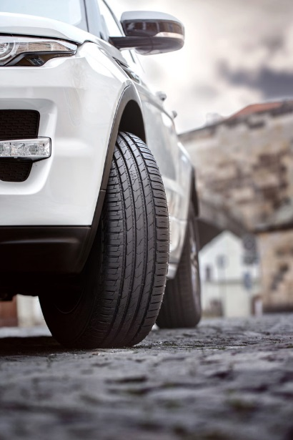

**Pleasant driving comfort and sporty handling**

The Nokian Line SUV summer tyre for versatile SUV use affords pleasant driving comfort, high performance and excellent wet grip on small and medium-sized SUVs. It simply runs and runs, being extremely hard-wearing thanks to its high-strength Nokian aramid sidewall technology. In the wet braking test, the Nokian Line SUV stops 3.4 m sooner, i.e. an SUV car length, than the premium competitors according to the test of Nokian Tyres. What is more, with fuel efficiency class B, this tyre uses less fuel; compared with premium competitors with fuel efficiency class F, motorists can save up to 430 euros in petrol.

The sporty Nokian zLine SUV summer tyre delivers precision handling, maximum durability, safety under extreme conditions and utmost driving pleasure for large SUVs. Its Nokian high-tech aramid sidewalls guarantee its exceptional durability. As this tyre has the best possible grip on wet roads, driving in the rain is safer.

“Drivers want to enjoy the power of their SUVs and also high performance coupled with a precise and comfortable driving feel”, says Product Development Manager Juha Pirhonen from Nokian Tyres. “The aramid fibre stiffens and reinforces the sidewall, allowing it to better withstand surprising impacts and cuts that can easily break the tyre and stop the car.”

The Nokian SUV summer tyres with Nokian Tyres Satisfaction are available from tyre retailers in various sizes from 15 to 22 inches also as complete wheels, on rims, for tyre changes.

[**www.nokiantyres.com**](http://www.nokiantyres.com)

**Vianor tyre and car-service of Nokian Tyres:**

[**http://vianor.com**](http://vianor.com/)

The 430 euros saving in petrol of the Nokian Line SUV with fuel efficiency class B compared to premium competitors with fuel efficiency class F was calculated using the “fuel savings calculator” of the European Commission

60,000 km mileage new tyres, 8.0 l/100 km average petrol consumption, €1.41 per litre average price for premium petrol in Europe, label improvement from F to B

<http://ec.europa.eu/energy/en/topics/energy-efficient-products-and-labels/tyres>

<https://www.adac.de/infotestrat/adac-im-einsatz/motorwelt/benzinpreis_ausland.aspx>

Editor: Dr Falk Köhler

**Photos captions**

PL5A9731.jpg

Picture caption:

The Nokian SUV summer tyres are the test winners in the Auto Bild allrad SUV summer tyre test 2015, as well as in OFF ROAD and auto TEST Photo: Nokian Tyres

Aramid_Sidewall_Nokian_Hakkapeliitta_8SUV.jpg

Picture caption:

The Nokian Tyres high-tech aramid sidewalls protect against wear and enhance safety Photo: Nokian Tyres

Nokian_Line_SUV_014.jpg

Picture caption:

The Nokian Line SUV summer tyre affords excellent wet grip for small and medium-sized SUVs Photo: Nokian Tyres

Nokian_Line_SUV_006.jpg

Picture caption:

Nokian Line SUV: Test winner in the Auto Bild allrad SUV summer tyre test 2015 achieving the top rating “exemplary” and in auto Test and is exceptionally durable Photo: Nokian Tyres

**Photo downloads:**

**Photo downloads Nokian Line SUV:**

[**www.nokiantyres.com/linesuv**](http://www.nokiantyres.com/linesuv)

**Photo downloads Nokian zLine SUV:**

[**www.nokiantyres.com/zlinesuv**](http://www.nokiantyres.com/zlinesuv)

**Photo downloads Nokian Line:**

[**www.nokiantyres.com/NokianLine**](http://www.nokiantyres.com/NokianLine)

**Videos:**

**Video: Nokian Tyres - Aramid saves tyres and lives**

**<http://youtu.be/xp_8Mi4w_Ao>**

**Nokian Tyres: Test winning summer tyres**

[**https://www.youtube.com/watch?v=WYB_BDc7XK0**](https://www.youtube.com/watch?v=WYB_BDc7XK0)

**Video: Nokian Line SUV – Tough wet performer**

[**http://youtu.be/kOD9prmIPEQ**](http://youtu.be/kOD9prmIPEQ)

**Video: Nokian zLine SUV – Tough cool performer**

[**http://youtu.be/sYHyUmczeS4**](http://youtu.be/sYHyUmczeS4)

**Video Nokian Line - Test winning summer tyre for Central Europe:**

[**http://youtu.be/YbsERA80v18**](http://youtu.be/YbsERA80v18)

**Video: Nokian summer tyres – Testing at the extremes**

[**http://youtu.be/6kT0wLEOxY4**](http://youtu.be/6kT0wLEOxY4)

**Read more:**

**Nokian Line SUV and Nokian zLine SUV are test winnersin Auto Bild allrad’s and OFF ROAD’s SUV summer tyre tests 2015**

[**http://www.nokiantyres.com/company/news-article/nokian-line-suv-and-nokian-zline-suv-are-test-winners-in-auto-bild-allrad-s-and-off-road-s-suv-summe/**](http://www.nokiantyres.com/company/news-article/nokian-line-suv-and-nokian-zline-suv-are-test-winners-in-auto-bild-allrad-s-and-off-road-s-suv-summe/)

**New Nokian SUV summer tyres – driving comfort and cool performance**

[**http://www.nokiantyres.com/company/news-article/new-nokian-suv-summer-tyres-driving-comfort-and-cool-performance/**](http://www.nokiantyres.com/company/news-article/new-nokian-suv-summer-tyres-driving-comfort-and-cool-performance/)

**Nokian Line SUV**

[**http://www.nokiantyres.com/company/news-article/nokian-line-suv-summer-tyre-driving-comfort-and-performance-for-versatile-use-on-suvs/**](http://www.nokiantyres.com/company/news-article/nokian-line-suv-summer-tyre-driving-comfort-and-performance-for-versatile-use-on-suvs/)

**Nokian zLine SUV**

**<http://www.nokiantyres.com/company/news-article/nokian-zline-suv-summer-tyre-cool-performance-and-extreme-durability-for-suvs/>**

**Nokian Line is test winner in the 2015 ADAC summer tyre test**

[**http://www.nokiantyres.com/company/news-article/nokian-line-is-test-winner-in-the-2015-adac-summer-tyre-test/**](http://www.nokiantyres.com/company/news-article/nokian-line-is-test-winner-in-the-2015-adac-summer-tyre-test/)

**Nokian Tyres test success**

[**www.nokiantyres.com/innovation/test-success/**](http://www.nokiantyres.com/innovation/test-success/)

**New Nokian Line – Top performance for wet roads**

[**http://www.nokiantyres.com/company/news-article/new-nokian-line-top-performance-for-wet-roads-2/**](http://www.nokiantyres.com/company/news-article/new-nokian-line-top-performance-for-wet-roads-2/)

**Nokian summer tyres offer high levels of safety and satisfaction in challenging summer conditions**

[**http://www.nokiantyres.com/company/news-article/nokian-summer-tyres-offer-high-levels-of-safety-and-satisfaction-in-challenging-summer-conditions/**](http://www.nokiantyres.com/company/news-article/nokian-summer-tyres-offer-high-levels-of-safety-and-satisfaction-in-challenging-summer-conditions/)

**Nokian Tyres is the world’s leading winter tyre specialist, a multiple test winner, winter tyre inventor, world record holder and innovation leader**

As the world’s leading winter tyre specialist, a multiple test winner, and inventor of the winter tyre, Nokian Tyres offers the safest tyres for Northern conditions. Innovative Nokian tyres for passenger cars, trucks, and heavy machinery demonstrate their high quality particularly well in snow, ice, tough climates, and demanding driving conditions. Nokian Tyres is the inventor of the winter tyre and has been designing, testing, and patenting innovative tyres for 80 years. Furthermore, Nokian Tyres produces tyres especially developed for European weather and the higher speeds on European motorways.

Standard Nokian winter tyres set a new Guinness world record “Fastest on Ice” with a car by reaching a top speed of 335.713 km/h. As a leading innovator, Nokian Tyres presented the world’s first non-studded winter tyres with studs that extend at the press of a button, allowing the tyre to grip better. The tyre manufacturer also introduced the most energy-efficient winter tyre in the world, with an “A” energy rating. The pioneer in winter tyre technology also introduced the Nokian WR D4 winter tyre that achieves the EU tyre label’s best A class in terms of wet grip. The world’s first AA class winter tyre in terms of wet grip and fuel efficiency is the revolutionary Nokian WR SUV 3.

Nokian tyres deliver excellent safety, save fuel, and are the forerunner of environmental friendliness. The company is number 1 in terms of brand recognition and appreciation in Scandinavia and Russia and has a positive, exceptional image.

**Nokian WR winter tyres are multiple test winners and have achieved numerous further test successes**

Nokian WR winter tyres, optimised for European demands, are multiple test winners and have achieved numerous further test successes. Achieving the top rating “exemplary”, the Nokian WR D3 winter tyre is test winner in the 2014 winter tyre test conducted by the German car magazine Auto Bild. Safe handling and short braking distances earned it the top rating on snow. As test winners, Nokian winter tyres also won the 2014 tests by Auto Club Europa ACE, GTÜ (Germany’s largest inspection organisation of freelance certified inspectors), and German car magazines Auto Bild allrad, OFF ROAD and SUV MAGAZIN, as well as Autoclub ARBÖ Austria. Nokian premium tyres were also awarded the top ratings “exemplary” and “highly recommended” in these tests.

Nokian Tyres now presents the first winter tyre in the world for cars with the best grip on wet roads in the EU tyre label's best A class. The new Nokian WR D4 winter tyre is a grip champion and offers unique innovations. The versatile chameleon for winter roads provides safe driving on wet and snowy roads alike. This supreme ruler of every type of winter weather, coming from the pioneer in winter tyre technology, provides a firm grip in rain, snow and slush. According to the test results of the inventor of the winter tyre, it has the shortest braking distance in the ever-changing European winter weather.

Nokian tyres came out on top in more than 40 winter tyre tests that were carried out by car magazines in this winter, thus confirming the good image of the Scandinavian premium brand.

**Nokian summer tyres are multiple test winners: in the 2015 ADAC summer tyre test, by the consumer organisation Stiftung Warentest, in the German SUV magazines Auto Bild allrad and OFF ROAD, and in additional tests**

Nokian summer tyres are multiple test winners, offering high levels of safety and saving fuel. The Nokian Line is test winner in the 2015 summer tyre tests of the German automobile club ADAC and of the German consumer organisation Stiftung Warentest. Being rated a top score of “good”, it is highly recommended. The Nokian Line SUV is test winner in the Auto Bild allrad SUV summer tyre test 2015 achieving the best rating “exemplary”, as well as with auto TEST. The Nokian zLine SUV is test winner in OFF ROAD being awarded the top rating “highly recommended”.

The Nokian Line already scored the top rating “good” in the 2014 ADAC summer tyre test and with Stiftung Warentest. Being rated highly recommended, it was among the test winner group. The Nokian Z SUV was also the test winner in German SUV magazine OFF ROAD, with the top rating “VERY RECOMMENDED”, and also in SUV MAGAZIN.

**Increased safety through innovations: Winter Safety Indicator with snowflake and Driving Safety Indicator (DSI) with aquaplaning warning**

The Nokian Driving Safety Indicator (DSI) with the unique snowflake symbol, the Winter Safety Indicator (WSI), on the Nokian WR winter tyre clearly shows the driver the groove depth as a number from 8 to 4 millimetres. The numbers disappear gradually as the tyre wears and its tread depth decreases. The snowflake remains visible down to 4 millimetres. When it disappears, the risk increases and the winter tyres should be replaced. The grooves must be a minimum of 4 millimetres deep in order to provide enough grip on snow and to prevent slush planing and aquaplaning on winter and summer tyres.

The Driving Safety Indicator on the Nokian summer tyres shows the driver the groove depth as a simple figure from 8 to 3. An aquaplaning alert within this warns of the danger of aquaplaning with a drop symbol. It disappears when there are only four millimetres of remaining tread, alerting the driver of the increased risk. No other tyre manufacturer has these innovations.

**Nokian Tyres achieved a 1.389 billion euro turnover in 2014**

Nokian Tyres achieved a turnover of 1.389billion euro in 2014 and had over 4,000 employees. In Europe, Nokian Tyres operates with own sales companies in ten countries. The company also owns the Vianor tyre and car-service chain that comprises over 1,300 outlets in 27 countries.

[**www.nokiantyres.com**](http://www.nokiantyres.com)

Vianor tyre and car-service of Nokian Tyres:

**[http://vianor.com](http://vianor.com/)**

**Press contact:**

**Dr Falk Köhler PR**

**Dr Falk Köhler**

Tel. +49 40 54 73 12 12

Fax +49 40 54 73 12 22

E-mail [Dr.Falk.Koehler@Dr-Falk-Koehler.de](mailto:Dr.Falk.Koehler@Dr-Falk-Koehler.de)

[**www.Dr-Falk-Koehler.de**](http://www.Dr-Falk-Koehler.de)

Ödenweg 59

22397 **Hamburg**

Germany

[**www.twitter.com/NokianTyresCom**](http://www.twitter.com/NokianTyresCom)

[**www.youtube.com/NokianTyresCom**](http://www.youtube.com/NokianTyresCom)

**[www.facebook.com/nokiantyres](https://www.facebook.com/nokiantyres)**

[**www.linkedin.com/company/nokian-tyres-plc**](http://www.linkedin.com/company/nokian-tyres-plc)

**Motorist blog:**

**<http://community.nokiantires.com/>**

**Expert blog:**

**<http://nordictyreblog.com/>**

**Nokian Tyres Europe**

**Nokian Tyres s.r.o**

V Parku 2336/22

148 00 Praha 4

Czech Republic

Managing Director Central Europe Hannu Liitsola, Tel. +420 605 236 440

E-mail [hannu.liitsola@nokiantyres.com](mailto:hannu.liitsola@nokiantyres.com)

Technical Customer Service Manager CE Sven Dittmann, Dipl.-Ing., Tel. +49 8143 444 850

E-mail [sven.dittmann@nokiantyres.com](mailto:sven.dittmann@nokiantyres.com)

Marketing Manager Lukáš Líbal, Tel. +420 222 507 759

E-mail [lukas.libal@nokiantyres.com](mailto:lukas.libal@nokiantyres.com)

**www.nokiantyres.com**

**Nokian Tyres Finland Headquarters**

**Nokian Tyres plc**

Pirkkalaistie 7

P.O.Box 20

37101 Nokia

Finland

Product Development Manager Olli Seppälä, Tel. +358 10 401 7549

E-mail [olli.seppala@nokiantyres.com](mailto:olli.seppala@nokiantyres.com)

Development Manager Juha Pirhonen, Tel. +358 10 401 7708

E-mail [juha.pirhonen@nokiantyres.com](mailto:juha.pirhonen@nokiantyres.com)

Technical Customer Service Manager Matti Morri, Tel. +358 10 401 7621

E-mail [matti.morri@nokiantyres.com](mailto:matti.morri@nokiantyres.com)

Product Manager Central Europe Stéphane Clepkens, Tel. +358 50 462 7536

E-mail [stephane.clepkens@nokiantyres.com](mailto:stephane.clepkens@nokiantyres.com)

**www.nokiantyres.com**