SUV tyres

Nokian Line SUV summer tyre – driving comfort and performance for versatile use on SUVs

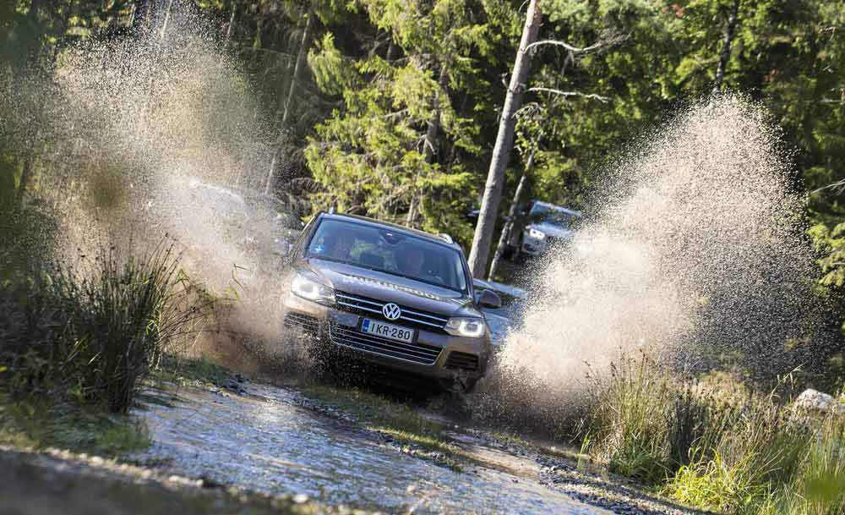
Controlled safety and highest durability by Nokian Aramid Sidewall technology. Dynamic handling, extreme wear resistance and firm wet grip on rough roads and in urban traffic for small and midsize SUVs.

The new Nokian Line SUV summer tyre for varied SUV use offers pleasant comfort, high performance and firm wet grip. It is the correct choice for drivers who value safe driving but also who want to enjoy the power of their SUVs on rough roads and in urban traffic alike. And the comfortable and sporty tyre keeps going, as it has excellent durability by its high tenacity Nokian Aramid Sidewall technology. Furthermore the tyre consumes little fuel, it is designed for the popular small and midsize SUVs. Nokian tyres from Finland are multiple test winners.

Aramid fibres reduce the sidewall damage

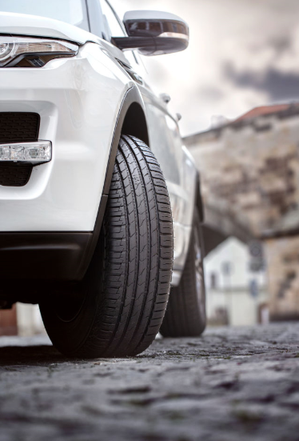
The service life is improved by aramid fibres which the world's northernmost tyre manufacturer's from Finland uses. The same material is also utilised in the aviation and military industries and reduces the sidewall damage that is common to SUV drivers. Several innovations that improve wet grip and maximise aquaplaning prevention make this versatile quality tyre one of the best products in its class.

The design of this new tyre, designed for varying European conditions, is based on the multiple test-winning Nokian Line. The Nokian Line SUV has very low rolling resistance, which also means very low fuel consumption.

The comprehensive size selection of the premium brand is aimed at the growing Central European SUV market, and it consists of a total of 32 tyres, with sizes from 15 to 19 inches. The speed ratings for the new products are T (190 km/h), H (210 km/h), and V (240 km/h), meaning that the Nokian Line SUV and its big brother, the Nokian zLine SUV, cover nearly all of the popular SUV models that are sold in Central Europe. The Nokian Line SUV is now available for purchase at tyre retailers.

The wide selection also includes a large number of special products that are marked XL for the highest possible load capacity.

Nokian Aramid Sidewall technology ensures extreme durability

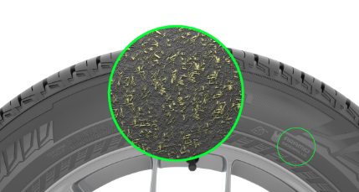
Durability has been one of the most requested features for summer tyres from SUV drivers who want to enjoy passenger car-like features of their tall and powerful vehicles. According to Nokian Tyres research, tyres are most often damaged by impacts to the tyre sidewall. Typical scenarios include driving into potholes with low inflation pressure and parking too carelessly, allowing a sharp kerb to damage the sidewall.

“The Nokian Line SUV moves precisely and lightly on gravel surfaces and asphalt alike, and its Nokian Aramid Sidewall technology reinforces its sidewall. The sidewall compound includes extremely durable aramid staple fibre,” says Product Development Manager Juha Pirhonen from Nokian Tyres, winter tyre inventor, innovation leader and world record holder. “The aramid fibre stiffens and reinforces the sidewall, allowing it to better withstand surprising impacts and cuts that can easily break the tyre and stop the car. We are the first tyre manufacturer using Aramid in the side wall.”

The wear resistance of the easily controllable Nokian Line SUV has been fine-tuned by using a next-generation tread compound that also works flawlessly under hot conditions and on uneven road surfaces.

Stone ejectors in the main grooves of the tread prevent rocks from becoming wedged in the grooves and tread blocks, which also improves durability. Other road users will also be happy, as the number of rock projectiles is reduced.

Comfortable running, precise handling

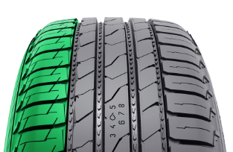
The asymmetrical inside-outside tread pattern is typical of the Nokian Line product family, known for its expertise under extreme conditions. The pattern increases driving comfort and gives the tyre precise handling.

The Smooth rolling concept represents the latest technology, combining low rolling resistance and safe handling at high speeds. The grooved, or siped, block patterns on the shoulder areas that have been optimised using several tread pattern tests and computer-assisted modelling, the varied opening of the grooves, and the differently sized tread blocks with risers all support the rigidity and flexibility of the tread pattern, allowing it to suit different driving scenarios. The end result is both a passenger car-like driving feel and reduced heat generation, significantly improving fuel efficiency.

The hemispherical indentations, reminiscent of a golf ball pattern, on the walls of the longitudinal ribs provide additional driving comfort. This Silent Groove Design innovation reduces the interior noise and external rolling noise of the vehicle. The design also reduces air resistance and cools the surface of the tyre, in turn improving wear resistance.

Slanted and rectangular Off-road Claws were designed for both shoulders for driving on sand roads and other soft surfaces. The Off-road Claws grip the road surface in a controlled manner, improving grip during traction and acceleration.

New innovations preventing aquaplaning: Trumpet Grooves and Hydro Grooves

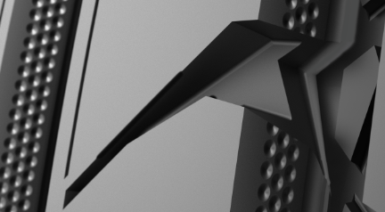
Several new innovations provide added safety for sudden rainfalls, which are an essential part of the Central European summer. The bullet-shaped Trumpet Grooves store water from between the tyre and the road, accelerating its flow from the main grooves towards the transverse grooves and maximising grip even on rain-soaked roads.

The outermost longitudinal ribs in the centre area are dominated by the deep diagonal grooves that open at one end and stabilise handling. At the same time, this new Hydro Grooves innovation effectively prevents aquaplaning by storing water and guiding it into the longitudinal grooves.

A leap forward in fuel efficiency

Compared to its predecessor, the Nokian Line SUV has made the biggest progress in wet grip, aquaplaning prevention, and rolling resistance.

The next-generation Line Coral Silica tread compound, developed by Nokian Tyres' product development professionals, uses the coral-like, expanding molecular structure of the silica and rubber compound to strengthen the stiffness of the tread pattern. This results in a precise steering feel for the driver. The entirely new combination of molecular chains also reduces heat generation and lowers fuel consumption. Due to this new innovation, this new product from the company that has already established itself as a pioneer in eco-friendliness consumes substantially less fuel and minimises the harmful CO2 emissions.

The new Nokian Line SUV provides excellent grip on both dry and wet roads. It has excellent wear resistance, and the tyre retains its state-of-the-art properties throughout its service life. Solutions also used in forestry machine tyres increase the tenacity and toughness of the rubber compound.

Simple safety: Driving Safety Indicator and info area

Tyres that are in good condition can substantially reduce the possibility of aquaplaning. In order to allow drivers to better monitor the groove depth of their tyres, Nokian Tyres has developed two ingenious innovations that improve safety: the Driving Safety Indicator and the aquaplaning indicator.

The Driving Safety Indicator (DSI) on the tyre's centre rib indicates the groove depth. The numbers allow you to check the remaining tread in millimetres. The numbers wear out one by one as the tyre wears down. The aquaplaning indicator warns against an increased risk for aquaplaning. The water drop symbol disappears when less than 4 mm of groove depth remains.

The location and pressure indicators on the sidewall information area improve safety. The information area allows for recording the correct inflation pressure and installation location during tyre changes. Comfort and safety are improved further by an additional section that can be used to record the tightening torque of bolts for alloy rims.

Nokian Line SUV – Wet performer

Aramid reinforced structure for unique durability

First-class comfort, performance, and fuel efficiency

Extreme safety for wet roads

Main innovations:

Nokian Aramid Sidewall technology. Unique durability. The sidewall compound includes extremely durable aramid staple fibre. The same material is also utilised in the aviation and military industries. The aramid fibre stiffens and reinforces the sidewall to even better withstand surprising impacts and cuts.

Trumpet Grooves. Effective aquaplaning prevention. The bullet-shaped Trumpet grooves store water from between the tyre and the road, accelerating its flow from the main grooves towards the transverse grooves and maximising grip even on rain-soaked roads.

Hydro Grooves. Better handling stability, safety for wet roads. The outermost longitudinal ribs in the centre area are dominated by the deep diagonal grooves that open at one end and stabilise handling. The innovation also effectively prevents aquaplaning by storing water and routing it into the longitudinal grooves.

Off-road Claws. Better grip. The diagonal, rectangular claws grab the road surface in a controlled manner, improving traction and braking on sandy roads and soft surfaces.

Stone Ejectors. More durability. Rock removers in the main grooves of the tread prevent rocks from becoming wedged in the grooves and tread blocks, which also improves durability. Other road users will also be happy, as the number of rock projectiles is reduced.

Smooth rolling concept. Lower fuel consumption, safe driving feel. The concept combines low rolling resistance and safe handling at higher speeds. The grooved, or siped, block patterns on the shoulder areas that have been optimised for placement, the varied opening of the grooves, and the differently sized tread blocks with risers all support the rigidity and flexibility of the tread pattern. The end result is both a passenger car-like driving feel and reduced heat generation, significantly improving fuel efficiency.

Silent Groove Design. More driving comfort. The hemispherical indentations, reminiscent of a golf ball pattern, on the walls of the longitudinal ribs provide additional driving comfort. The innovation reduces the interior noise and external rolling noise of the vehicle. The design also reduces air resistance and cools the surface of the tyre, in turn improving wear resistance.

Line Coral Silica tread compound. Excellent driving feel, advanced wet grip properties, and lower fuel consumption. The next-generation tread compound uses the coral-like, expanding molecular structure of the silica and rubber compound to strengthen the stiffness of the tread pattern. This results in a precise steering feel for the driver. Thanks to the new tread compound, the Nokian Line SUV provides excellent grip on both dry and wet roads. It has excellent wear resistance, and the tyre retains its state-of-the-art properties throughout its service life. The entirely new combination of molecular chains also reduces heat generation and lowers fuel consumption.

www.nokiantyres.com

Vianor tyre and car-service of Nokian Tyres:
http://vianor.com

Edited by: Dr Falk Köhler

Photos downloads Nokian Line SUV:

www.nokiantyres.com/linesuv

Videos Nokian Line SUV:

Video: Nokian Line SUV – Tough wet performer

http://youtu.be/kOD9prmIPEQ

Video: Unique durability – Nokian Aramid sidewall concept
http://youtu.be/N5LvBke-UqY

Video: Nokian summer tyres – Testing at the extremes
http://youtu.be/6kT0wLEOxY4

Further information:

Nokian Tyres – the world's northernmost tyre manufacturer and the inventor of the winter tyre
www.nokiantyres.com/company/about-us/history/

Nokian WR is test winner 2014 in the Auto Bild winter tyre test
http://www.nokiantyres.com/company/news-article/nokian-wr-is-test-winner-2014-in-the-auto-bild-winter-tyre-test/

Nokian Tyres test success
www.nokiantyres.com/innovation/test-success/

Nokian Tyres is the world's leading winter tyre specialist, a multiple test winner, the inventor of the winter tyre and a premium brand

As the world's leading winter tyre specialist, a multiple test winner, and a premium brand, Nokian Tyres offers the safest tyres for Northern conditions. Innovative Nokian tyres from Finland for cars, trucks, and heavy machinery demonstrate their high quality particularly well in snow, ice, tough climates, and demanding driving situations. Nokian is the inventor of the winter tyre and has been designing, testing, and patenting innovative tyres for 80 years. Furthermore, Nokian produces tyres especially developed for European weather and the higher speeds on European motorways. Nokian tyres deliver excellent safety, save fuel, and are the forerunner of environmental friendliness. The company is number 1 in terms of brand recognition and appreciation in Scandinavia and Russia and has a positive, exceptional image.

Nokian WR winter tyres are test winners and have achieved numerous further test successes

Nokian WR winter tyres, optimised for European demands, are test winners and have achieved numerous further test successes. The Nokian WR D3 winter tyre scores the top rating “good”, and is thus “especially recommended” in the 2013 winter tyre test of the German automobile club ADAC and the consumer protection organisation Stiftung Warentest and is amongst the best. The Nokian WR D3 is rated “Especially recommended” by the German car magazine auto motor sport. The new Nokian WR SUV 3 high performance winter tyre comes out on top in the big SUV winter tyre test 2013 by OFF ROAD, with the top rating “highly recommended”.

Nokian winter tyres are the test winners in the 2012 winter tyre tests conducted by the German car magazines Auto Bild, auto motor sport, and AUTOStraßenverkehr earning top ratings of “exemplary”, “highly recommended”, and “very good”. In more than 20 winter tyre tests carried out by car magazines in Germany and other European countries last winter, Nokian tyres came out on top and thus confirmed the positive image of the Nordic premium brand. The Finnish tyres are given the top rating of “good” by the German automobile club ADAC and consumer protection organisation Stiftung Warentest.

Standard Nokian winter tyres set a new Guinness world record Fastest on Ice by reaching a top speed of 335.713 km/h.

Nokian tyres rated “good” in the ADAC summer tyre test 2014 and by the consumer organisation Stiftung Warentest and test winner in the German SUV magazine OFF ROAD

Nokian summer tyres are multiple test winners, offering high levels of safety and saving fuel. The Nokian Line summer tyre scores the top rating “good” in the summer tyre test 2014 of the German automobile club ADAC and with the German consumer organisation Stiftung Warentest Being rated “especially recommended”, Nokian Line is among the test winner group. As such, the Nokian tyre achieved a double success in the two best-selling tyre sizes tested for the compact and middle-sized category and for small cars. The Nokian strengths in the ADAC test: Very balanced tyre, good on wet and dry roads.

The test winner is the Nokian Z SUV in the big SUV summer tyre test 2014 by the German SUV magazine OFF ROAD, with the top rating “HIGHLY RECOMMENDED” and also in SUV MAGAZIN.

Nokian tyres were test winners 70 times or were among test winner group, scoring “good” or “recommended” 51 times in 121 test reports from autumn 2011 to spring 2014 – in Central Europe alone.

Increased safety through innovations: Winter Safety Indicator with snowflake and Driving Safety Indicator (DSI) with aquaplaning warning

The Nokian Driving Safety Indicator (DSI) with the unique snowflake symbol, the Winter Safety Indicator (WSI), on the Nokian WR winter tyre clearly shows the driver the groove depth as a number from 8 to 4 millimetres. The snowflake remains visible down to 4 millimetres. When it disappears, the risk increases and the winter tyres should be replaced. The grooves must be a minimum of 4 millimetres deep in order to provide enough grip on snow and to prevent slush planing and aquaplaning on winter and summer tyres.

The Driving Safety Indicator on the Nokian summer tyres shows the driver the groove depth as a simple figure from 8 to 3. An aquaplaning alert within this warns of the danger of aquaplaning with a drop symbol. It disappears when there are only four millimetres of remaining tread, alerting the driver of the increased risk. No other tyre manufacturer has these innovations.

Nokian Tyres achieved a 1.521 billion euro turnover in 2013

Nokian Tyres achieved a turnover of 1.521 billion euro in 2013 and had over 4,000 employees. In Central Europe, Nokian Tyres operates with own sales companies in ten countries. The company also owns the Vianor tyre and car-service chain that comprises over 1,300 outlets in 27 countries.

www.nokiantyres.com

Vianor tyre and car-service of Nokian Tyres:
http://vianor.com

Press contact:
Dr Falk Köhler PR
Dr Falk Köhler
Tel. +49 40 54 73 12 12
Fax +49 40 54 73 12 22
E-mailDr.Falk.Koehler@Dr-Falk-Koehler.de
www.Dr-Falk-Koehler.de
Ödenweg 59
22397 Hamburg
Germany

Further information:

www.twitter.com/NokianTyresCom
www.youtube.com/NokianTyresCom
www.facebook.com/nokiantyres
www.linkedin.com/company/nokian-tyres-plc
Motorist blog:
http://hakkapedia.us/blog/en
Expert blog:
http://nordictyreblog.com/

Nokian Tyres Europe
Nokian Tyres s.r.o

V Parku 2336/22

148 00 Praha 4
Czech Republic
Business Director Central Europe Dieter Köppner, Tel. +420 222 507 761,
E-mail: dieter.koppner@nokiantyres.com
Technical Customer Service Manager CE Sven Dittmann, Dipl.-Ing., Tel. +49 8143 444 850

E-Mail sven.dittmann@nokiantyres.com

Marketing Manager Lukáš Líbal, Tel. +420 222 507 759

E-Mail lukas.libal@nokiantyres.com
www.nokiantyres.com

Nokian Tyres Finland Headquarters
Nokian Tyres plc
Pirkkalaistie 7
P.O.Box 20
37101 Nokia
Finland
Development Manager Juha Pirhonen, Tel. +358 10 401 7708

E-Mail juha.pirhonen@nokiantyres.com
Technical Customer Service Manager Matti Morri, Tel. +358 10 401 7621

E-Mail matti.morri@nokiantyres.com
Product Manager Central Europe Stéphane Clepkens, Tel. +358 50 462 7536
E-Mail stephane.clepkens@nokiantyres.com
www.nokiantyres.com

