New summer tyre for small and medium-sized cars

Nokian iLine summer tyre – More comfort and economy with excellent driving feel

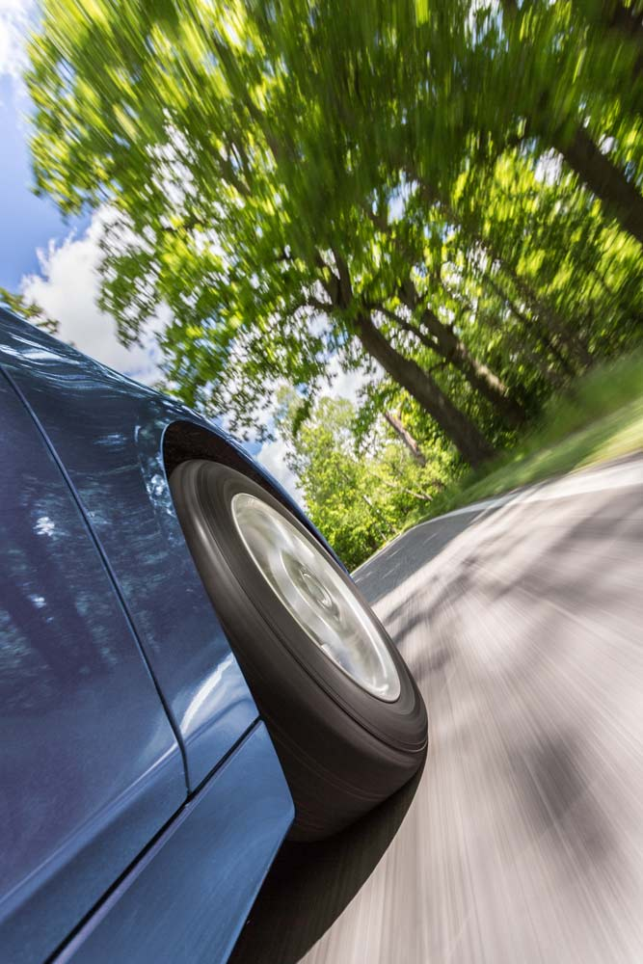
The new Nokian iLine for small and medium-sized cars rolls pleasantly and safely in any summer weather. This summer tyre from Nokian Tyres offers first-class fuel efficiency, which amounts to greener driving. The top-notch driving feel remains stable and reliable even under extreme conditions. The unique Venturi Grooves effectively prevent aquaplaning and the pine oil added to the rubber compound maximises tyre durability.

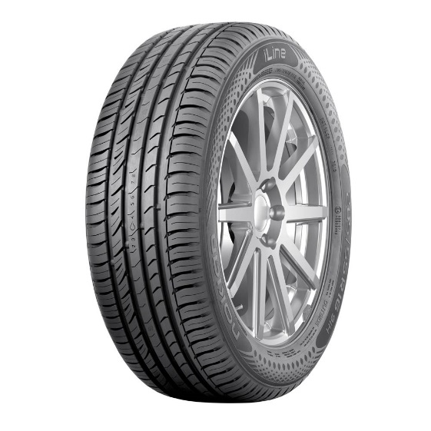
The new summer tyre from the world’s northernmost tyre manufacturer supplements the selection of Nokian Tyres premium summer tyres for the increasingly varied Central European summer weather. The wide size selection (13–16 inches) is excellently suited for drivers who want to stay safe on rain-soaked asphalt and sun-scorched gravel roads alike. The most common speed ratings are T (190 km/h) and H (210 km/h). The entire size selection will be made available to drivers during the spring of 2016.

Central Europe is the most important market for the new tyres of the Nokian Line summer tyre family that took first places in comparison tests by ADAC and Auto Bild, for example. As multiple test winner, the inventor of the winter tyre, world record holder and innovation leader Nokian Tyres from Finland offers the safest tyres.

Venturi Grooves improve aquaplaning prevention

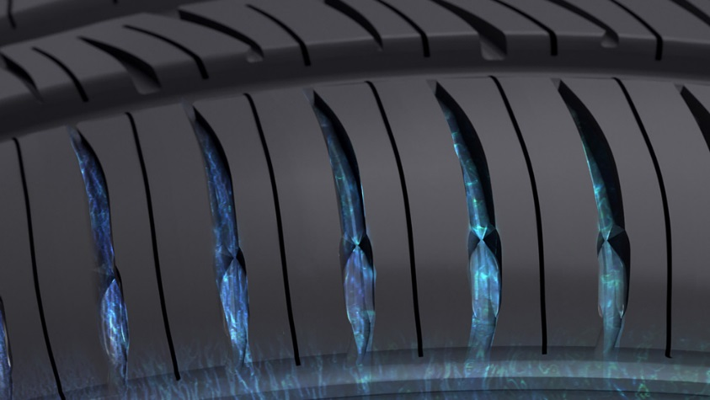
The Nokian iLine has a stable driving feel, and it is not afraid of rainfall from the summer’s sudden thunderstorms or the ever-treacherous aquaplaning. The Venturi Grooves on the inner and outer shoulder further improve aquaplaning prevention. The contoured grooves located between the tread blocks on the shoulder area accelerate the flow of discharged water.

The carefully designed asymmetrical inside-outside tread pattern also improves the aquaplaning properties of the Nokian iLine. The polished main grooves facilitate the removal of water. The optimised, open design at the mouth of the main grooves increases groove volume, thereby preventing further aquaplaning.

Better mileage, lower noise

The new Nokian iLine has low rolling resistance and good wear resistance thanks to several technological innovations. The hemispherical, golf ball-like indentations on the walls of the longitudinal ribs cool the tyre down. This new Silent Groove Design reduces air resistance and increases the range of the vehicle through lower fuel consumption.

The design of the sides of the longitudinal ribs also controls the interior and exterior rolling noise of the vehicle. The indentations guide the airflow, removing the noise waves caused by the edges of the transversal grooves and thereby preventing that unpleasant, howling sound.

The new Nokian iLine Silica tread compound is a skilful combination of safety and eco-friendliness. Pine oil has been added to the full silica compound that guarantees commendable wet grip under all conditions. Pine oil effectively reduces the temperature of the rubber compound by reducing the friction caused by inter-molecular movement. The Nokian iLine lasts longer and rolls lightly, consumes less fuel and minimises harmful emissions.

The water drop symbol reminds you of the risk of aquaplaning

Tyres that are in good condition will increase your safety by substantially reducing the possibility of aquaplaning. In addition to the Driving Safety Indicator (DSI) patented by Nokian Tyres, the tyres also have an aquaplaning indicator. Its water drop symbol disappears at the point where less than four millimetres of tread are remaining, indicating an increased risk for aquaplaning.

The new Nokian iLine – Comfort and economy

Uncompromising safety

Stable and pleasantly silent

Low rolling resistance saves fuel and preserves the environment

Main innovations:

Venturi Grooves. Effective aquaplaning prevention. The shaped grooves located between the shoulder blocks speed up the outflow of water. The speed of water flow increases at the point of constriction, effectively removing water between the tyre and driving surface.

Nokian iLine Silica rubber compound. Excellent wet grip and fuel efficiency. The new environmentally friendly full-silica compound ensures excellent wet grip and a low rolling resistance at all temperatures. The pine oil added to the rubber compound improves wear resistance.

Silent Groove Design. More driving comfort. The hemispherical indentations, reminiscent of a golf ball pattern, on the walls of the longitudinal ribs provide additional driving comfort. The innovation reduces the interior noise and external rolling noise of the vehicle. The design also reduces air resistance and cools the surface of the tyre, in turn improving wear resistance.

www.nokiantyres.com

Vianor tyre and car-service of Nokian Tyres:
http://vianor.com

Edited by Dr. Falk Köhler

Photos captions

Nokian_iLine_003.jpg
caption:

Nokian iLine summer tyre for small and medium-sized cars provides more comfort and economy with top-notch driving feel Photo: Nokian Tyres

Nokian_iLine.jpg
caption:

New Nokian iLine summer tyre offers first-class fuel efficiency, which amounts to greener driving Photo: Nokian Tyres

Nokian_iLine_Venturi_grooves3.jpg
caption:

Nokian iLine summer tyre: Unique Venturi Grooves accelerate the flow of discharged water and effectively prevent aquaplaning Photo: Nokian Tyres

Product photos
www.nokiantyres.com/NokianiLine

Videos

Nokian summer tyres – Testing at the extremes

https://youtu.be/6kT0wLEOxY4

Unique durability - Nokian Aramid Sidewall technology
http://youtu.be/N5LvBke-UqY

Read more

Nokian Line is test winner in the 2015 ADAC summer tyre test

http://www.nokiantyres.com/company/news-article/nokian-line-is-test-winner-in-the-2015-adac-summer-tyre-test/

Nokian summer tyres

www.nokiantyres.com/tyres/passenger-car/summer-tyres/

Nokian Tyres – the world's northernmost tyre manufacturer and the inventor of the winter tyre
www.nokiantyres.com/company/about-us/history/

Nokian Tyres is the world’s leading winter tyre specialist, a multiple test winner, winter tyre inventor, world record holder and innovation leader

As the world’s leading winter tyre specialist, a multiple test winner and inventor of the winter tyre, Nokian Tyres offers the safest tyres for the Northern conditions. Innovative Nokian tyres for passenger cars, trucks, and heavy machinery demonstrate their high quality particularly well in snow, ice, extreme climates and demanding driving conditions. Nokian Tyres is the inventor of the winter tyre and has been designing, testing and patenting innovative tyres for 80 years. Furthermore, Nokian Tyres produces tyres especially developed for European weather and the higher speeds on European motorways.

Standard Nokian winter tyres set a new Guinness World Record for “Fastest on Ice” with a car by reaching a top speed of 335.713 km/h. As a leading innovator, Nokian Tyres presented the world’s first non-studded winter tyres with studs that extend at the press of a button, allowing the tyre to grip better. The tyre manufacturer also introduced the most energy-efficient winter tyre in the world, with an “A” energy rating.

Nokian Tyres offers the world’s first AA class winter tyre in terms of wet grip and fuel efficiency as well as the first A wet grip category winter tyre in the world for cars

The world’s first winter tyre in the tyre label’s top A category in wet grip and fuel efficiency comes from Nokian Tyres, the Nokian WR SUV 3. The revolutionary Nokian WR SUV 3 winter tyre for SUVs can reduce braking distance by up to 18 metres on wet roads and save up to 0.6 litres of fuel per 100 kilometres (size 265/50 R19 V). Its Nokian Twin Trac Silica rubber compound offers extremely firm grip and low fuel consumption, and its Nokian Aramid Sidewall technology guarantees optimum durability.

The Nokian WR D4 is the first winter tyre in the world with wet grip in the EU tyre label's best A class for cars. It is a grip champion and offers unique innovations. This versatile chameleon for winter roads provides safe driving on wet and snowy roads alike. It is a supreme ruler of every type of winter weather, providing a firm grip in rain, snow and slush and it has the shortest braking distance in the varying European winter weather.

Large winter tyre range available from the premium brand Nokian Tyres

Nokian Tyres’ exceptionally wide range of premium winter tyres includes the new Nokian WR D4, Nokian WR SUV 3, Nokian WR C3 van tyres and Nokian Weatherproof All-Weather tyres, as well as the Nokian WR A3 for high-performance cars and the multiple test winner Nokian WR D3.

Nokian tyres deliver excellent safety, save fuel and are the forerunner of environmental friendliness. The company is number 1 in terms of brand recognition and appreciation in Scandinavia and Russia and has a positive, exceptional image.

Nokian WR winter tyres are multiple test winners and have achieved numerous further test successes

Nokian WR winter tyres, optimised for European conditions are multiple test winners and have achieved numerous other test successes. Achieving the top rating “exemplary”, the Nokian WR D3 winter tyre is test winner in the 2014 winter tyre test conducted by the German car magazine Auto Bild. Safe handling and short braking distances earned it the top rating on snow. As test winners, Nokian winter tyres also won the 2014 tests by Auto Club Europa ACE, GTÜ (Germany’s largest inspection organisation of freelance certified inspectors), and the German car magazines Auto Bild allrad, OFF ROAD and SUV MAGAZIN, as well as Autoclub ARBÖ Austria. Nokian premium tyres were also awarded the top ratings “exemplary” and “highly recommended” in these tests. Nokian Weatherproof All-Weather tyre is the test winner in the all-season tyre tests of German car magazine Auto Zeitung, British Auto Express and German TV station VOX. Nokian WR SUV 3 is the test winner in the Off Road winter tyre test and with SUV Magazin. New Nokian WR D4 is “very recommendable“ in the winter tyre test 2015 of German car magazine Auto Zeitung.

Nokian Tyres has achieved altogether over 25 test wins so far in winter tyre comparison tests in Central Europe, Nordic countries and in Russia. Nokian tyres came out on top in more than 40 winter tyre tests that were carried out by car magazines last winter, thus confirming the good image of the Nordic premium brand.

Nokian summer tyres are multiple test winners: in the 2015 ADAC summer tyre test, by the consumer organisation Stiftung Warentest, in the German SUV magazines Auto Bild allrad and OFF ROAD, and in other tests

Nokian summer tyres are multiple test winners, offering high levels of safety and fuel savings. The Nokian Line is test winner in the 2015 summer tyre tests of the German automobile club ADAC and of the German consumer organisation Stiftung Warentest. Being rated at a top score of “good”, it is highly recommended. The Nokian Line SUV is test winner in the Auto Bild allrad SUV summer tyre test 2015 achieving the best rating “exemplary”, as well as with auto TEST. The Nokian zLine SUV is test winner in OFF ROAD being awarded the top rating “highly recommended”.

The Nokian Line already scored the top rating “good” in the 2014 ADAC summer tyre test and with Stiftung Warentest. Being rated highly recommended, it was among the test winning group. The Nokian Z SUV was also the test winner in the German SUV magazine OFF ROAD, with the top rating “VERY RECOMMENDED”, and also in SUV MAGAZIN.

New AA-rated Nokian eLine 2 summer tyre ensures the best possible class A in the EU tyre label’s wet grip and fuel efficiency categories, advanced safety and greener mobility. Nokian iLine summer tyre provides precise driving feel and optimal comfort for medium-sized cars.

Increased safety through innovations: Winter Safety Indicator with snowflake and Driving Safety Indicator (DSI) with aquaplaning warning

The Nokian Driving Safety Indicator (DSI) along with the unique snowflake symbol, the Winter Safety Indicator (WSI), on the Nokian WR winter tyre clearly show the driver the groove depth as a number from 8 to 4 millimetres. The numbers disappear gradually as the tyre wears and its tread depth decreases. The snowflake remains visible down to 4 millimetres. When it disappears, the risk increases and the winter tyres should be replaced. There must be a minimum of 4 millimetres of tread in order to provide enough grip on snow as well as to prevent slush planing and aquaplaning on winter and summer tyres.

The Driving Safety Indicator on the Nokian summer tyres informs drivers of the groove depth as a simple figure from 8 to 3. An aquaplaning alert within this warns of the danger of aquaplaning with a water drop symbol. It disappears when there are only four millimetres of remaining tread, alerting the driver of the increased risk. No other tyre manufacturer has these innovations.

Nokian Tyres achieved a 1.389 billion euro turnover in 2014

Nokian Tyres achieved a turnover of 1.389 billion euros in 2014 and had over 4,000 employees. In Europe, Nokian Tyres operates with own sales companies in ten countries. The company also owns the Vianor tyre and car-service chain that comprises more than 1,300 outlets in 27 countries.

www.nokiantyres.com

Vianor tyre and car-service of Nokian Tyres:
http://vianor.com

Press contact:
Dr Falk Köhler PR
Dr Falk Köhler
Tel. +49 40 54 73 12 12
Fax +49 40 54 73 12 22
E-mail Dr.Falk.Koehler@Dr-Falk-Koehler.de
www.Dr-Falk-Koehler.de
Ödenweg 59
22397 Hamburg
Germany

More information:

www.twitter.com/NokianTyresCom
www.youtube.com/NokianTyresCom
www.facebook.com/nokiantyres
www.linkedin.com/company/nokian-tyres-plc
Motorist blog:
http://community.nokiantires.com/
Expert blog:
http://nordictyreblog.com/

Nokian Tyres Europe
Nokian Tyres s.r.o

V Parku 2336/22

148 00 Praha 4
Czech Republic
Managing Director Central Europe Hannu Liitsola, Tel. +420 605 236 440
E-mail hannu.liitsola@nokiantyres.com
Technical Customer Service Manager CE Sven Dittmann, Dipl.-Ing., Tel. +49 8143 444 850

E-mail sven.dittmann@nokiantyres.com

Marketing Manager Lukáš Líbal, Tel. +420 222 507 759

E-mail lukas.libal@nokiantyres.com
www.nokiantyres.com

Nokian Tyres Finland Headquarters
Nokian Tyres plc
Pirkkalaistie 7
P.O.Box 20
37101 Nokia
Finland
Product Development Manager Jarno Ahvenlammi, Tel. +358 10 401 7741
E-Mail jarno.ahvenlammi@nokiantyres.com
Development Manager Juha Pirhonen, Tel. +358 10 401 7708

E-mail juha.pirhonen@nokiantyres.com
Product Manager Central Europe Stéphane Clepkens, Tel. +358 50 462 7536
E-mail stephane.clepkens@nokiantyres.com
www.nokiantyres.com

