Nokian Hakka Truck Drive tyre for trucks and buses wins "busplaner" innovations prize

The new all-season tyre for buses from Nokian Heavy Tyres withstands slush and therefore convinced the readers of the industry magazine in the Technology category.

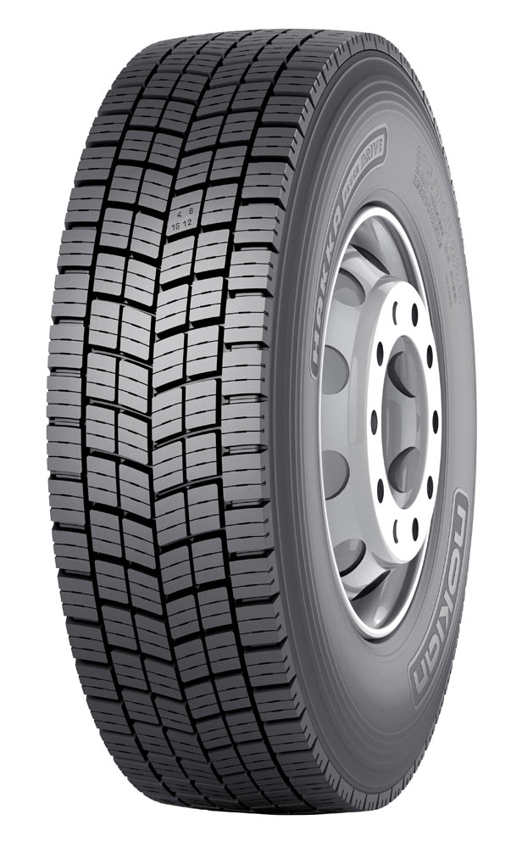
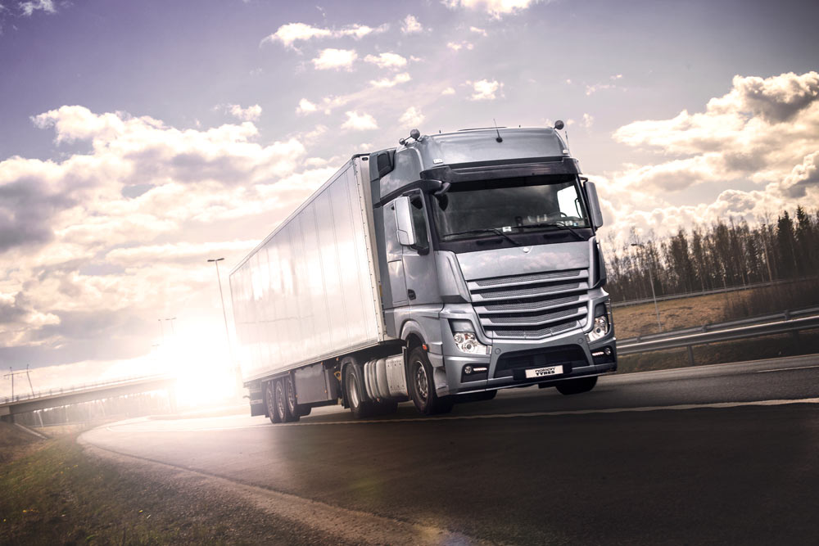
The new "Nokian Hakka Truck Drive" all-season tyre for buses by Nokian Heavy Tyres was selected by 43 percent of readers of busplaner, the German industry magazine for bus contractors and travel businesses, to stand on the winner's podium. The innovation: A V-shaped arrow pattern on the surface of the tyre prevents slush and snow from getting into the tread grooves. This maintains the grip on snow slush as well. During the wearing process, additional grooves gradually emerge and the lamellae automatically generate themselves.

The Nokian Hakka Truck Drive is an all-season drive tyre for long and medium distances in the freight and bus transport industry. The tyre was designed for the changing weather conditions in Central Europe, and has excellent wear resistance, a strong grip and very good driving stability. The Nokian Hakka Truck Drive completes the Nokian-Hakka product family, which already includes tyres for the front axle and for trailers.

Safety and economy for the demanding needs of professional drivers

The truck and bus tyres from Nokian Tyres are designed for the demanding needs of professional drivers and for changing circumstances in order to ensure safe driving in all weather and road conditions. The extreme driving conditions are tested in all seasons in the company's own test centres in Ivalo in Finnish Lapland and at Nokia in Western Finland.

To facilitate further development, millions of kilometres are driven in different application environments and weather conditions with the tyres all year. Through close collaboration with traffic and transport businesses, Nokian Heavy Tyres is able to gain valuable experience from practice, aiding the design work. The purpose of the various tyre tests is to provide professional drivers the safest and most economical tyres in the market. The strong expertise of the company is based on long traditions: Nokian Tyres has developed the first winter tyre for the professionals of the heavy transport industry in 1934.

www.nokianheavytyres.com
Vianor tyre and car service of Nokian Tyres:
http://vianor.com

Download photos
www.nokiantyres.com/nokianhakkatruckdrive

Videos

Nokian truck and bus tyres

http://youtu.be/k021F3tdnpg

Hakkapeliitta Test Experience

http://youtu.be/SSGI1MIr5F4

The first winter tyre in the world celebrates its 80th anniversary

http://youtu.be/Z2zTVOy-QRk

Source

http://www.busplaner.de/aktuelles/veranstaltungen-omnibustouristikbranche/Innovationspreis/10986/busplaner-Innovationspreise-2016

Read more:

Nokian Tyres and Valtra set the New World Record for tractors: 130.165 km/h!
http://www.nokiantyres.com/company/news-article/nokian-tyres-and-valtra-set-the-new-world-record-for-tractors-130-165-km-h/

Nokian Tyres is the world’s northernmost tyre manufacturer and innovation leader

Nokian Tyres is the world’s northernmost tyre manufacturer. The company promotes and facilitates safe travel in demanding conditions. Whether driving through a winter storm or heavy summer rain, Nokian Tyres’ products offer reliability, performance, and peace of mind. The Finnish company is the only tyre manufacturer to focus on products for demanding conditions and customer requirements. As the world’s leading winter tyre specialist, Nokian Tyres offers innovative tyres for passenger cars, trucks, and heavy machinery that are mainly marketed in areas with challenging driving conditions due to snow, forests and varying seasons.

Nokian Tyres is the inventor of the winter tyre and has been designing, testing and patenting innovative tyres for 80 years. Exceptionally demanding conditions require quick thinking, a relentless fighting spirit and the ability to cooperate. This recipe is also used to create the market’s most advanced summer tyres that master rough roads and heavy weather. Furthermore, premium brand Nokian Tyres produces tyres especially developed for European weather and the higher speeds on European motorways.

Large summer tyre and winter tyre and range available from the premium brand Nokian Tyres

The new AA Class Nokian eLine 2 premium summer tyre provides the best of the tyre label class A in wet grip, fuel consumption, advanced security and greener mobility. The new Nokian iLine summer tyre brings better driving comfort and economy for small and medium cars.

Nokian Tyres’ exceptionally wide range of premium winter tyres includes the new Nokian WR D4, Nokian WR A4 high-performance tyre, Nokian WR SUV 3, Nokian WR C3 van tyres and Nokian Weatherproof All-Weather tyres, as well as multiple test winner Nokian WR D3.

Nokian Tyres’ products deliver excellent safety, save fuel and are the forerunners of environmental friendliness. The company is number 1 in terms of brand recognition and appreciation in Scandinavia and Russia and has a positive, exceptional image.

Increased safety through innovations: Driving Safety Indicator (DSI) with aquaplaning warning

The Driving Safety Indicator on the summer tyres informs drivers of the groove depth as a simple figure from 8 to 3. An aquaplaning alert within this warns of the danger of aquaplaning with a water drop symbol. It disappears when there are only four millimetres of remaining tread, alerting the driver of the increased risk.
Nokian Tyres achieved a 1.360 billion euro turnover in 2015

Nokian Tyres achieved a turnover of 1.360 billion euros in 2015 and had over 4,000 employees. In Europe, Nokian Tyres operates with own sales companies in ten countries. The company also owns the Vianor tyre and car-service chain that comprises more than 1,400 outlets in 26 countries.

www.nokiantyres.com

Vianor tyre and car-service of Nokian Tyres:
http://vianor.com

Press contact:
Dr Falk Köhler PR
Dr Falk Köhler
Tel. +49 40 54 73 12 12
Fax +49 40 54 73 12 22
Email Dr.Falk.Koehler@Dr-Falk-Koehler.de
www.Dr-Falk-Koehler.de
Ödenweg 59
22397 Hamburg
Germany

Further information:

www.twitter.com/NokianTyresCom
www.youtube.com/NokianTyresCom
www.facebook.com/nokiantyres
www.linkedin.com/company/nokian-tyres-plc

Nokian Tyres Europe
Nokian Tyres s.r.o

V Parku 2336/22

148 00 Praha 4
Czech Republic
Managing Director Central Europe Hannu Liitsola, Tel. +420 605 236 440
E-mail hannu.liitsola@nokiantyres.com
www.nokianheavytyres.com

Nokian Tyres Finland Headquarters
Nokian Tyres plc
Pirkkalaistie 7
P.O.Box 20
37101 Nokia
Finland
Product Manager Truck Tyres Teppo Siltanen, Tel. + 358 10 401 7709
E-Mail teppo.siltanen@nokiantyres.com
www.nokianheavytyres.com

