**New** **AA-rated premium summer tyre for Central European drivers**

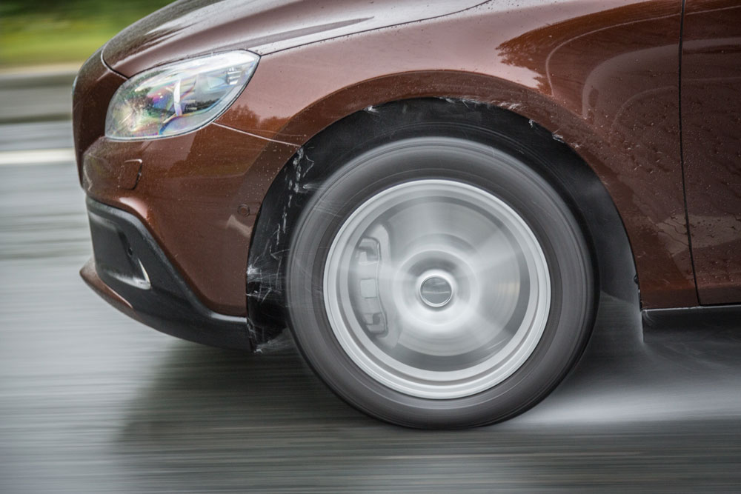**Nokian eLine 2 class AA summer tyre - Advanced safety and greener mobility**

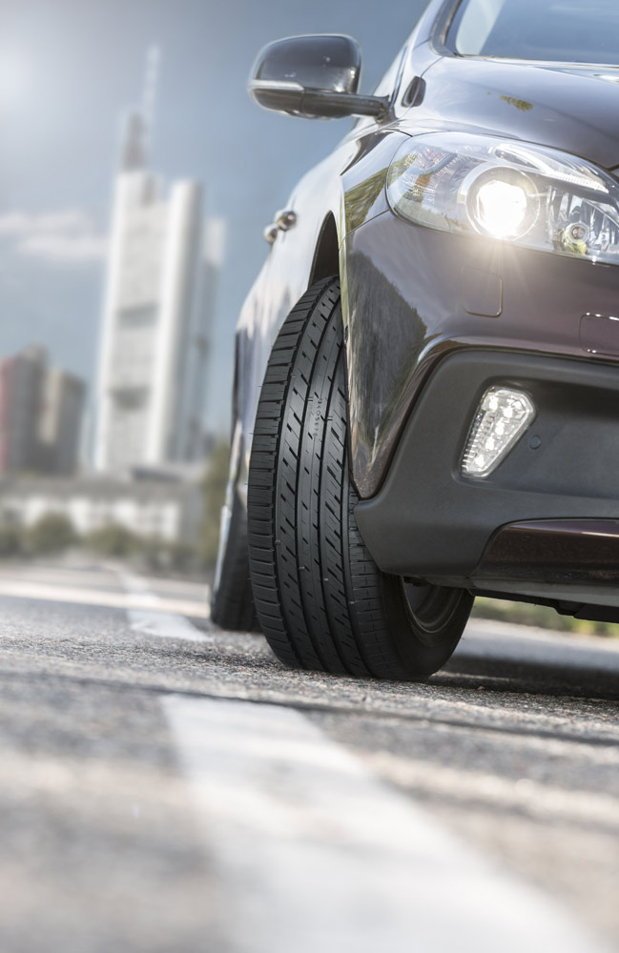**The new AA-rated** [**Nokian eLine 2**](http://www.nokiantyres.com/summer-tyres/nokian-eline-2/) **summer tyre ensures the best possible class A in the EU tyre label’s wet grip and fuel efficiency categories. The premium summer tyre from** [**Nokian Tyres**](http://www.nokiantyres.com/)**, the world’s northernmost tyre manufacturer, offers reliable top performance under all weather conditions. On the road, this can mean a braking distance that is up to 18 metres shorter on wet roads and fuel consumption that is 0.6 l/100 km lower.**

The precise driving feel and optimal comfort can be felt and seen from the first moments of spring until late autumn. A unique innovation, Nokian Tyres Coanda Technology, guides and accelerates the removal of water from between the tyre and the road, thus effectively preventing aquaplaning. The next-generation Driving Safety Indicator improves safety.

The Nokian eLine 2 summer tyre utilises the most modern technology in the industry. It was developed for Central European drivers who want to enjoy a safer, greener future today. The growing size selection has a total of 5 state-of-the-art products in sizes of 15” and 16” that suit medium-sized cars. The speed ratings are H (210 km/h) and W (270 km/h). The new premium product will be available to consumers in the spring of 2016.

As multiple test winner, the inventor of the winter tyre, world record holder and innovation leader Nokian Tyres from Finland offers the safest tyres.

**Shorter braking distance, lower fuel consumption**

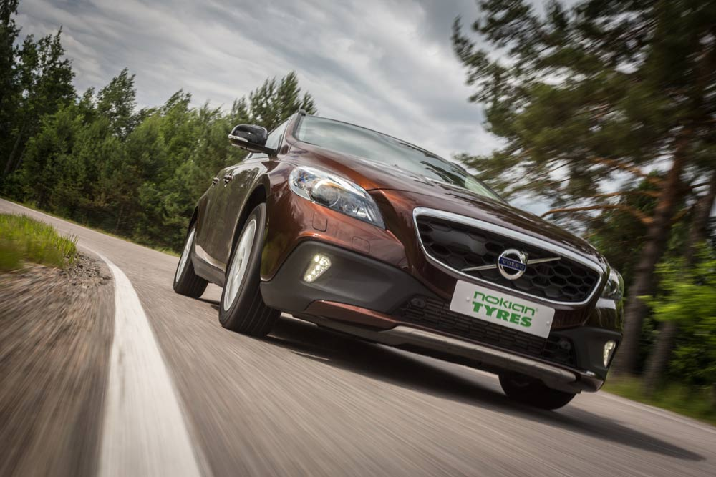

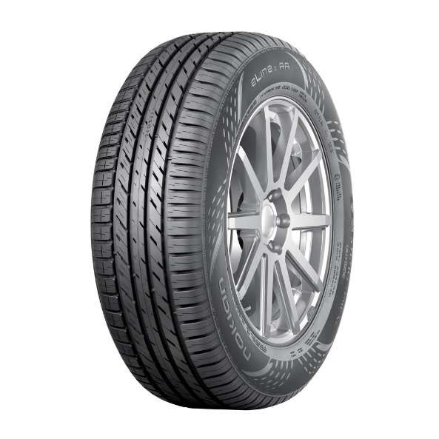Nokian Tyres is known for its high-quality, safe and eco-friendly products that are carefully tailored for different demanding purposes. The excellent test success of the summer tyres from the world’s northernmost tyre manufacturer is the result of relentless, long-term development. Over half of the product development resources are spent on testing products.

As a result of nearly four years of development and extensive field testing in Germany, Finland and Spain, the Nokian eLine 2 premium summer tyre has commendable safety and handling characteristics. The tyre’s wet grip and fuel efficiency classification, according to the EU tyre label, are among the best in the industry, in class A.

On a wet road, the braking distance of the new Nokian eLine 2 from a speed of 80 km/h is up to 18 metres, or four car lengths, shorter than that of a weak summer tyre. (Difference between classes A and F in the EU tyre label). For drivers who favour green values and extremely low fuel consumption, the Nokian eLine 2 offers savings of up to 0.6 litres per 100 km (difference between classes A and G).

“Combining absolutely reliable safety characteristics and the green values favoured by the consumers in the same tyre is the largest challenge for tyre manufacturers. The balanced nature of the Nokian eLine 2 is made possible by the new, eco-friendly structural and material solutions. Precise handling under extreme conditions is combined with lightly rolling driving comfort,” Product Development Manager Jarno Ahvenlammi from Nokian Tyres summarises.

**Advanced structure and tread pattern solutions**

The Nokian eLine 2 masters all the forms of summer. It is built around sustainable safety and eco-friendly driving, both of which are supported by the structure, tread pattern and rubber compound solutions from the master of extreme conditions. The same advanced technology will also be utilised in Nokian Tyres’ other summer tyres in the future.

The unique characteristics of this stylish new introduction were fine-tuned using several innovations that promote safe and comfortable driving and a tailored rubber compound.

The molecular chains of the next-generation functional Nokian eLine 2 Silica tread compound bond with the silica particles to form a strong but flexible combination. The rubber compound is exemplary across a wide temperature range and it improves wet grip and reduces rolling resistance, thereby essentially reducing fuel consumption and lowering hazardous emissions.

**Effectively prevents aquaplaning** - **Nokian Tyres Coanda Technology**

The real safety characteristics and resources of a summer tyre are measured in centimetres and seconds on a wet road. The precise steering and excellent grip of the Nokian eLine 2 during lane changes and evasions provide additional peace of mind for drivers.

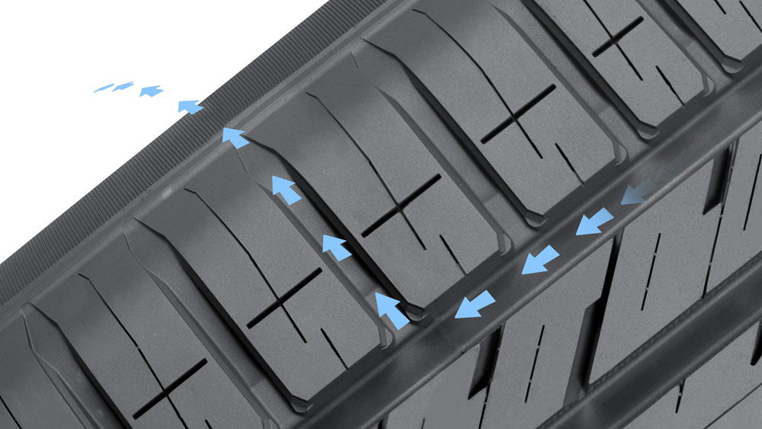The Nokian Tyres Coanda Technology accelerates the removal of water from the longitudinal groove and effectively prevents aquaplaning. The curved, ramp-like design of the tread blocks on the inner shoulder guides and accelerates the flow of water from the longitudinal groove into the transverse groove. The Coanda effect denotes the tendency of flow to turn towards a nearby surface. The Coanda effect is also utilised to improve the aerodynamics of aeroplane wings and Formula 1 cars.

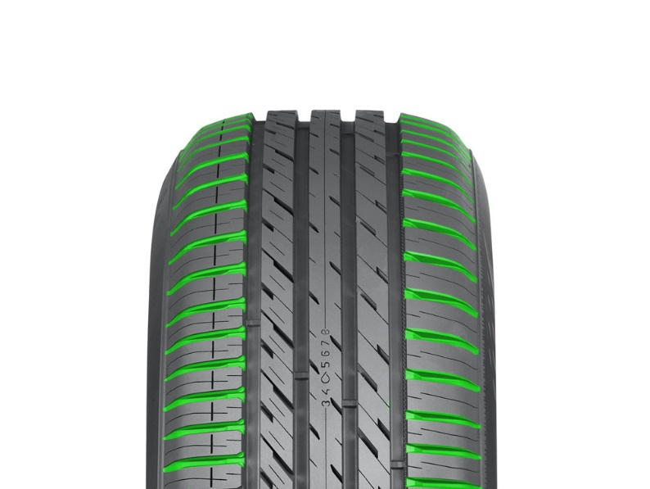The Trumpet Grooves on the shoulder areas also store water and accelerate its removal from the transverse grooves; this ensures double efficiency against aquaplaning. The excellent aquaplaning prevention properties are retained even as the tyre wears down.

**Maximising comfort – Silent Sidewall Technology**

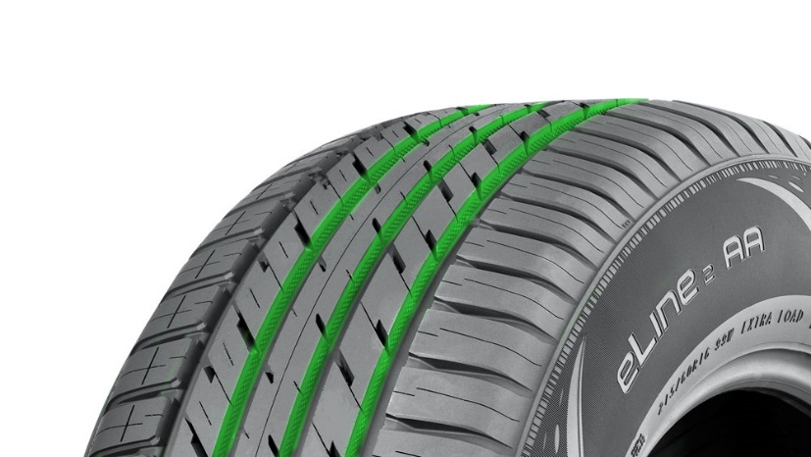The Silent Sidewall Technology maximises driving comfort. The tailored special rubber compound between the sidewall and tread actively filters the sound and steel belt package vibration originating from the driving surface, preventing the passage of harmful sound waves through the sidewall into the rim and further into the passenger compartment. This innovation significantly reduces the noise level inside the vehicle.

The familiar Silent Groove Design innovation is also used to control the interior and exterior noise of the vehicle. The semi-circular indentations on the longitudinal ribs also reduce air resistance, which results in lower fuel consumption and increases the range of the vehicle.

**Simple safety – Next-generation Driving Safety Indicator**

Tyres that are in good condition can substantially reduce the risk of aquaplaning. In order to allow drivers to better monitor the tread depth of their tyres, Nokian Tyres developed an ingenious innovation that improves safety: the Driving Safety Indicator and the aquaplaning indicator.

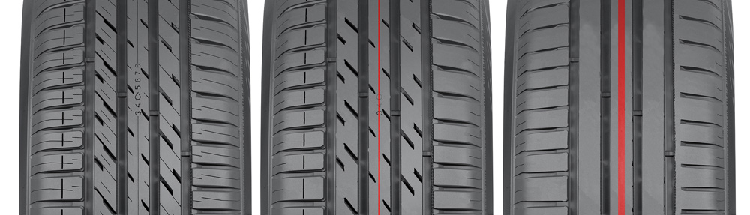The next-generation Driving Safety Indicator on the centre rib indicates tread depth. You can check the amount of remaining tread in millimetres by examining the row of numbers on the tread. The numbers and water drop symbol indicating a risk of aquaplaning disappear, as the tyre wears down. When the tread depth is below 4 mm, a red stripe that indicates low tread depth will appear around the tyre. When this happens, please purchase new summer tyres in order to ensure maximum safety.

**Northproof by Nokian Tyres**

Nokian Tyres is the only tyre manufacturer in the world that focuses on products and services that facilitate safe transportation in northern conditions. The company’s innovative passenger car, truck and heavy duty machinery tyres are mainly marketed in areas that have snow, forest and changing seasons that make driving conditions demanding.

Nokian Tyres' state-of-the-art product development is based on know-how from over 80 years in the business, determined testing, and a continuous search for better solutions. The company developed and manufactured the world’s first winter tyre for the winter frost in 1934. Summer tyre production begun already two years earlier in 1932. In the autumn of 2015 Nokian Tyres offered European drivers the world’s first winter tyre that achieved the best possible class A in wet grip and fuel efficiency of the EU tyre label.

**The new Nokian eLine 2 – Ultimate green safety**

Ultimate control on wet road

Unique green motoring, fuel savings of up to 0.6 litres per 100 km

Premium driving comfort at any speed

**Main innovations:**

**Nokian Tyres Coanda Technology. Effective aquaplaning prevention.** The curved, ramp-like design of the tread blocks on the inner shoulder guides and accelerates the flow of water from the longitudinal grooves into the transverse grooves. The excellent aquaplaning prevention properties are retained even as the tyre wears down. There is also a flow-optimized support between the tread blocks that reduces the movement between them. The support improves handling and ensures a comfortable rolling noise and a more even wear pattern.

**Trumpet grooves. Prevent aquaplaning.** The shoulder areas have trumpet grooves, bullet-type indentations that have been optimized for flow; they store water from between the tyre and the road, accelerating its flow from the main grooves towards the transverse grooves and maximizing grip.

**Silent Groove Design. More driving comfort.** The hemispherical indentations, reminiscent of a golf ball pattern, on the walls of the transverse ribs provide additional driving comfort. The innovation reduces the interior noise and external rolling noise of the vehicle. The design also reduces air resistance and cools the surface of the tyre, in turn improving wear resistance.

**New Driving safety Indicator (DSI). Increases safety and driving comfort.**

The next-generation Driving Safety Indicator on the centre rib indicates tread depth. You can check the amount of remaining tread in millimetres by examining the row of numbers on the tread. The numbers and water drop symbol indicating a risk of aquaplaning disappear, as the tyre wears down. When the tread depth is below 4 mm, a red stripe that indicates low tread depth will appear around the tyre. When this happens, please purchase new summer tyres in order to ensure maximum safety.

[**www.nokiantyres.com**](http://www.nokiantyres.com)

**Vianor tyre and car-service of Nokian Tyres:**

[**http://vianor.com**](http://vianor.com/)

Edited by Dr. Falk Köhler

**Photos captions**

Nokian_eLine_2_025.jpg

caption:

The Nokian eLine 2 summer tyre ensures the best possible class A in the EU tyre label’s wet grip and fuel efficiency categories Photo: Nokian Tyres

Nokian_eLine_2_010.jpg

caption:

On wet roads, the braking distance of the new AA-rated Nokian eLine 2 is up to 18 metres shorter Photo: Nokian Tyres

Nokian_eLine_2.jpg

caption:

The Nokian eLine 2 AA-rated premium summer tyre is built around sustainable safety and eco-friendly driving, both of which are supported by the structure, tread pattern and rubber compound solutions Photo: Nokian Tyres

Nokian_eLine_2_020.jpg

caption:

Nokian eLine 2 premium summer tyre: reliable top performance under all weather conditions, commendable safety and handling characteristics, low fuel consumption and optimal comfort Photo: Nokian Tyres

Nokian_eLine_2_Coanda_Technology3.jpg

caption:

The Nokian Tyres Coanda Technology accelerates the removal of water from the longitudinal groove and effectively prevents aquaplaning Photo: Nokian Tyres

Nokian_eLine_2_Trumpet_Grooves.jpg

caption:

The Trumpet Grooves on the shoulder areas also store water and accelerate its removal from the transverse grooves; this ensures double efficiency against aquaplaning Photo: Nokian Tyres

Nokian_eLine_2_Silent_Groove_Design.jpg

caption:

The familiar Silent Groove Design innovation is also used to control the interior and exterior noise of the vehicle Photo: Nokian Tyres

Nokian_eLine_2_new_DSI.jpg

caption:

The Nokian Tyres Driving Safety Indicator on the centre rib with numbers and water drop symbol indicates tread depth. When the tread depth is below 4 mm, a red stripe that indicates low tread depth will appear around the tyre. When this happens, please purchase new summer tyres in order to ensure maximum safety. Photo: Nokian Tyres

**Photo Downloads Nokian eLine 2**

[**www.nokiantyres.com/NokianeLine2**](http://www.nokiantyres.com/NokianeLine2)

**Videos**

**Nokian summer tyres – Testing at the extremes**

[**https://youtu.be/6kT0wLEOxY4**](https://youtu.be/6kT0wLEOxY4)

**Unique durability - Nokian Aramid Sidewall technology**

[**http://youtu.be/N5LvBke-UqY**](http://youtu.be/N5LvBke-UqY)

**Read more:**

**Nokian Line is test winner in the 2015 ADAC summer tyre test**

[**http://www.nokiantyres.com/company/news-article/nokian-line-is-test-winner-in-the-2015-adac-summer-tyre-test/**](http://www.nokiantyres.com/company/news-article/nokian-line-is-test-winner-in-the-2015-adac-summer-tyre-test/)

**Nokian summer tyres**

[**www.nokiantyres.com/tyres/passenger-car/summer-tyres/**](http://www.nokiantyres.com/tyres/passenger-car/summer-tyres/)

**Nokian Tyres – the world's northernmost tyre manufacturer and the inventor of the winter tyre**

[**www.nokiantyres.com/company/about-us/history/**](http://www.nokiantyres.com/company/about-us/history/)

**Nokian Tyres is the world’s leading winter tyre specialist, a multiple test winner, winter tyre inventor, world record holder and innovation leader**

As the world’s leading winter tyre specialist, a multiple test winner and inventor of the winter tyre, Nokian Tyres offers the safest tyres for the Northern conditions. Innovative Nokian tyres for passenger cars, trucks, and heavy machinery demonstrate their high quality particularly well in snow, ice, extreme climates and demanding driving conditions. Nokian Tyres is the inventor of the winter tyre and has been designing, testing and patenting innovative tyres for 80 years. Furthermore, Nokian Tyres produces tyres especially developed for European weather and the higher speeds on European motorways.

Standard Nokian winter tyres set a new Guinness World Record for “Fastest on Ice” with a car by reaching a top speed of 335.713 km/h. As a leading innovator, Nokian Tyres presented the world’s first non-studded winter tyres with studs that extend at the press of a button, allowing the tyre to grip better. The tyre manufacturer also introduced the most energy-efficient winter tyre in the world, with an “A” energy rating.

**Nokian Tyres offers the world’s first AA class winter tyre in terms of wet grip and fuel efficiency as well as the first A wet grip category winter tyre in the world for cars**

The world’s first winter tyre in the tyre label’s top A category in wet grip and fuel efficiency comes from [Nokian Tyres](http://www.nokiantyres.de), the [Nokian WR SUV 3](http://www.nokiantyres.de/winterreifen/nokian-wr-suv-3/). The revolutionary Nokian WR SUV 3 winter tyre for SUVs can reduce braking distance by up to 18 metres on wet roads and save up to 0.6 litres of fuel per 100 kilometres (size 265/50 R19 V). Its Nokian Twin Trac Silica rubber compound offers extremely firm grip and low fuel consumption, and its Nokian Aramid Sidewall technology guarantees optimum durability.

The Nokian WR D4 is the first winter tyre in the world with wet grip in the EU tyre label's best A class for cars. It is a grip champion and offers unique innovations. This versatile chameleon for winter roads provides safe driving on wet and snowy roads alike. It is a supreme ruler of every type of winter weather, providing a firm grip in rain, snow and slush and it has the shortest braking distance in the varying European winter weather.

**Large winter tyre range available from the premium brand Nokian Tyres**

Nokian Tyres’ exceptionally wide range of premium winter tyres includes the new Nokian WR D4, Nokian WR SUV 3, Nokian WR C3 van tyres and Nokian Weatherproof All-Weather tyres, as well as the Nokian WR A3 for high-performance cars and the multiple test winner Nokian WR D3.

Nokian tyres deliver excellent safety, save fuel and are the forerunner of environmental friendliness. The company is number 1 in terms of brand recognition and appreciation in Scandinavia and Russia and has a positive, exceptional image.

**Nokian WR winter tyres are multiple test winners and have achieved numerous further test successes**

Nokian WR winter tyres, optimised for European conditions are multiple test winners and have achieved numerous other test successes. Achieving the top rating “exemplary”, the Nokian WR D3 winter tyre is test winner in the 2014 winter tyre test conducted by the German car magazine Auto Bild. Safe handling and short braking distances earned it the top rating on snow. As test winners, Nokian winter tyres also won the 2014 tests by Auto Club Europa ACE, GTÜ (Germany’s largest inspection organisation of freelance certified inspectors), and the German car magazines Auto Bild allrad, OFF ROAD and SUV MAGAZIN, as well as Autoclub ARBÖ Austria. Nokian premium tyres were also awarded the top ratings “exemplary” and “highly recommended” in these tests. Nokian Weatherproof All-Weather tyre is the test winner in the all-season tyre tests of German car magazine Auto Zeitung, British Auto Express and German TV station VOX. Nokian WR SUV 3 is the test winner in the Off Road winter tyre test and with SUV Magazin. New [Nokian WR D4](http://www.nokiantyres.com/winter-tyres/nokian-wr-d4/) is “very recommendable“ in the winter tyre test 2015 of German car magazine Auto Zeitung.

Nokian Tyres has achieved altogether over 25 test wins so far in winter tyre comparison tests in Central Europe, Nordic countries and in Russia. Nokian tyres came out on top in more than 40 winter tyre tests that were carried out by car magazines last winter, thus confirming the good image of the Nordic premium brand.

**Nokian summer tyres are multiple test winners: in the 2015 ADAC summer tyre test, by the consumer organisation Stiftung Warentest, in the German SUV magazines Auto Bild allrad and OFF ROAD, and in other tests**

Nokian summer tyres are multiple test winners, offering high levels of safety and fuel savings. The Nokian Line is test winner in the 2015 summer tyre tests of the German automobile club ADAC and of the German consumer organisation Stiftung Warentest. Being rated at a top score of “good”, it is highly recommended. The Nokian Line SUV is test winner in the Auto Bild allrad SUV summer tyre test 2015 achieving the best rating “exemplary”, as well as with auto TEST. The Nokian zLine SUV is test winner in OFF ROAD being awarded the top rating “highly recommended”.

The Nokian Line already scored the top rating “good” in the 2014 ADAC summer tyre test and with Stiftung Warentest. Being rated highly recommended, it was among the test winning group. The Nokian Z SUV was also the test winner in the German SUV magazine OFF ROAD, with the top rating “VERY RECOMMENDED”, and also in SUV MAGAZIN.

New AA-rated Nokian eLine 2 summer tyre ensures the best possible class A in the EU tyre label’s wet grip and fuel efficiency categories, advanced safety and greener mobility. Nokian iLine summer tyre provides precise driving feel and optimal comfort for medium-sized cars.

**Increased safety through innovations: Winter Safety Indicator with snowflake and Driving Safety Indicator (DSI) with aquaplaning warning**

The Nokian Driving Safety Indicator (DSI) along with the unique snowflake symbol, the Winter Safety Indicator (WSI), on the Nokian WR winter tyre clearly show the driver the groove depth as a number from 8 to 4 millimetres. The numbers disappear gradually as the tyre wears and its tread depth decreases. The snowflake remains visible down to 4 millimetres. When it disappears, the risk increases and the winter tyres should be replaced. There must be a minimum of 4 millimetres of tread in order to provide enough grip on snow as well as to prevent slush planing and aquaplaning on winter and summer tyres.

The Driving Safety Indicator on the Nokian summer tyres informs drivers of the groove depth as a simple figure from 8 to 3. An aquaplaning alert within this warns of the danger of aquaplaning with a water drop symbol. It disappears when there are only four millimetres of remaining tread, alerting the driver of the increased risk. No other tyre manufacturer has these innovations.

**Nokian Tyres achieved a 1.389 billion euro turnover in 2014**

Nokian Tyres achieved a turnover of 1.389billion euros in 2014 and had over 4,000 employees. In Europe, Nokian Tyres operates with own sales companies in ten countries. The company also owns the Vianor tyre and car-service chain that comprises more than 1,300 outlets in 27 countries.

[**www.nokiantyres.com**](http://www.nokiantyres.com)

Vianor tyre and car-service of Nokian Tyres:

[**http://vianor.com**](http://vianor.com/)

**Press contact:**

**Dr Falk Köhler PR**

**Dr Falk Köhler**

Tel. +49 40 54 73 12 12

Fax +49 40 54 73 12 22

E-mail [Dr.Falk.Koehler@Dr-Falk-Koehler.de](mailto:Dr.Falk.Koehler@Dr-Falk-Koehler.de)

[**www.Dr-Falk-Koehler.de**](http://www.Dr-Falk-Koehler.de)

Ödenweg 59

22397 **Hamburg**

Germany

**More information:**

[**www.twitter.com/NokianTyresCom**](http://www.twitter.com/NokianTyresCom)

[**www.youtube.com/NokianTyresCom**](http://www.youtube.com/NokianTyresCom)

**[www.facebook.com/nokiantyres](https://www.facebook.com/nokiantyres)**

[**www.linkedin.com/company/nokian-tyres-plc**](http://www.linkedin.com/company/nokian-tyres-plc)

**Motorist blog:**

[**http://community.nokiantires.com/**](http://community.nokiantires.com/)

**Expert blog:**

[**http://nordictyreblog.com/**](http://nordictyreblog.com/)

**Nokian Tyres Europe**

**Nokian Tyres s.r.o**

V Parku 2336/22

148 00 Praha 4

Czech Republic

Managing Director Central Europe Hannu Liitsola, Tel. +420 605 236 440

E-mail [hannu.liitsola@nokiantyres.com](mailto:hannu.liitsola@nokiantyres.com)

Technical Customer Service Manager CE Sven Dittmann, Dipl.-Ing., Tel. +49 8143 444 850

E-mail [sven.dittmann@nokiantyres.com](mailto:sven.dittmann@nokiantyres.com)

Marketing Manager Lukáš Líbal, Tel. +420 222 507 759

E-mail [lukas.libal@nokiantyres.com](mailto:lukas.libal@nokiantyres.com)

**www.nokiantyres.com**

**Nokian Tyres Finland Headquarters**

**Nokian Tyres plc**

Pirkkalaistie 7

P.O.Box 20

37101 Nokia

Finland

Product Development Manager Jarno Ahvenlammi, Tel. +358 10 401 7741

E-Mail [jarno.ahvenlammi@nokiantyres.com](mailto:jarno.ahvenlammi@nokiantyres.com)

Development Manager Juha Pirhonen, Tel. +358 10 401 7708

E-mail [juha.pirhonen@nokiantyres.com](mailto:juha.pirhonen@nokiantyres.com)

Product Manager Central Europe Stéphane Clepkens, Tel. +358 50 462 7536

E-mail [stephane.clepkens@nokiantyres.com](mailto:stephane.clepkens@nokiantyres.com)

[**www.nokiantyres.com**](http://www.nokiantyres.com)