Maximum winter safety

New Nokian WR C3 van tyre delivers unfailing performance for the European winter

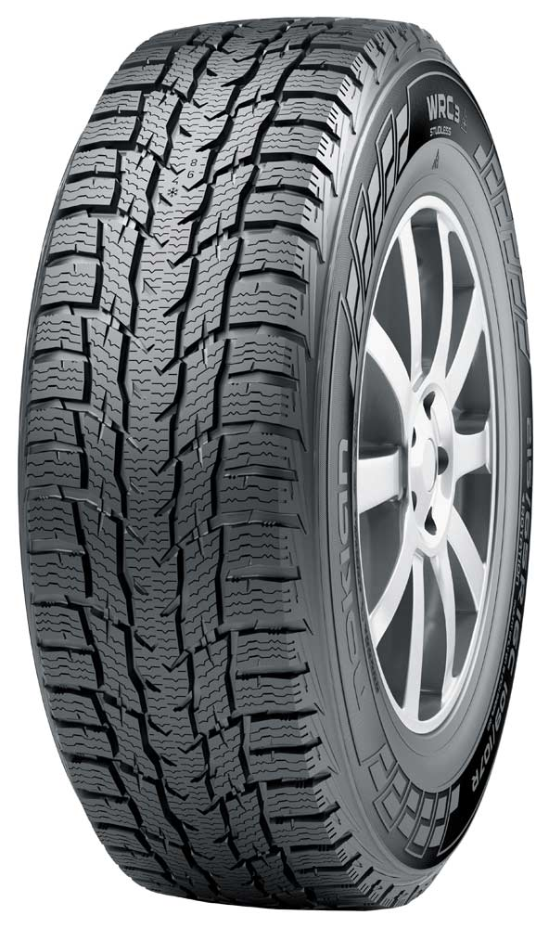
The new Nokian WR C3 tackles the extremes of winter with its precise winter grip. This efficient roller is designed for versatile use on delivery vehicles and vans, and it drives safely, durably and lightly on the urban streets and country roads of Central Europe. In addition to the passenger car-like driving comfort and very low rolling resistance, this new product optimises the safety-enhancing handling properties on icy, snowy and wet roads. These are highly valued by professional drivers.

The comprehensive size selection of the Nokian WR C3 offers versatility and high performance, and it is tailored for modern vehicles. The inventor of the winter tyre offers a selection of 22 products, all the way from 14 inches up to 17 inches. The new product family uses one tread pattern for both the lighter and heavier vehicles. The new Nokian WR C3 will be available at tyre retailers in the autumn of 2015.

Balanced and precise

The new Nokian WR C3 has a reassuringly firm grip on the rapidly changing Central European winter weather. The sturdy new product retains its grip and steering feel on snowy and slushy roads alike. The safety features and durability of the new product were ramped up by using a tread pattern tailored for varying winter conditions, a next-generation rubber compound and a number of structural innovations.

The balanced handling is supported by numerous inventions that have been relentlessly tested by the inventor of the winter tyre. A denser sipe mesh covers the aggressive directional tread pattern. Wider individual sipes provide much-needed grip surface as the friction of the road varies.

In order to maximise grip at higher speeds and under surprising conditions, the tread blocks on the shoulder have pocket-like sipes. The sipes remove, or even pump, water out of the road surface, ensuring stable and sure grip. These patented pump sipes especially boost wet grip.

The unified centre rib and bound centre area of the symmetrical tread pattern promote driving stability. Years of development ensures a more even wear pattern, providing added safety as the tyre ages. Winter tyres installed on driving wheels will most likely wear out in the centre area first.

The carefully considered and tested block geometry in the tread pattern of the smooth Nokian WR C3 can be seen in its excellent handling on grooved roads. The precise handling also helps the driver to observe any changes in the level of friction, and to react in time.

Tailored rubber compound improves wear resistance

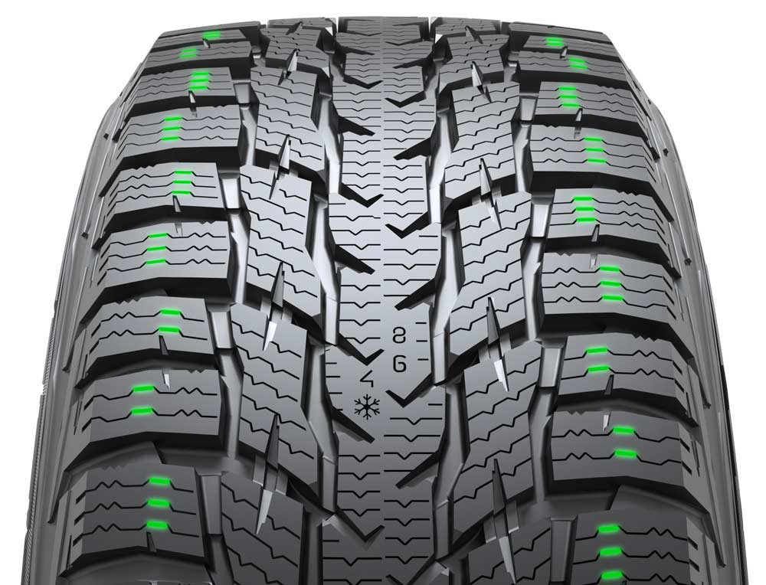
The durable tread compound is tailored for demanding and varying use on vans, and it can safely master the high temperature differences that are typical of the Central European winter. The rubber compound uses plenty of natural rubber as well as canola oil in order to improve winter grip and tear strength.

This new rubber compound allows the sturdy Nokian WR C3 to achieve exceptional grip on snowy and wet roads as well as excellent wear resistance. The sipes on the tread blocks work actively regardless of variations in grip level and temperature. The tailored rubber compound also significantly reduces wear resistance, which in turn saves fuel.

A special Clinch rubber compound was also developed for the bead area of the tyre. The rubber compound presses flexibly against the wheel flange, providing the bead area with more durability when moving massive loads. This innovation also successfully minimises the interior noise of the vehicle.

Sturdy structure is suited for hard use

In addition to the tread pattern, the stable and silent driving behaviour of the Nokian WR C3 is also due to its sturdy structure. The extremely strong new double steel belt structure can tolerate hard use and reliably carry even high wheel loads.

The new, more flexible steel wire used for the steel belts improves puncture protection. This also reduces rolling resistance, which translates into smaller fuel consumption. The steel belt structure also reduces heat generation, further improving wear resistance.

Additional safety and comfort

Indicators on the tread provide increased comfort and add to safety The Driving Safety Indicator (DSI) developed and patented by Nokian Tyres displays the remaining amount of tread surface on the tyre’s main grooves in numbers. The numbers wear out as the tyre wears down. The Driving Safety Indicator is now standard equipment on all Nokian winter tyres. The snowflake symbol (Winter Safety Indicator, WSI) also indicates the winter safety of the tyre. It remains visible to a groove depth of four millimetres.

The sidewall information area has location and pressure indicators. The information area allows for recording the correct inflation pressure and installation location during a tyre change. Safety is improved further by a new section that can be used to record the tightening torque of the wheel nuts for alloy wheels.

Correct tyre pressure is especially important in commercial driving and under heavy loads. Correct tyre pressure improves the driving feel of the car, ensures the structural durability of the tyre, and reduces fuel consumption.

New Nokian WR C3 – Tough performance

- Maximum winter safety and comfort
- Precise and stable handling
- Excellent durability, even with heavy loads

Main innovations:

Pump sipes. More grip on wet and icy surfaces. The pocket-type sipes on the tyre shoulder remove, or even pump, water out of the road surface, ensuring stable and sure grip.

Tailored tread pattern. More driving stability. The unified centre rib and bound centre area of the symmetrical tread pattern promote driving stability. Precise handling. Even wear pattern.

Tread compound adjusted for the varying weather. More safety, durability and fuel efficiency. The winter compound optimised for heavy use works safely across a wide temperature range and reduces rolling resistance. The compound achieves exceptional winter grip, lower fuel consumption and excellent wear resistance.

Special Clinch rubber compound. Optimised durability. The rubber compound presses flexibly against the wheel flange, providing the bead area with more durability. The innovation also effectively minimises the interior noise, since it dampens the vibrations from the tyre body, preventing them from passing into the tyre and further inside the vehicle.

Sturdy steel belt structure. Driving stability and durability. In addition to the tread pattern, the stable and silent handling is attributable to the sturdy structure. The extremely strong double steel belt structure can reliably carry even high wheel loads. The new, more flexible steel wire used for the belts improves structural durability and allows the tyre to maintain its state-of-the-art properties. This also reduces rolling resistance, which translates into lower fuel consumption.

Dense sipe mesh. Optimal grip and handling. The aggressive tread pattern is covered by a denser sipe mesh. Wider individual sipes provide in the centre area much-needed grip surface, especially when friction is at its lowest.

www.nokiantyres.com

Vianor tyre and car-service of Nokian Tyres:
http://vianor.com

Product photos
www.nokiantyres.com/NokianWRC3

Read more:

Nokian Tyres - The world's first winter tyre with an A energy rating
http://youtu.be/Wo4omb0Eil4

World's first winter tyre with pop-out studs
www.nokiantyres.com/company/news-article/nokian-tyres-the-world-s-first-nonstudded-winter-tyre-with-studs/

Winter season 2014: Over 40 test wins for Nokian winter tyres
www.nokiantyres.com/innovation/test-success/

At the top of winter tyre testing: Ivalo Testing Center – White Hell
http://youtu.be/UEGUTw7KHxE

Nokian Hakkapeliitta 8: World record for the fastest car on ice, 335.713 km/h:
www.nokiantyres.com/innovation/testing/fastest-on-ice/fastest-on-ice-2013/

How was the world's first winter tyre invented?
http://www.nokiantyres.com/first-winter-tyres

Comparing the world's first winter tyre to the state-of-the-art non-studded winter tyre
www.nokiantyres.com/company/about-us/history/this-is-how-the-winter-tyre-has-changed/

Nokian Tyres is the world's leading winter tyre specialist, a multiple test winner, the inventor of the winter tyre and a premium brand

As the world's leading winter tyre specialist, a multiple test winner, and a premium brand, Nokian Tyres offers the safest tyres for Northern conditions. Innovative Nokian tyres from Finland for cars, trucks, and heavy machinery demonstrate their high quality particularly well in snow, ice, tough climates, and demanding driving situations. Nokian is the inventor of the winter tyre and has been designing, testing, and patenting innovative tyres for 80 years. Furthermore, Nokian produces tyres especially developed for European weather and the higher speeds on European motorways. Nokian tyres deliver excellent safety, save fuel, and are the forerunner of environmental friendliness. The company is number 1 in terms of brand recognition and appreciation in Scandinavia and Russia and has a positive, exceptional image.

Nokian WR winter tyres are test winners and have achieved numerous further test successes

Nokian WR winter tyres, optimised for European demands, are test winners and have achieved numerous further test successes. The Nokian WR D3 winter tyre scores the top rating “good”, and is thus “especially recommended” in the 2013 winter tyre test of the German automobile club ADAC and the consumer protection organisation Stiftung Warentest and is amongst the best. The Nokian WR D3 is rated “Especially recommended” by the German car magazine auto motor sport. The new Nokian WR SUV 3 high performance winter tyre comes out on top in the big SUV winter tyre test 2013 by OFF ROAD, with the top rating “highly recommended”.

Nokian winter tyres are the test winners in the 2012 winter tyre tests conducted by the German car magazines Auto Bild, auto motor sport, and AUTOStraßenverkehr earning top ratings of “exemplary”, “highly recommended”, and “very good”. In more than 20 winter tyre tests carried out by car magazines in Germany and other European countries last winter, Nokian tyres came out on top and thus confirmed the positive image of the Nordic premium brand. The Finnish tyres are given the top rating of “good” by the German automobile club ADAC and consumer protection organisation Stiftung Warentest.

Standard Nokian winter tyres set a new Guinness world record Fastest on Ice by reaching a top speed of 335.713 km/h.

Nokian tyres rated “good” in the ADAC summer tyre test 2014 and by the consumer organisation Stiftung Warentest and test winner in the German SUV magazine OFF ROAD

Nokian summer tyres are multiple test winners, offering high levels of safety and saving fuel. The Nokian Line summer tyre scores the top rating “good” in the summer tyre test 2014 of the German automobile club ADAC and with the German consumer organisation Stiftung Warentest Being rated “especially recommended”, Nokian Line is among the test winner group. As such, the Nokian tyre achieved a double success in the two best-selling tyre sizes tested for the compact and middle-sized category and for small cars. The Nokian strengths in the ADAC test: Very balanced tyre, good on wet and dry roads.

The test winner is the Nokian Z SUV in the big SUV summer tyre test 2014 by the German SUV magazine OFF ROAD, with the top rating “HIGHLY RECOMMENDED” and also in SUV MAGAZIN.

Nokian tyres were test winners 70 times or were among test winner group, scoring “good” or “recommended” 51 times in 121 test reports from autumn 2011 to spring 2014 – in Central Europe alone.

Increased safety through innovations: Winter Safety Indicator with snowflake and Driving Safety Indicator (DSI) with aquaplaning warning

The Nokian Driving Safety Indicator (DSI) with the unique snowflake symbol, the Winter Safety Indicator (WSI), on the Nokian WR winter tyre clearly shows the driver the groove depth as a number from 8 to 4 millimetres. The snowflake remains visible down to 4 millimetres. When it disappears, the risk increases and the winter tyres should be replaced. The grooves must be a minimum of 4 millimetres deep in order to provide enough grip on snow and to prevent slush planing and aquaplaning on winter and summer tyres.

The Driving Safety Indicator on the Nokian summer tyres shows the driver the groove depth as a simple figure from 8 to 3. An aquaplaning alert within this warns of the danger of aquaplaning with a drop symbol. It disappears when there are only four millimetres of remaining tread, alerting the driver of the increased risk. No other tyre manufacturer has these innovations.

Nokian Tyres achieved a 1.389 billion euro turnover in 2014

Nokian Tyres achieved a turnover of 1.389 billion euro in 2014 and had over 4,000 employees. In Central Europe, Nokian Tyres operates with own sales companies in ten countries. The company also owns the Vianor tyre and car-service chain that comprises over 1,300 outlets in 27 countries.

www.nokiantyres.com

Vianor tyre and car-service of Nokian Tyres:
http://vianor.com

Press contact:
Dr Falk Köhler PR
Dr Falk Köhler
Tel. +49 40 54 73 12 12
Fax +49 40 54 73 12 22
E-mail Dr.Falk.Koehler@Dr-Falk-Koehler.de
www.Dr-Falk-Koehler.de
Ödenweg 59
22397 Hamburg
Germany

Further information:

www.twitter.com/NokianTyresCom
www.youtube.com/NokianTyresCom
www.facebook.com/nokiantyres
www.linkedin.com/company/nokian-tyres-plc
Motorist blog:
http://hakkapedia.us/blog/en
Expert blog:
http://nordictyreblog.com/

Nokian Tyres Europe
Nokian Tyres s.r.o

V Parku 2336/22

148 00 Praha 4
Czech Republic
Business Director Central Europe Dieter Köppner, Tel. +420 222 507 761,
E-mail: dieter.koppner@nokiantyres.com
Technical Customer Service Manager CE Sven Dittmann, Dipl.-Ing., Tel. +49 8143 444 850

E-Mail sven.dittmann@nokiantyres.com

Marketing Manager Lukáš Líbal, Tel. +420 222 507 759

E-Mail lukas.libal@nokiantyres.com
www.nokiantyres.com

Nokian Tyres Finland Headquarters
Nokian Tyres plc
Pirkkalaistie 7
P.O.Box 20
37101 Nokia
Finland
Development Manager Juha Pirhonen, Tel. +358 10 401 7708

E-Mail juha.pirhonen@nokiantyres.com
Technical Customer Service Manager Matti Morri, Tel. +358 10 401 7621

E-Mail matti.morri@nokiantyres.com
Product Manager Central Europe Stéphane Clepkens, Tel. +358 50 462 7536
E-Mail stephane.clepkens@nokiantyres.com
www.nokiantyres.com

