**SUV tyres**

**New Nokian SUV summer tyres – driving comfort and cool performance**

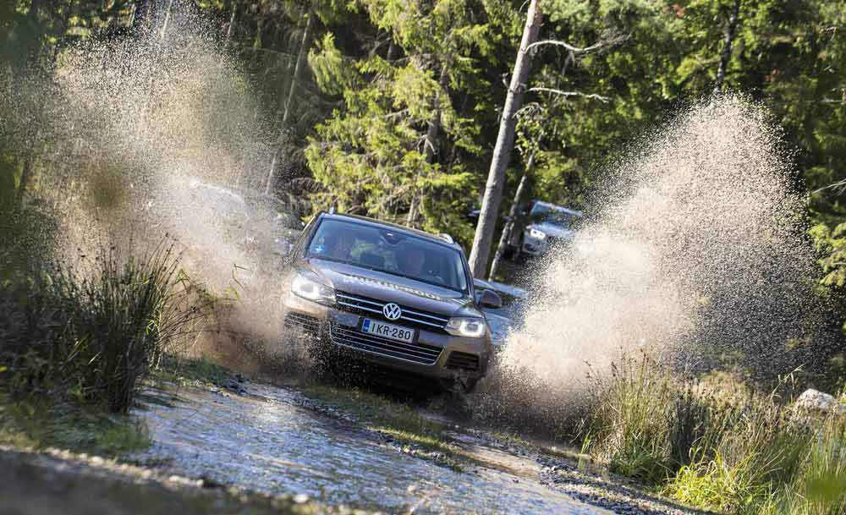**Controlled safety and extreme durability by Nokian Aramid Sidewall technology. Nokian Line SUV: Dynamic handling, pleasant comfort and firm wet grip for small and midsize SUVs. Nokian zLine SUV: Sporty handling, perfect driving pleasure, quick steering and best possible wet grip for the largest SUVs. Van tyre Nokian cLine: more kilometres, high safety and stability.**

Nokian Tyres' summer tyre range, developed for varying summer weather, is now more comprehensive than ever before. Since last summer, the world's northernmost tyre manufacturer has grown its summer selection by 30% by introducing new products and expanding the size selection. Especially the selection of popular SUV tyres is now substantially more versatile. Nokian tyres from Finland are multiple test winners.

Nokian Tyres introduces two new premium SUV summer tyres and a new van tyre for summer 2015.

The new Nokian Line SUV summer tyre for varied SUV use offers pleasant comfort, high performance and firm wet grip. It keeps going under varying weather and road conditions, as it has excellent durability by Nokian Aramid Sidewall technology. Furthermore this summer tyre designed for the popular small and midsize SUVs consumes little fuel.

The sporty Nokian zLine SUV summer tyre provides precise handling, extreme durability, safety for demanding conditions and perfect driving pleasure. Its sidewalls are likewise reinforced by sturdy Aramid. Aramid fibres are also used in the aviation industry and provide much-needed durability to the largest SUVs. Best possible wet grip makes them safer even in rainy roads.

Summer van tyre Nokian cLine offers firm stability, long durability, and high safety for demanding professional use.

**Nokian Line SUV: Aramid fibres** **reduce the sidewall damage**

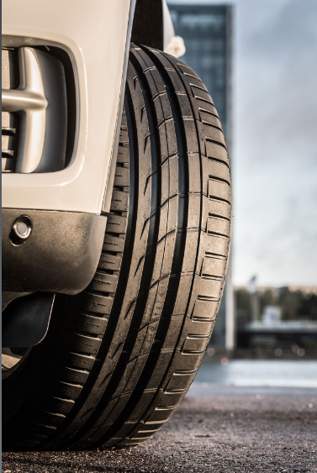The comfortable and sporty Nokian Line SUV is the correct choice for drivers who value safe driving but also want to enjoy the power of their SUVs on rough roads and in urban traffic alike.

The service life is improved by aramid fibres which the world's northernmost tyre manufacturer from Finland uses. The same material is also utilised in the aviation and military industries and reduces the sidewall damage that is common to SUV drivers. Several innovations that improve wet grip and maximise aquaplaning prevention make this versatile quality tyre one of the best products in its class.

The design of this new tyre, designed for varying European conditions, is based on the multiple test-winning Nokian Line. The Nokian Line SUV has very low rolling resistance, which also means very low fuel consumption.

The comprehensive size selection of the premium brand is aimed at the growing Central European SUV market, and it consists of a total of 32 tyres, with sizes from 15 to 19 inches. The speed ratings for the new products are T (190 km/h), H (210 km/h), and V (240 km/h), meaning that the Nokian Line SUV and its big brother, the Nokian zLine SUV, cover nearly all of the popular SUV models that are sold in Central Europe. The Nokian Line SUV is now available for purchase at tyre retailers.

**Nokian zLine SUV: extreme durability, sporty handling and high safety**

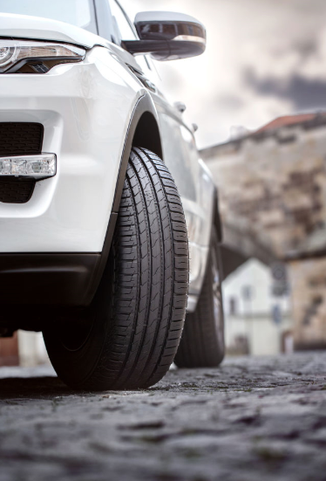

The Nokian zLine SUV steers logically, quickly, and responsively at high speeds. Thus drivers can unleash the full potential of their powerful SUVs. It is the latest display of skill from the world's northernmost tyre manufacturer from Finland that combines SUV owners' requests for safety under extreme conditions, pleasant comfort, and care-free driving.

The sporty and precise Nokian zLine SUV is the result of nearly four years of careful development, and its unique durability and handling properties are the key features setting it apart from its predecessors.

“More durability, state-of-the-art handling, and the best possible safety for rain-slick roads vote for this premium tyre,” says Product Development Manager Juha Pirhonen from Nokian Tyres.“ Drivers who want to enjoy the power of their SUVs will value durability in addition to a precise and comfortable driving feel.”

SUV tyres are most often damaged by impacts to the tyre sidewall. The Nokian zLine SUV uses Nokian Aramid Sidewall technology to better withstand surprising impacts and cuts.

The Nokian zLine SUV exudes power, and it is designed for the largest SUVs in the main market Europe. The comprehensive selection of 25 sizes from 17 to 22 inches has the speed ratings V (240 km/h), W (270 km/h), and Y (300 km/h). Nokian zLine SUV is now available to consumers.

**Nokian cLine van tyre: Nokian cline Cargo for heavier loads and Nokian cLine Van for lighter**

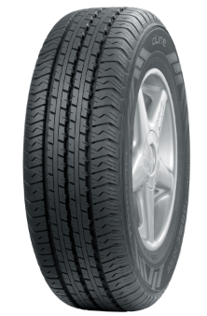

The new Nokian cLine summer van tyre offers more kilometres, stability, durability, and safety for demanding professional use on European roads.

These tyres from Finnish tyre manufacturer are intended for modern vans and delivery trucks as well as minibusses. The sturdy and well-built Nokian cLine Cargo summer tyre for heavy vehicles like delivery and transport trucks even carries higher wheel loads with ease. Its non-directional tread and structure are similar to those of a truck tyre.

Nokian cLine Van is perfectly suited for lighter loads and passenger transport.

Nokian cLine covering a selection 23 tyres all the way from 14 inches up to 17 inches is now available at retailers.

[**www.nokiantyres.com**](http://www.nokiantyres.com)

Vianor tyre and car-service of Nokian Tyres:

[**http://vianor.com**](http://vianor.com/)

**Photos captions**

PL5A9731.jpg

caption:

The new Nokian Line SUV summer tyre for varied SUV use offers pleasant comfort, high performance and firm wet grip with Off-road Claws Photo: Nokian Tyres

Nokian_Line_SUV_006.jpg

caption:

Nokian Line SUV summer tyre for varied SUV use: pleasant comfort, high performance and firm wet grip Photo: Nokian Tyres

Nokian_zLine_SUV_005.jpg

caption:

Nokian zLine SUV summer tyre: sporty handling, extreme durability, and high safety for demanding conditions Photo: Nokian Tyres

Nokian_cLine_Cargo.jpg

caption:

Nokian cLine Cargo van tyre for heavier loads offers more kilometres, stability and durability and even carries higher wheel loads with ease Photo: Nokian Tyres

**Photos downloads Nokian Line SUV:**

[**www.nokiantyres.com/linesuv**](http://www.nokiantyres.com/linesuv)

**Photos downloads Nokian zLine SUV:**

[**www.nokiantyres.com/zlinesuv**](http://www.nokiantyres.com/zlinesuv)

**Photos downloads Nokian cLine:**

[**www.nokiantyres.com/cline**](http://www.nokiantyres.com/cline)

**Videos:**

**Video: Nokian Line SUV – Tough wet performer**

[**http://youtu.be/kOD9prmIPEQ**](http://youtu.be/kOD9prmIPEQ)

**Video: Nokian zLine SUV – Tough cool performer**

[**http://youtu.be/sYHyUmczeS4**](http://youtu.be/sYHyUmczeS4)

**Video: Unique durability – Nokian Aramid sidewall concept**

[**http://youtu.be/N5LvBke-UqY**](http://youtu.be/N5LvBke-UqY)

**Video: Nokian summer tyres – Testing at the extremes**

[**http://youtu.be/6kT0wLEOxY4**](http://youtu.be/6kT0wLEOxY4)

**Nokian Line SUV summer tyre press release in full-length:**

[**http://www.nokiantyres.com/company/news-article/nokian-line-suv-summer-tyre-driving-comfort-and-performance-for-versatile-use-on-suvs/**](http://www.nokiantyres.com/company/news-article/nokian-line-suv-summer-tyre-driving-comfort-and-performance-for-versatile-use-on-suvs/)

**Nokian zLine SUV summer tyre press release in full-length:**

[**http://www.nokiantyres.com/company/news-article/nokian-zline-suv-summer-tyre-cool-performance-and-extreme-durability-for-suvs/**](http://www.nokiantyres.com/company/news-article/nokian-zline-suv-summer-tyre-cool-performance-and-extreme-durability-for-suvs/)

**Nokian cLine van tyre press release in full-length:**

[**http://www.nokiantyres.com/company/news-article/nokian-cline-van-tyre-more-kilometres-high-safety-and-stability/**](http://www.nokiantyres.com/company/news-article/nokian-cline-van-tyre-more-kilometres-high-safety-and-stability/)

**Further information:**

**Nokian tyres rated “good” in ADAC summer tyre test 2014 and by consumer organisation Stiftung Warentest**

[**http://www.nokiantyres.com/company/news-article/nokian-tyres-rated-good-in-adac-summer-tyre-test-2014-and-by-consumer-organisation-stiftung-warentest-2/**](http://www.nokiantyres.com/company/news-article/nokian-tyres-rated-good-in-adac-summer-tyre-test-2014-and-by-consumer-organisation-stiftung-warentest-2/)

**Nokian WR is test winner 2014 in the Auto Bild winter tyre test**

[**http://www.nokiantyres.com/company/news-article/nokian-wr-is-test-winner-2014-in-the-auto-bild-winter-tyre-test/**](http://www.nokiantyres.com/company/news-article/nokian-wr-is-test-winner-2014-in-the-auto-bild-winter-tyre-test/)

**Nokian Tyres test success**

[**www.nokiantyres.com/innovation/test-success/**](http://www.nokiantyres.com/innovation/test-success/)

**Nokian Tyres is the world's leading winter tyre specialist, a multiple test winner, the inventor of the winter tyre and a premium brand**

As the world's leading winter tyre specialist, a multiple test winner, and a premium brand, Nokian Tyres offers the safest tyres for Northern conditions. Innovative Nokian tyres from Finland for cars, trucks, and heavy machinery demonstrate their high quality particularly well in snow, ice, tough climates, and demanding driving situations. Nokian is the inventor of the winter tyre and has been designing, testing, and patenting innovative tyres for 80 years. Furthermore, Nokian produces tyres especially developed for European weather and the higher speeds on European motorways. Nokian tyres deliver excellent safety, save fuel, and are the forerunner of environmental friendliness. The company is number 1 in terms of brand recognition and appreciation in Scandinavia and Russia and has a positive, exceptional image.

**Nokian WR winter tyres are test winners and have achieved numerous further test successes**

Nokian WR winter tyres, optimised for European demands, are test winners and have achieved numerous further test successes. The Nokian WR D3 winter tyre scores the top rating “good”, and is thus “especially recommended” in the 2013 winter tyre test of the German automobile club ADAC and the consumer protection organisation Stiftung Warentest and is amongst the best. The Nokian WR D3 is rated “Especially recommended” by the German car magazine auto motor sport. The new Nokian WR SUV 3 high performance winter tyre comes out on top in the big SUV winter tyre test 2013 by OFF ROAD, with the top rating “highly recommended”.

Nokian winter tyres are the test winners in the 2012 winter tyre tests conducted by the German car magazines Auto Bild, auto motor sport, and AUTOStraßenverkehr earning top ratings of “exemplary”, “highly recommended”, and “very good”. In more than 20 winter tyre tests carried out by car magazines in Germany and other European countries last winter, Nokian tyres came out on top and thus confirmed the positive image of the Nordic premium brand. The Finnish tyres are given the top rating of “good” by the German automobile club ADAC and consumer protection organisation Stiftung Warentest.

Standard Nokian winter tyres set a new Guinness world record Fastest on Ice by reaching a top speed of 335.713 km/h.

**Nokian tyres rated “good” in the ADAC summer tyre test 2014 and by the consumer organisation Stiftung Warentest and test winner in the German SUV magazine OFF ROAD**

Nokian summer tyres are multiple test winners, offering high levels of safety and saving fuel. The Nokian Line summer tyre scores the top rating “good” in the summer tyre test 2014 of the German automobile club ADAC and with the German consumer organisation Stiftung Warentest Being rated “especially recommended”, Nokian Line is among the test winner group. As such, the Nokian tyre achieved a double success in the two best-selling tyre sizes tested for the compact and middle-sized category and for small cars. The Nokian strengths in the ADAC test: Very balanced tyre, good on wet and dry roads.

The test winner is the Nokian Z SUV in the big SUV summer tyre test 2014 by the German SUV magazine OFF ROAD, with the top rating “HIGHLY RECOMMENDED” and also in SUV MAGAZIN. Nokian tyres were test winners 70 times or were among test winner group, scoring “good” or “recommended” 51 times in 121 test reports from autumn 2011 to spring 2014 – in Central Europe alone.

**Increased safety through innovations: Winter Safety Indicator with snowflake and Driving Safety Indicator (DSI) with aquaplaning warning**

The Nokian Driving Safety Indicator (DSI) with the unique snowflake symbol, the Winter Safety Indicator (WSI), on the Nokian WR winter tyre clearly shows the driver the groove depth as a number from 8 to 4 millimetres. The snowflake remains visible down to 4 millimetres. When it disappears, the risk increases and the winter tyres should be replaced. The grooves must be a minimum of 4 millimetres deep in order to provide enough grip on snow and to prevent slush planing and aquaplaning on winter and summer tyres.

The Driving Safety Indicator on the Nokian summer tyres shows the driver the groove depth as a simple figure from 8 to 3. An aquaplaning alert within this warns of the danger of aquaplaning with a drop symbol. It disappears when there are only four millimetres of remaining tread, alerting the driver of the increased risk. No other tyre manufacturer has these innovations.

**Nokian Tyres achieved a 1.389 billion euro turnover in 2014**

Nokian Tyres achieved a turnover of 1.389billion euro in 2014 and had over 4,000 employees. In Central Europe, Nokian Tyres operates with own sales companies in ten countries. The company also owns the Vianor tyre and car-service chain that comprises over 1,300 outlets in 27 countries.

[**www.nokiantyres.com**](http://www.nokiantyres.com)

Vianor tyre and car-service of Nokian Tyres:

**[http://vianor.com](http://vianor.com/)**

**Press contact:**

**Dr Falk Köhler PR**

**Dr Falk Köhler**

Tel. +49 40 54 73 12 12

Fax +49 40 54 73 12 22

E-mail[Dr.Falk.Koehler@Dr-Falk-Koehler.de](mailto:Dr.Falk.Koehler@Dr-Falk-Koehler.de)

[**www.Dr-Falk-Koehler.de**](http://www.Dr-Falk-Koehler.de)

Ödenweg 59

22397 **Hamburg**

Germany

**Further information:**

[**www.twitter.com/NokianTyresCom**](http://www.twitter.com/NokianTyresCom)

[**www.youtube.com/NokianTyresCom**](http://www.youtube.com/NokianTyresCom)

**[www.facebook.com/nokiantyres](https://www.facebook.com/nokiantyres)**

[**www.linkedin.com/company/nokian-tyres-plc**](http://www.linkedin.com/company/nokian-tyres-plc)

**Motorist blog:**

**<http://hakkapedia.us/blog/en>**

**Expert blog:**

**<http://nordictyreblog.com/>**

**Nokian Tyres Europe**

**Nokian Tyres s.r.o**

V Parku 2336/22

148 00 Praha 4

Czech Republic

Business Director Central Europe Dieter Köppner, Tel. +420 222 507 761,

E-mail: [dieter.koppner@nokiantyres.com](mailto:dieter.koppner@nokiantyres.com" \o "blocked::mailto:dieter.koppner@nokiantyres.com)

Technical Customer Service Manager CE Sven Dittmann, Dipl.-Ing., Tel. +49 8143 444 850

E-Mail [sven.dittmann@nokiantyres.com](mailto:sven.dittmann@nokiantyres.com)

Marketing Manager Lukáš Líbal, Tel. +420 222 507 759

E-Mail [lukas.libal@nokiantyres.com](mailto:lukas.libal@nokiantyres.com)

**www.nokiantyres.com**

**Nokian Tyres Finland Headquarters**

**Nokian Tyres plc**

Pirkkalaistie 7

P.O.Box 20

37101 Nokia

Finland

Development Manager Juha Pirhonen, Tel. +358 10 401 7708

E-Mail [juha.pirhonen@nokiantyres.com](mailto:juha.pirhonen@nokiantyres.com)

Technical Customer Service Manager Matti Morri, Tel. +358 10 401 7621

E-Mail [matti.morri@nokiantyres.com](mailto:matti.morri@nokiantyres.com)

Product Manager Central Europe Stéphane Clepkens, Tel. +358 50 462 7536

E-Mail [stephane.clepkens@nokiantyres.com](mailto:stephane.clepkens@nokiantyres.com)

**www.nokiantyres.com**