**New drive axle tyre Nokian Hakka Truck Drive: Unique stability, grip and safety for year-round use**

[**Nokian Heavy Tyres**](http://www.nokianheavytyres.com/en/) **is introducing an entirely new type of drive axle tyre for all-year cargo and coach traffic on long and medium distances. The Nokian Hakka Truck Drive is intended for the varying Central European and Nordic weather conditions. The new drive axle tyre offers excellent wear resistance, grip and driving stability without any compromises. The Nokian Hakka Truck Drive supplements the Nokian Hakka Truck product family that already offers tyres for the steer axle and trailer.**

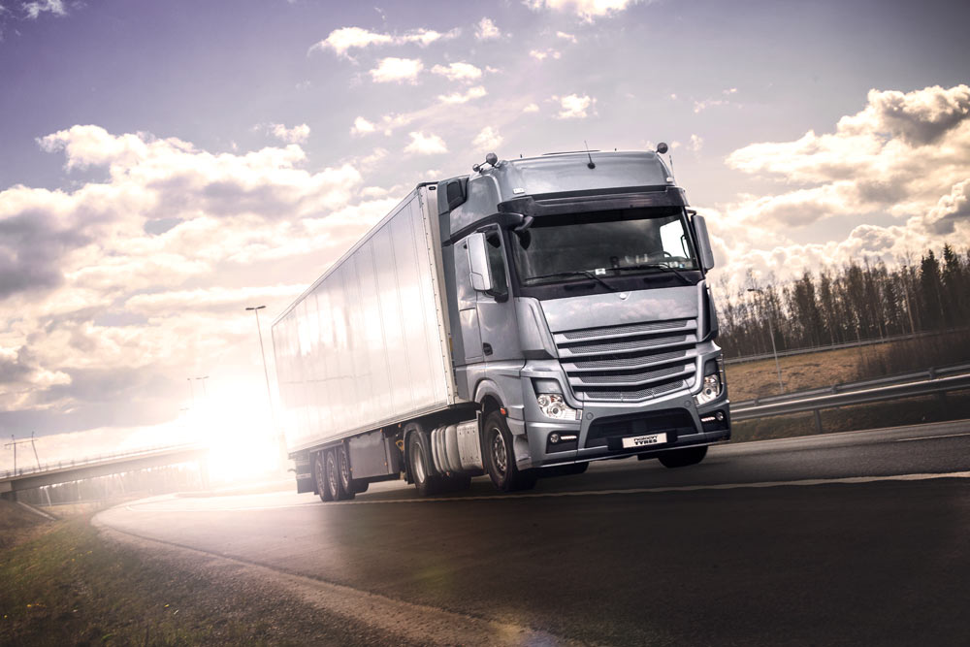The many innovations of the Nokian Hakka Truck Drive guarantee stable handling and grip in snow and rain alike. The new semi-open shoulder supports the rolling of the tyre and adds to driving stability without compromising on grip. The V-shaped tread pattern improves the cleaning of the grooves and prevents them from filling up with slush and snow. This allows the tyre to maintain grip even on slushy surfaces. The additional grooves that appear as the tyre wears down and the Self-Generating Siping allow the tread to retain its properties even as the kilometres add up.

The first two sizes, 315/70 R22.5 and 315/80 R22.5, will become available throughout Europe during the spring and summer 2015. In 2016, the size selection will expand to 295/80 R22.5.

* The innovations in the Nokian Hakka Truck Drive have been developed to ensure the driver’s safety on dry, wet and snowy roads alike. The unique shoulder structure, V-shaped tread pattern, additional grooves and Self-Generating Siping ensure the tyre’s peak properties in any weather during the tyre’s entire service life, says Teppo Siltanen, Product Manager for Truck Tyres at Nokian Heavy Tyres.

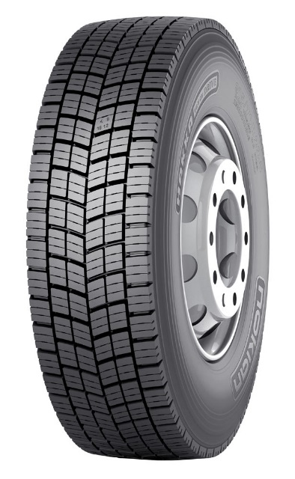The Driving Safety Indicator (DSI), developed and patented by Nokian Tyres, also makes it easier to monitor the safety and wear of the tyre. It displays the remaining amount of tread surface on the tyre's main grooves in numbers.

**Designed for year-round use**

The Nokian Hakka Truck Drive tyre can be used all year long, and it can be fitted in any season. The tyre maintains its grip even on snowy roads. In addition to the M+S label, the tyre also bears the 3PMSF label (snowflake symbol) as proof of this. Tyres that receive the snowflake symbol have been proved to work under demanding snow conditions. The unique siping and the open tread centre section mean that winter grip remains good even as the tyre wears down.

The special rubber compound developed for demanding all-year use guarantees grip and durability in any weather. The rubber compound and optimised pattern distribution keep rolling resistance low. Low rolling resistance reduces fuel costs and the optimised tread pattern makes the tyre comfortably silent to drive.

The Nokian Hakka Truck Drive offers excellent durability. This is due to the optimised block distribution of the tread. The tread distribution has been designed to create a wear pattern that is as even as possible. The durable casing also ensures excellent retreading properties. Nokian Tyres offers several high-quality Nokian Noktop tread models.

The Nokian Hakka Truck Drive is excellently suited for trucks and coaches, but also for heavier transport where sturdiness is required. The tyre is recommended for all-year use in areas with varying weather conditions, such as Central Europe and the Nordic countries.

**Safety and cost savings for demanding professional use**

The Nokian truck and bus tyres are developed for demanding professional use and varying conditions in order to enable safe driving under all weather and road conditions. Nokian Tyres tests extreme driving situations under all weather conditions at their own testing centres in Ivalo and Nokia.

All of the truck and bus tyres in the Nokian Hakka Truck family are developed to be reliable and economical. The optimised tread pattern and durable structure provide not only a pleasant driving experience, but also clear savings in fuel costs thanks to the low rolling resistance. The Nokian Hakka Truck tyres have been developed to master even the most challenging, rapidly changing weather and road conditions – with respect for the environment.

The Nokian Hakkapeliitta Truck product family, on the other hand, is a match for the world’s most demanding winter weather. The Nokian Hakkapeliitta Truck tyres superbly combine modern technology and unique innovations, which results in a comfortable world-class winter tyre for the user.

The tyres are developed by driving millions of kilometres in different operating environments and all kinds of weather. Nokian Tyres’ close co-operation with bus and transport companies offers valuable operating experience to support the design work. The purpose of versatile testing is to offer the market’s safest, most economical tyres for professional driving. The company’s strong competence is based on long traditions. Nokian Tyres developed the world’s first winter tyre for professionals in heavy traffic in 1934.

[**www.nokiantyres.com/heavy**](http://www.nokiantyres.com/heavy)

Vianor tyre and car-service of Nokian Tyres:

[**http://vianor.com**](http://vianor.com/)

**Photos**:

[**www.nokiantyres.com/nokianhakkatruckdrive**](http://www.nokiantyres.com/nokianhakkatruckdrive)

**Videos:**

**Nokian Truck Tyres**

[**http://youtu.be/BsPztTuGijU**](http://youtu.be/BsPztTuGijU)

**Hakkapeliitta Test Experience**

[**http://youtu.be/SSGI1MIr5F4**](http://youtu.be/SSGI1MIr5F4)

**Read more:**

**Nokian Tyres and Valtra set the New World Record for tractors: 130.165 km/h!**

[**http://www.nokiantyres.com/company/news-article/nokian-tyres-and-valtra-set-the-new-world-record-for-tractors-130-165-km-h/**](http://www.nokiantyres.com/company/news-article/nokian-tyres-and-valtra-set-the-new-world-record-for-tractors-130-165-km-h/)

**2014: 80 years since the world's first winter tyre**

[**http://www.nokiantyres.com/company/about-us/history/nokian-kelirengas-en/**](http://www.nokiantyres.com/company/about-us/history/nokian-kelirengas-en/)

**Nokian Tyres is the world's leading winter tyre specialist, a multiple test winner, winter tyre inventor, world record holder and innovation leader**

As the world's leading winter tyre specialist, a multiple test winner, and inventor of the winter tyre, Nokian Tyres offers the safest tyres for Northern conditions. Innovative Nokian tyres for passenger cars, trucks, and heavy machinery demonstrate their high quality particularly well in snow, ice, tough climates, and demanding driving conditions. Nokian Tyres is the inventor of the winter tyre and has been designing, testing, and patenting innovative tyres for 80 years. Furthermore, Nokian Tyres produces tyres especially developed for European weather and the higher speeds on European motorways.

Standard Nokian winter tyres set a new Guinness world record “Fastest on Ice” with a car by reaching a top speed of 335.713 km/h. As a leading innovator, Nokian Tyres presented the world’s first non-studded winter tyres with studs that extend at the press of a button, allowing the tyre to grip better. The tyre manufacturer also introduced the most energy-efficient winter tyre in the world, with an “A” energy rating. The pioneer in winter tyre technology also introduced the Nokian WR D4 winter tyre that achieves the EU tyre label’s best A class in terms of wet grip. The world’s first AA class winter tyre in terms of wet grip and fuel efficiency is the revolutionary Nokian WR SUV 3.

Nokian tyres deliver excellent safety, save fuel, and are the forerunner of environmental friendliness. The company is number 1 in terms of brand recognition and appreciation in Scandinavia and Russia and has a positive, exceptional image.

**Nokian WR winter tyres are multiple test winners and have achieved numerous further test successes**

Nokian WR winter tyres, optimised for European demands, are multiple test winners and have achieved numerous further test successes. Achieving the top rating “exemplary”, the Nokian WR D3 winter tyre is test winner in the 2014 winter tyre test conducted by the German car magazine Auto Bild. Safe handling and short braking distances earned it the top rating on snow. As test winners, Nokian winter tyres also won the 2014 tests by Auto Club Europa ACE, GTÜ (Germany’s largest inspection organisation of freelance certified inspectors), and German car magazines Auto Bild allrad, OFF ROAD and SUV MAGAZIN, as well as Autoclub ARBÖ Austria. Nokian premium tyres were also awarded the top ratings “exemplary” and “highly recommended” in these tests.

Nokian Tyres now presents the first winter tyre in the world for cars with the best grip on wet roads in the EU tyre label's best A class. The new Nokian WR D4 winter tyre is a grip champion and offers unique innovations. The versatile chameleon for winter roads provides safe driving on wet and snowy roads alike. This supreme ruler of every type of winter weather, coming from the pioneer in winter tyre technology, provides a firm grip in rain, snow and slush. According to the test results of the inventor of the winter tyre, it has the shortest braking distance in the ever-changing European winter weather.

Nokian tyres came out on top in more than 40 winter tyre tests that were carried out by car magazines in this winter, thus confirming the good image of the Scandinavian premium brand.

**Nokian summer tyres are multiple test winners: in the 2015 ADAC summer tyre test, by the consumer organisation Stiftung Warentest, in the German SUV magazine OFF ROAD, and in additional tests**

Nokian summer tyres are multiple test winners, offering high levels of safety and saving fuel. The Nokian Line is test winner in the 2015 summer tyre tests of the German automobile club ADAC and of the German consumer organisation Stiftung Warentest. Being rated a top score of “good”, it is highly recommended. The Nokian Line SUV is test winner in the Auto Bild allrad SUV summer tyre test 2015 achieving the best rating “exemplary”. The Nokian zLine SUV is test winner in OFF ROAD being awarded the top rating “highly recommended”.

The Nokian Line already scored the top rating “good” in the 2014 ADAC summer tyre test and with Stiftung Warentest. Being rated highly recommended, it was among the test winner group. The Nokian Z SUV was also the test winner in German SUV magazine OFF ROAD, with the top rating “VERY RECOMMENDED”, and also in SUV MAGAZIN.

**Increased safety through innovations: Winter Safety Indicator with snowflake and Driving Safety Indicator (DSI) with aquaplaning warning**

The Nokian Driving Safety Indicator (DSI) with the unique snowflake symbol, the Winter Safety Indicator (WSI), on the Nokian WR winter tyre clearly shows the driver the groove depth as a number from 8 to 4 millimetres. The numbers disappear gradually as the tyre wears and its tread depth decreases. The snowflake remains visible down to 4 millimetres. When it disappears, the risk increases and the winter tyres should be replaced. The grooves must be a minimum of 4 millimetres deep in order to provide enough grip on snow and to prevent slush planing and aquaplaning on winter and summer tyres.

The Driving Safety Indicator on the Nokian summer tyres shows the driver the groove depth as a simple figure from 8 to 3. An aquaplaning alert within this warns of the danger of aquaplaning with a drop symbol. It disappears when there are only four millimetres of remaining tread, alerting the driver of the increased risk. No other tyre manufacturer has these innovations.

**Nokian Tyres achieved a 1.389 billion euro turnover in 2014**

Nokian Tyres achieved a turnover of 1.389billion euro in 2014 and had over 4,000 employees. In Europe, Nokian Tyres operates with own sales companies in ten countries. The company also owns the Vianor tyre and car-service chain that comprises over 1,300 outlets in 27 countries.

[**www.nokiantyres.com/heavy**](http://www.nokiantyres.com/heavy)

Vianor tyre and car-service of Nokian Tyres:

[**http://vianor.com**](http://vianor.com/)

**Press contact:**

**Dr Falk Köhler PR**

**Dr Falk Köhler**

Tel. +49 40 54 73 12 12

Fax +49 40 54 73 12 22

E-mail [Dr.Falk.Koehler@Dr-Falk-Koehler.de](mailto:Dr.Falk.Koehler@Dr-Falk-Koehler.de)

[**www.Dr-Falk-Koehler.de**](http://www.Dr-Falk-Koehler.de)

Ödenweg 59

22397 **Hamburg**

Germany

**Further information:**

[**www.twitter.com/NokianTyresCom**](http://www.twitter.com/NokianTyresCom)

[**www.youtube.com/NokianTyresCom**](http://www.youtube.com/NokianTyresCom)

**[www.facebook.com/nokiantyres](https://www.facebook.com/nokiantyres)**

[**www.linkedin.com/company/nokian-tyres-plc**](http://www.linkedin.com/company/nokian-tyres-plc)

**Nokian Tyres Europe**

**Nokian Tyres s.r.o**

V Parku 2336/22

148 00 Praha 4

Czech Republic

Managing Director Central Europe Hannu Liitsola, Tel. +420 605 236 440

E-mail [hannu.liitsola@nokiantyres.com](mailto:hannu.liitsola@nokiantyres.com)

[**www.nokiantyres.com/heavy**](http://www.nokiantyres.com/heavy)

**Nokian Tyres Finland Headquarters**

**Nokian Tyres plc**

Pirkkalaistie 7

P.O.Box 20

37101 Nokia

Finland

Product Manager Truck Tyres Teppo Siltanen, Tel. + 358 10 401 7709

E-Mail [teppo.siltanen@nokiantyres.com](mailto:teppo.siltanen@nokiantyres.com)

[**www.nokiantyres.com/heavy**](http://www.nokiantyres.com/heavy)