**Mandatory tyre pressure monitoring system enhances safety**

**Changing tyres at home will become more complicated and, for this reason, should be left to a professional tyre service centre, advises tyre specialist Nokian Tyres. The tyre pressure monitoring system TPMS warns drivers when a tyre is too low on the pressure. Correct tyre pressure reduces fuel consumption, ensures a pleasant drive and precise steering responses.**

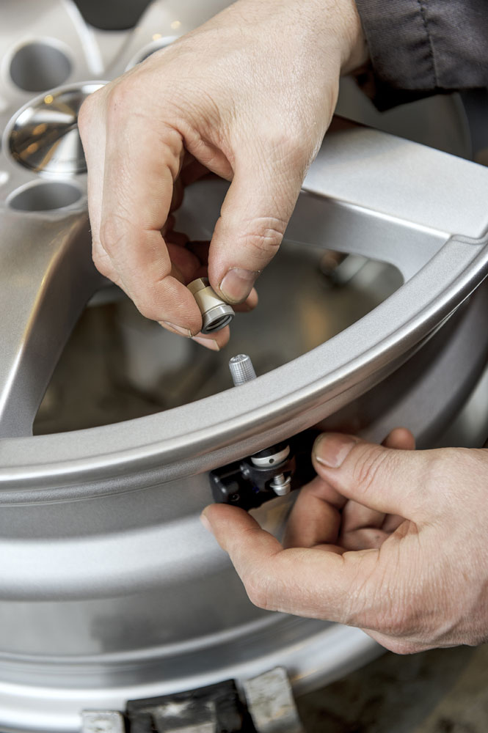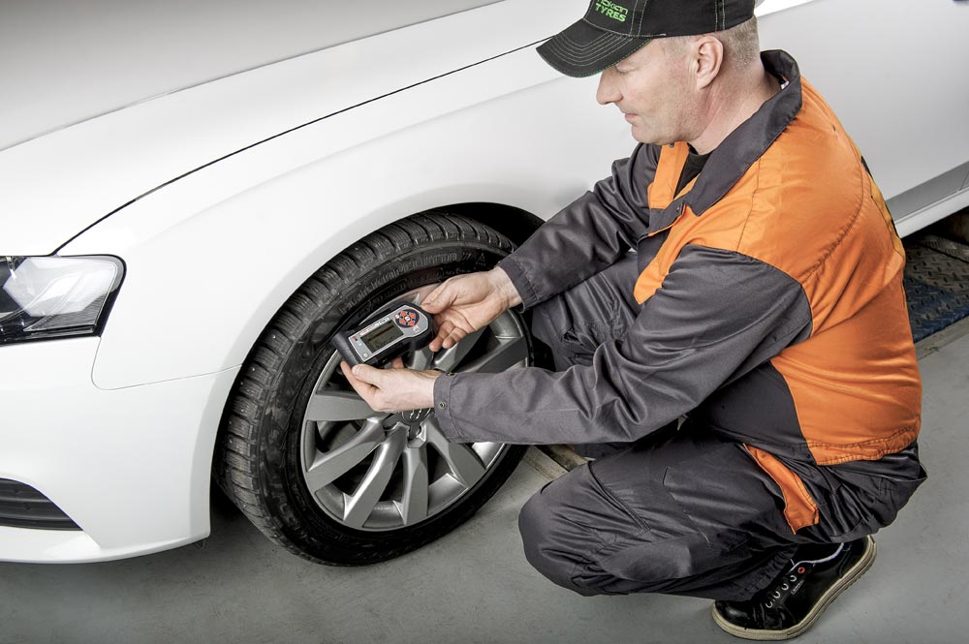The mandatory tyre pressure monitoring system significantly enhances safety, but makes changing tyres at home more complicated. For this reason, a professional tyre service centre should change the tyres, advises tyre specialist Nokian Tyres. The tyre pressure monitoring system TPMS warns the driver when a tyre is too low on pressure. The correct tyre pressure reduces fuel consumption, ensures maximum driving comfort in addition to precise steering responses and prolongs the life of the tyres. According to an EU directive, all new cars must be fitted with a tyre pressure monitoring system TPMS from 1 November on.

The introduction of the tyre pressure monitoring system offers various advantages for motorists, argues tyre specialist Nokian from Finland. TPMS ensures the right tyre pressure for the prevailing conditions. "Tyre pressure plays a notable role in the car's driving properties and the service life of tyres,” says Ville Nikkola, Product Manager Passenger Car Tyres from Vianor tyre and car-service chain of Nokian Tyres. “Grooved road surfaces, unexpected side wind, sudden evasive movements and quickly changing conditions pose challenges on traffic safety. Safety can be improved by adjusting the vehicle's tyre pressure according to its load and the driving conditions.“

20 per cent of Finnish motorists risk driving dangerously with at least 0.5 bar under-inflated tyres, according to the Finnish tyre dealer association Autonrengasliitto ry. Only a third of motorists in Finland have checked their tyre pressure within the last month.

TPMS also helps reduce fuel consumption. Optimal tyre pressure translates into maximal driving comfort, precise steering response and tyres rolling easily, which saves fuel. The Finnish Transport Safety Agency (Trafi) has estimated that fuel savings as high as 2.5 per cent could be achieved if all passenger cars driving in Finland were equipped with the tyre pressure monitoring system TPMS.

Similarly large fuel savings can be achieved throughout Europe, predicts Vianor tyre and car service chain of Nokian Tyres.

**Direct or indirect tyre pressure monitoring systems warn the driver**

Car manufacturers can choose between a direct or indirect TPMS. With the direct system, each wheel is fitted with a battery-powered sensor that transmits data about tyre pressure, temperature and other such factors to the car's instrument cluster.

"TPMS whether it is a direct or an indirect system warns the driver if the pressure of any one tyre decreases by more than 20 per cent from the pre-set value, and always if it falls below 150 kPa," Nikkola explains. “Depending on the car model, the system usually also indicates, which tyre is under-inflated.” The choice of system is always made by the car manufacturer.

**More complicated tyre change**

Sensors fitted directly in wheels will be the clearly most commonly used system deployment methods. For car owners, this may add some technical complication to tyre change, because certain cars' instrument clusters require that the sensors must be 'retaught' through an OBD port if the change of tyres also involves a change of sensors.

"Vianor will obtain all required tools to all of its outlets and train its staff. This is a major change that can feel difficult both to our customers and our employees," Ville Nikkola states.

New passenger car registrations in the EU are pursuing an upward trend according to the European Automobile Manufacturer Association ACEA. They totalled 9,572,259 units between January and September 2014 which is an increase of 6.1 per cent compared to 2013.

Nokian tyres are also available from retailers as complete wheels on rims for tyre changes.

[**www.nokiantyres.com**](http://www.nokiantyres.com)

Vianor tyre and car-service chain of Nokian Tyres:

[**http://vianor.com**](http://vianor.com/)

Edited by: Dr Falk Köhler

**Photos captions**

Vianor_TMPS_1.jpg caption:

Tyre mechanic of Vianor tyre and car-service analysing the pressure monitoring sensor's operation with a diagnostic tool Foto: Nokian Tyres

Vianor_TMPS_2.jpg caption:

The tyre pressure monitoring sensor can be fitted on the tyre valve Photo: Nokian Tyres

**Photo downloads tyre pressure monitoring system:**

[**www.nokiantyres.com/tpms**](http://www.nokiantyres.com/tpms)

**More information:**

**Nokian tyres rated “good” in ADAC summer tyre test 2014 and by consumer organisation Stiftung Warentest:**

[**http://www.nokiantyres.com/company/news-article/nokian-tyres-rated-good-in-adac-summer-tyre-test-2014-and-by-consumer-organisation-stiftung-warentest-2/**](http://www.nokiantyres.com/company/news-article/nokian-tyres-rated-good-in-adac-summer-tyre-test-2014-and-by-consumer-organisation-stiftung-warentest-2/)

**Nokian summer tyres offer high levels of safety and satisfaction in challenging summer conditions:**

[**http://www.nokiantyres.com/company/news-article/nokian-summer-tyres-offer-high-levels-of-safety-and-satisfaction-in-challenging-summer-conditions/**](http://www.nokiantyres.com/company/news-article/nokian-summer-tyres-offer-high-levels-of-safety-and-satisfaction-in-challenging-summer-conditions/)

**Sources:**

20 per cent of Finnish motorists risk driving dangerously with at least 0.5 bar under-inflated tyres according to the Finnish tyre dealer association Autonrengasliitto ry. Only a third of motorists in Finland have checked their tyre pressure within the last month:

Autonrengasliitto ry Annual Report 2013

<http://www.autonrengasliitto.fi/?s=EN>

New passenger car registrations in the EU are pursuing an upward trend. They totalled 9,572,259 units between January and September 2014 which is an increase of 6.1 per cent compared to 2013 according to the European Automobile Manufacturer Association ACEA.

<http://www.acea.be/press-releases/article/passenger-car-registrations-6.1-over-nine-months-6.4-in-september>

**Nokian Tyres is the world's leading winter tyre specialist, a multiple test winner, winter tyre inventor, world record holder and innovation leader**

As the world's leading winter tyre specialist, a multiple test winner, and a premium brand, Nokian Tyres offers the safest tyres for Northern conditions. Innovative Nokian tyres from Finland for cars, trucks, and heavy machinery demonstrate their high quality particularly well in snow, tough climates, and demanding driving situations, and deliver sustainable added value. Standard Nokian winter tyres set a new Guinness world record Fastest on Ice by reaching a top speed of 335.713 km/h. As a leading innovator, Nokian Tyres presented the world's first non-studded winter tyres with studs that extend at the press of a button so that the tyre grips better.

Furthermore, the premium-brand Nokian produces tyres especially developed for European weather and the higher speeds on European motorways. Nokian tyres deliver excellent safety, save fuel, and are the forerunner of environmental friendliness. The company is number 1 in terms of brand recognition and appreciation in Scandinavia and Russia and has a positive, exceptional image.

**Nokian WR winter tyres are test winners and have achieved numerous further test successes**

Nokian WR winter tyres, optimised for European demands, are test winners and have achieved numerous further test successes. Nokian WR D3 winter tyre is test winner in the 2014 winter tyre test by Europe’s largest car magazine Auto Bild Germany, with the top rating “exemplary”. It earned top results on snow, thanks to safe driving behaviour and short braking distance. Nokian winter tyres also won the 2014 tests by Auto Club Europe ACE, GTÜ, Germany’s largest inspection organisation of freelance certified inspectors, German car magazines Auto Bild allrad and OFF ROAD as well as auto club ARBÖ Austria. The premium tyres, developed in Finland, were awarded the top ratings “exemplary” and “highly recommended” also in these tests.

In more than 25 winter tyre tests carried out by car magazines in Germany and other European countries last winter, Nokian tyres came out on top and thus confirmed the positive image of the Nordic premium brand.

**Nokian tyres rated “good” in the ADAC summer tyre test 2014 and by the consumer organisation Stiftung Warentest and test winner in the German SUV magazine OFF ROAD**

Nokian summer tyres are multiple test winners, offering high levels of safety and saving fuel. The Nokian Line summer tyre scores the top rating “good” in the summer tyre test 2014 of the German automobile club ADAC and with the German consumer organisation Stiftung Warentest Being rated “especially recommended”, Nokian Line is among the test winner group. As such, the Nokian tyre achieved a double success in the two best-selling tyre sizes tested for the compact and middle-sized category and for small cars.

The test winner is the Nokian Z SUV in the big SUV summer tyre test 2014 by the German SUV magazine OFF ROAD, with the top rating “HIGHLY RECOMMENDED” and also in SUV MAGAZIN.

Nokian tyres were test winners 70 times or were among test winner group, scoring “good” or “recommended” 51 times in 121 test reports from autumn 2011 to spring 2014 – in Central Europe alone.

**Nokian Satisfaction Guarantee - peace of mind for the tyre buyer**

Nokian Satisfaction Guarantee is a special offer from Nokian Tyres Authorized Dealers and Vianors. If a consumer for whatever reason is not satisfied with his new tyres from Nokian, he can exchange them within 14 days for another set of tyres at his dealer’s. Mounting and balancing are free of charge. Nokian Satisfaction Guarantee goes way beyond normal product guarantees – it is for pleasure, feeling and satisfaction.

**Increased safety through innovations: Winter Safety Indicator with snowflake and Driving Safety Indicator (DSI) with aquaplaning warning**

The Nokian Driving Safety Indicator (DSI) with the unique snowflake symbol, the Winter Safety Indicator (WSI), on the Nokian WR winter tyre clearly shows the driver the groove depth as numbers from 8 to 4 millimetres. The snowflake remains visible down to 4 millimetres. When it disappears, the risk increases and the winter tyres should be replaced. The grooves must be a minimum of 4 millimetres deep in order to provide enough grip on snow and to prevent slush planing and aquaplaning on winter and summer tyres.

The Driving Safety Indicator on the Nokian summer tyres shows the driver the groove depth as simple figures from 8 to 3. An aquaplaning alert within this warns of the danger of aquaplaning with a drop symbol. It disappears when there are only four millimetres of remaining tread, alerting the driver of the increased risk. No other tyre manufacturer has these innovations.

**Nokian Tyres achieved a 1.521 billion euro turnover in 2013**

Nokian Tyres achieved a turnover of 1.521 billion euro in 2013 and had over 4,000 employees. In Central Europe, Nokian Tyres operates with own sales companies in ten countries. The company also owns the Vianor tyre and car-service that comprises over 1,200 outlets in 27 countries.

[**www.nokiantyres.com**](http://www.nokiantyres.com)

Vianor tyre and car-service of Nokian Tyres:

[**http://vianor.com**](http://vianor.com/)

**Press contact:**

**Dr Falk Köhler PR**

**Dr Falk Köhler**

Tel. +49 40 54 73 12 12

Fax +49 40 54 73 12 22

E-mail[Dr.Falk.Koehler@Dr-Falk-Koehler.de](mailto:Dr.Falk.Koehler@Dr-Falk-Koehler.de)

[**www.Dr-Falk-Koehler.de**](http://www.Dr-Falk-Koehler.de)

Ödenweg 59

22397 **Hamburg**

Germany

**Further information:**

[**www.twitter.com/NokianTyresCom**](http://www.twitter.com/NokianTyresCom)

[**www.youtube.com/NokianTyresCom**](http://www.youtube.com/NokianTyresCom)

**[www.facebook.com/nokiantyres](https://www.facebook.com/nokiantyres)**

[**www.linkedin.com/company/nokian-tyres-plc**](http://www.linkedin.com/company/nokian-tyres-plc)

**Motorist blog: <http://hakkapedia.us/blog/en>**

**Expert blog:** [**http://nordictyreblog.com/**](http://nordictyreblog.com/)

**Vianor tyre and car-service**

Product Manager, Passenger Car Tyres Ville Nikkola, Tel. +358 3 340 7596

E-Mail [ville.nikkola@vianor.com](mailto:ville.nikkola@vianor.com)

[**http://vianor.com**](http://vianor.com/)

**Nokian Tyres Europe**

**Nokian Tyres s.r.o**

V Parku 2336/22

148 00 Praha 4

Czech Republic

Business Director Central Europe Dieter Köppner, Tel. +420 222 507 761,

E-mail: [dieter.koppner@nokiantyres.com](mailto:dieter.koppner@nokiantyres.com)

Product Development Manager CE Sven Dittmann, Dipl.-Ing., Tel. +49 8143 444 850

E-Mail [sven.dittmann@nokiantyres.com](mailto:sven.dittmann@nokiantyres.com)

Marketing Manager Lukáš Líbal, Tel. +420 222 507 759

E-Mail [lukas.libal@nokiantyres.com](mailto:lukas.libal@nokiantyres.com)

**www.nokiantyres.com**

**Nokian Tyres Finland Headquarters**

**Nokian Tyres plc**

Pirkkalaistie 7

P.O.Box 20

37101 Nokia

Finland

Development Manager Juha Pirhonen, Tel. +358 10 401 7708

E-Mail [juha.pirhonen@nokiantyres.com](mailto:juha.pirhonen@nokiantyres.com)

Technical Customer Service Manager Matti Morri, Tel. +358 10 401 7621

E-Mail [matti.morri@nokiantyres.com](mailto:matti.morri@nokiantyres.com)

**www.nokiantyres.com**