Recyclability of the tires

Recycling is a part of circular economy, which is a system that reduces waste and mitigates raw material scarcity through the continual use of resources. In accordance with the European Union’s waste legislation, both companies and individual consumers must act in accordance with the waste hierarchy, which primarily regulates the reduction of waste and, secondarily, its recycling.

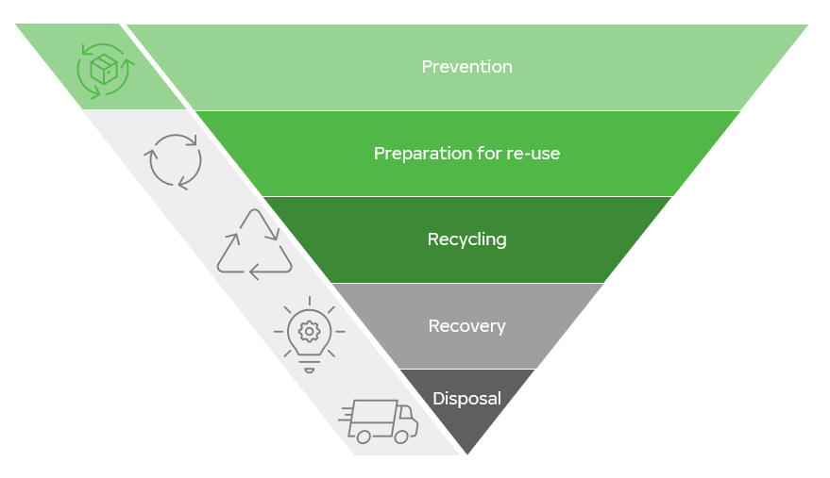
Figure 1. Waste hierarchy.

The life cycle of tires

Tire manufacturers have an important role in ensuring that the waste hierarchy is realized, for example by using sustainable raw materials and making sure that it is technically possible to recycle waste tires without causing the release of harmful substances in the recycling process. The best way to save natural resources is to ensure optimal tire maintenance in the use phase, such as by avoiding low tire pressure and sub-optimal load. Increasing tire lifetime by means of advanced tire design and optimal tire maintenance during the use phase make it possible to reduce environmental impacts.

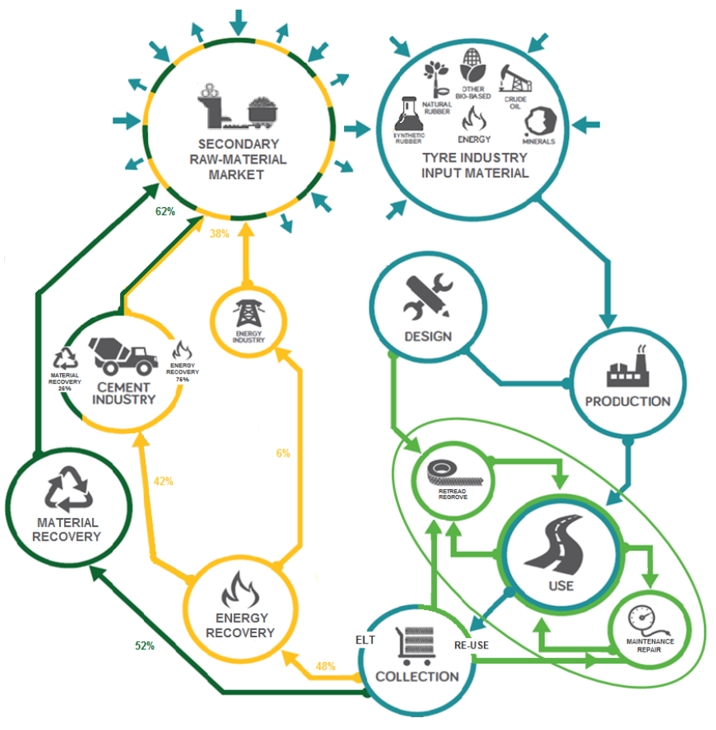
Figure 2. The life cycle of tires is a part of circular economy, which improves material efficiency and reduces waste.

Heavy tires such as truck tires may be retreaded up to three times before they end up as waste. Retreading refers to the process of replacing the worn-out tire tread. Retreading advances circular economy and minimizes the use of virgin raw materials. Compared to a new tire, it saves around 100 kg or 70% of raw materials and reduces waste by approximately 160 kg for each tire retreaded twice. Retreaded tires have a lower acquisition cost compared to new tires, and they are an environmentally friendly solution producing 24% less CO₂ emissions and just over 20% fewer other air emissions.

In Europe, for example, more than three million metric tons of end-of-life tire are collected and treated through various recycling and recovery processes. The aim of the waste legislation is, first and foremost, to prevent the generation of waste. At their end-of-life, to the maximum extent possible, the tires are prepared for reuse, recycled as material, or recovered as energy – in this order of preference.
Most European countries have in place a recycling system based on producer responsibility. The consumer will be charged a small recycling fee when buying new tires, after which the consumer can return their old tires for recycling.

The collected secondary raw materials from end-of-life tires are important resources for industries such as construction, automotive, cement, etc. The aim of the European tire and recycling industries is to increase the value of secondary raw materials derived from tires. After the shredding of the steel and fabric components, the rubber is reduced to rubber granules and powder. The rubber granules can be utilized in molded rubber products such as wheels for caddies and dustbins. Rubber granules and powder may also be used as surface materials on playgrounds and athletics tracks. They are also used as shock absorbing mats at stables and in paving blocks. The most typical way of using the granules is as infill of artificial turf in football fields. Rubber powder is used to increase the elasticity and noise absorption of asphalt materials. It also increases the life span of the road surface and improves safety on wet roads. Whole tires can be used in civil engineering applications like coastal protection, as erosion barriers, breakwaters, and road embankments. The size of granules from mechanically sheared tires ranges from 25 to 300 mm and they are used as foundation for roads and railways and as a draining material replacement for sand or gravel, in landfill construction, and in embankments. It is an efficient solution as a light material. Sheared tires are 30–50% lighter than soil. They drain water ten times better than well graded soil and insulate eight times better than gravel.

Energy recovery is only a secondary recovery option. However, the calorific value of the tires is almost comparable to that of virgin fuel oil. Thermal treatment technologies such as pyrolysis involve intermediate substances: gas, oil, and carbon black. High temperature resource recovery is quite expensive and the obtained price of by-products often fails to justify the process costs. The process is developing, and new options may be able to increase the recycling rates. Various recovery options are being developed all the time. The goal is to utilize used tires as efficiently as possible as a material, thereby reducing the environmental impact.

Tire recycling at Nokian Tyres
Nokian Tyres is known as a pioneer in environmental matters. This concerns the entire life cycle of a tire. As for production, it means measures such as using only purified oils and utilizing raw materials as efficiently as possible. Nokian Tyres is the world’s first tire manufacturer to have fully eliminated high-aromatic (HA) oils in its production in 2005. Respect for the environment is part of our product development philosophy. We aim to pay increasing attention to environmental issues in the design of new products, starting from ethical raw material acquisition all the way to a well-functioning recycling system.
In 1995, Nokian Tyres and other companies in the tire industry established Finnish Tyre Recycling Ltd to promote the centralized collection and utilization of tires nationally. Nokian Tyres is a member of the Finnish Tyre Recycling Ltd and the US Tire Manufacturers Association, USTMA, to promote the centralized collection and utilization of tires nationally. The following picture presents an example of a centralized tire recycling system lead by national company specializing in the management of end-of life tires.

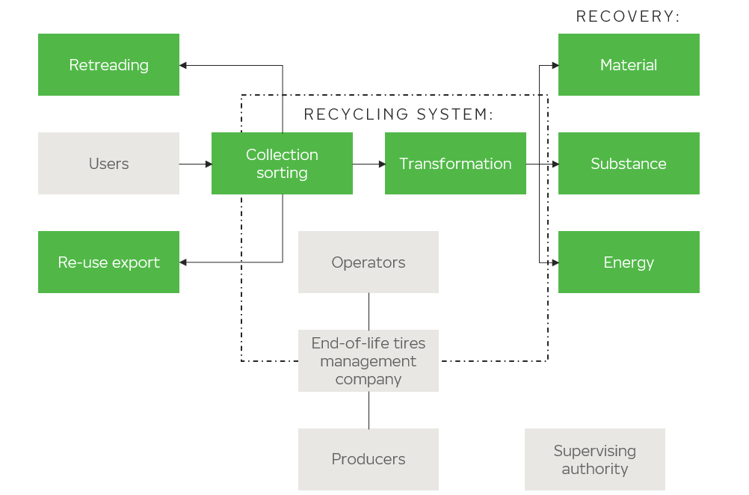
Figure 3. Recycling system and utilization of tires.

How to recycle your tires?

Think about nature and recycle your used tires wisely.

DO NOT… | DO
Neglect to maintain your tires. | Keep the correct tire pressure on your tires and avoid sub-optimal load.
Waste natural resources. | Retread your tires as many times as possible.
Dump tires into a land fill. | Return your used tires to your dealer or find an authorized tire recycler.
Dump your tires into nature. | Return your used tires to your dealer or find an authorized tire recycler.
Burn your tires by yourself. | Return your used tires to your dealer or find an authorized tire recycler.

Further information:

Read more about tire recycling at Nokian Tyres.
Sustainability of Nokian Heavy Tyres

Sustainability of Nokian Tyres Plc.

European Commission 2022. Waste framework directive. Available from: https://ec.europa.eu/environment/topics/waste-and-recycling/waste-framework-directive_en
ETRMA 2022. Circular Economy. Circular Economy is a system to reduce – and eventually eliminate – waste and manage raw materials’ scarcity through the continual use of resources. Available from: https://www.etrma.org/key-topics/circular-economy/
Ernst & Young 2016. The socio-economic impact of truck tire retreading in Europe. The circular economy of tires in danger.
ETRMA 2022. Circular Economy. Recycling Applications. Available from: https://www.etrma.org/key-topics/circular-economy/
Finnish Tyre Recycling 2022. Versatile utilization. Available from: https://www.rengaskierratys.com/en/tyre_recycling/recovery_routes

